
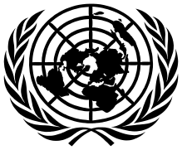
United Nations Human Rights Council
United Nations High Commissioner
for Human Rights

Easy to read

Making sure that all children can get enough money and support to help them have a good start in life
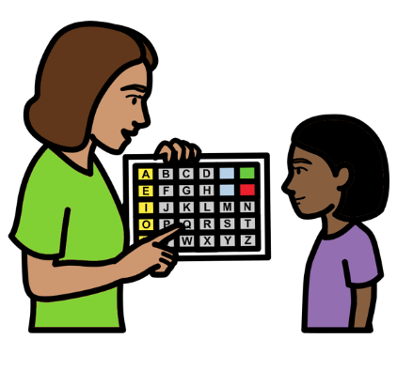

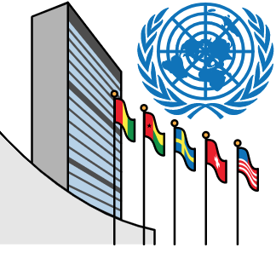
About this report

We are part of the United Nations (UN).

The United Nations is a group of countries that works together to make the world better and safer.

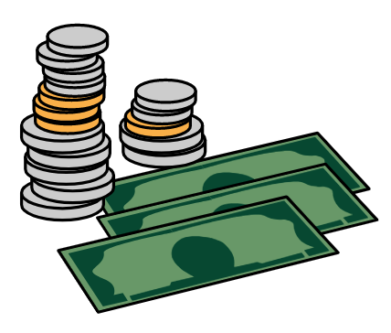

This report is about making sure that all children can get enough money and support to have a good start in life.

This money and support is called social protection.

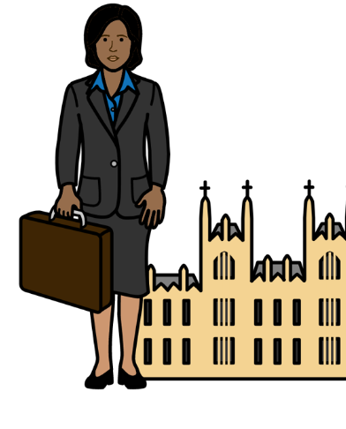

Governments are in charge of giving people this money and support.

Governments are the people who run countries.

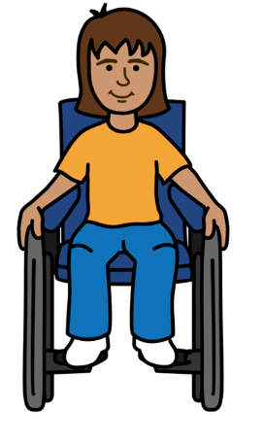
Countries should be making sure that all children and their families get enough extra money and support if they need it.

For example, many children in the world do not have enough money to live on.

Or they might have a disability or need extra support to do things every day.

There are many ways that countries could give people this money and support.

For example, countries could pay families extra money to get food, medicine, clothes or other things in an emergency.

An emergency might be things like war,
floods or not enough food to eat.



Countries could also pay families some money called benefits.

For example, benefits could be paid to families every week or month to help them buy the things they need.

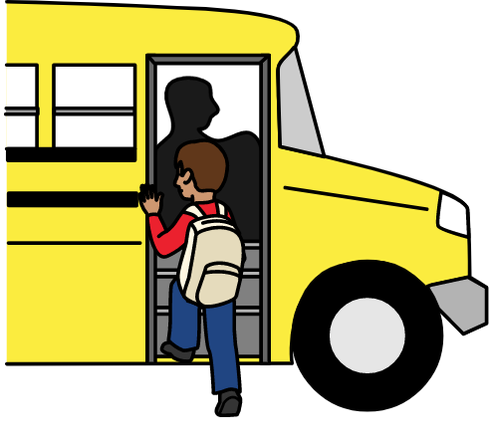
Countries could also give families things for free or for less money.

Like healthy food, transport to school and free school meals.

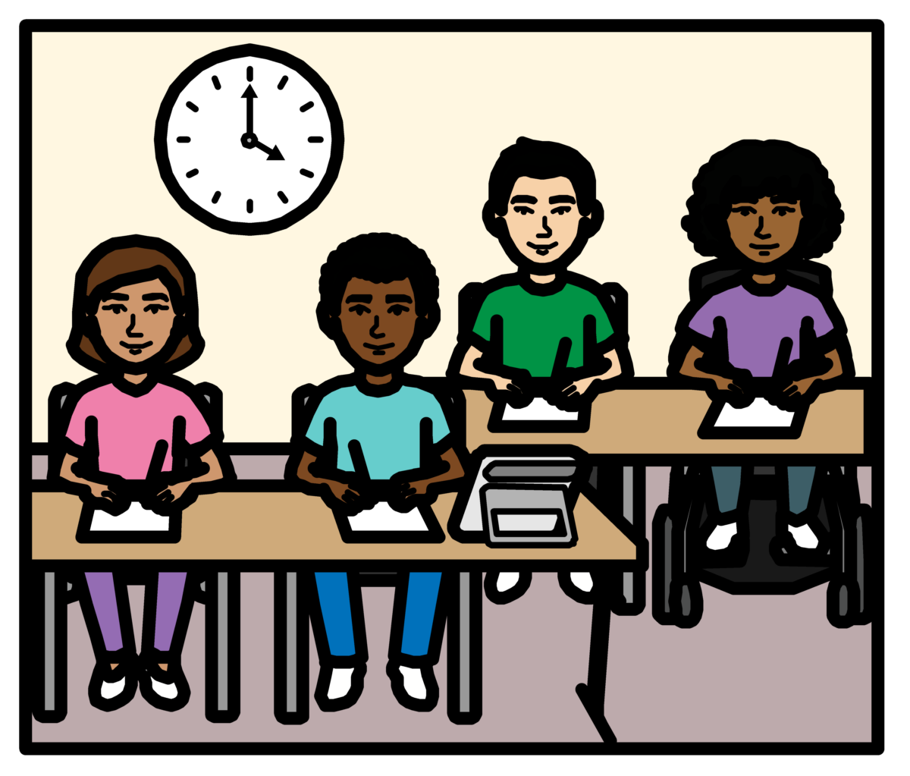

Countries should also make sure that all children get other things they need.

Like good health care, education and housing.

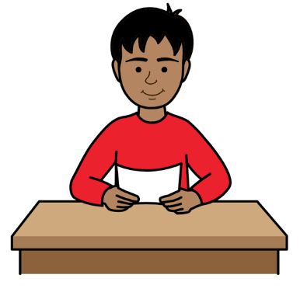
This report looks at:

- Why many children are not getting this money and support when they need it.

- Some good work that countries are already doing.

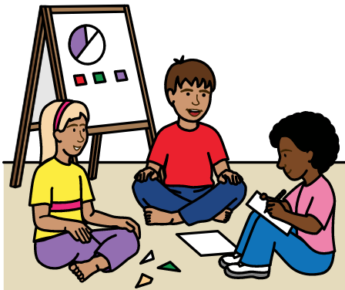
- What countries should do next.

Many countries and people gave us their ideas for this report.

That includes children from different countries.
What is happening at the moment?
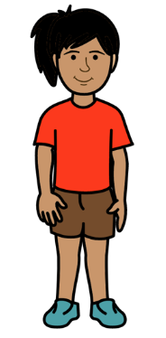
This includes what children told us.

The money and support we talk about in this report is very important.

It can stop problems happening or getting worse for children.

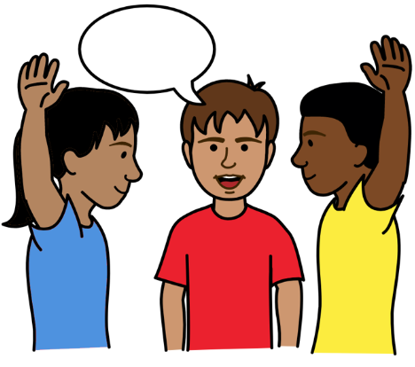

For example, it can help to stop children being poor.

And it can help to make sure that all children are treated fairly and have the same chances to do well.



There are important laws in the world about the rights of all children.

The laws say that all children should have enough support and money to live on when they need it.


Many countries have promised to follow these laws.

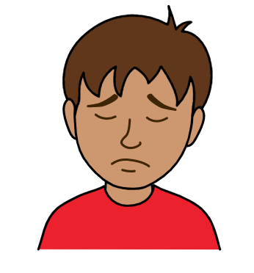

But many children and their families are not getting the money and support they need.

This can stop children from having a good life.


For example, children might not have enough healthy food, clean water or clothes to wear.
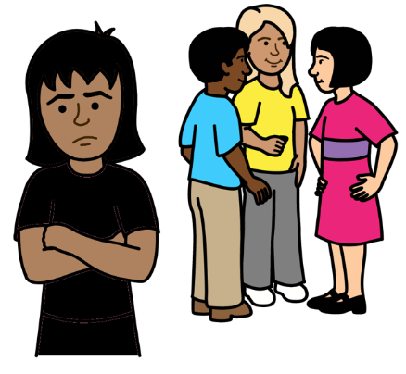

Or they might not be able to go to school or get a job where they are treated fairly when they are older.
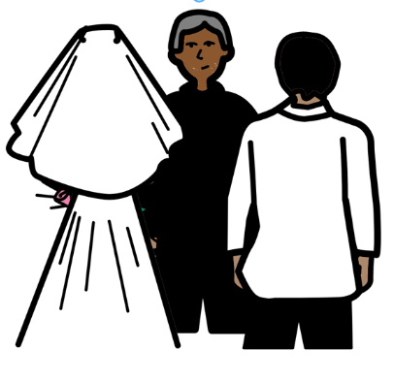

People might also force children to work or get married if they do not have enough money.

Some problems that stop many children from getting the money and support they need

Countries might give some children and their families extra money and support.
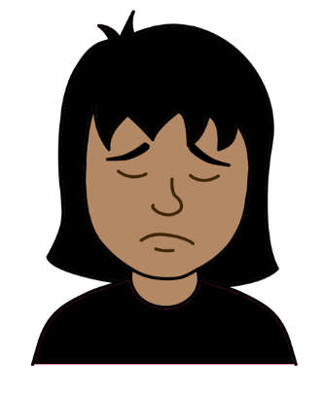


But many children and their families are left out.

Or they do not get enough support or money to live on.

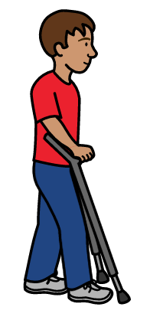

That might include:

- Children with disabilities.

- Children who live in the countryside.
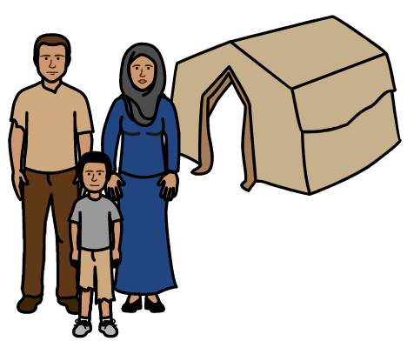

- Children who had to leave their homes because of war or other problems.

- Girls and women.

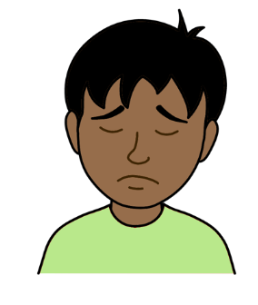
It can be hard for many children and their families to get the money and support they need.

That includes health care and education.
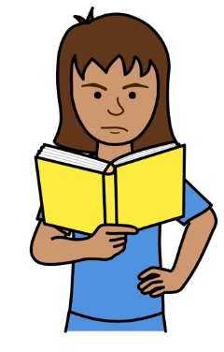

For example, the rules about who can get money and support might be hard to understand.

Or the rules might stop some children from getting extra money or support.
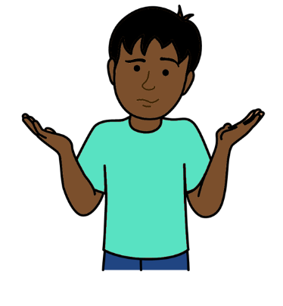

Children and their families might not know what money and support they can get.

Information about the support they can get might be hard to understand.
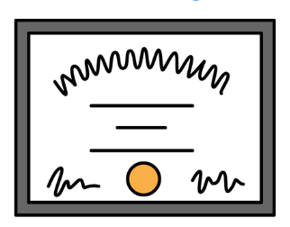

Children and families might not have the documents they need to get the support.

Like documents to show who they are.
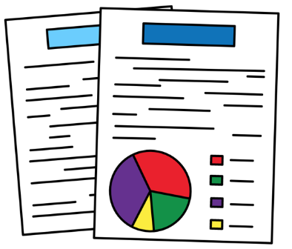

Many countries do not have good information to show them what children need.
Some good work that countries have done
Some countries have already done good work to help children get what they need.

That includes:

- Paying benefits money to all children in the country.
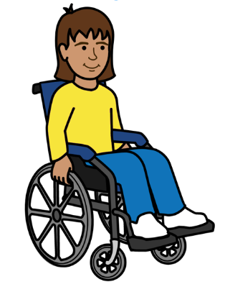

- More care, education and money for very young children.

- Extra money and support for children who are often left out. Like children with disabilities.
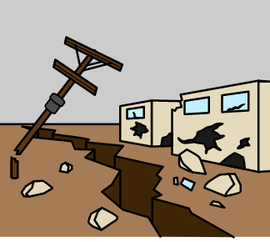

- Money and support for children and their families in an emergency.

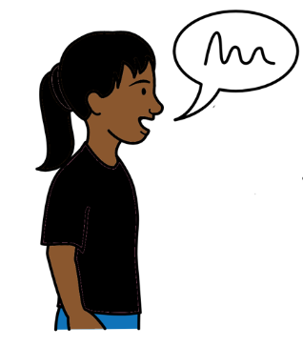
- Support for children to go to school. Like money for children who are poor and free school meals.

- Support for children and young people to take part in making decisions.
What countries should do next
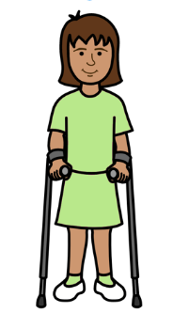
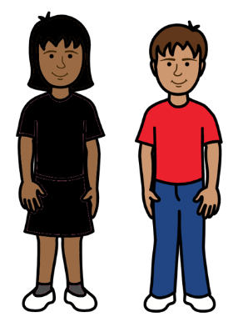

Countries should make sure that all children can get enough money and support to be safe, happy and healthy.

That includes children who cannot get the money and support they need now.

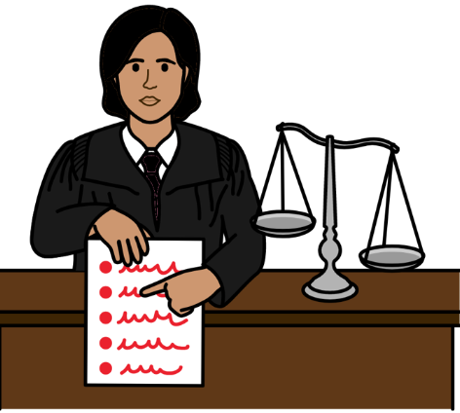

All children should get the right money and support for them.

That means making laws and rules that work for all children and their rights.

Money and support include:

- Enough benefits money for all children and their families.
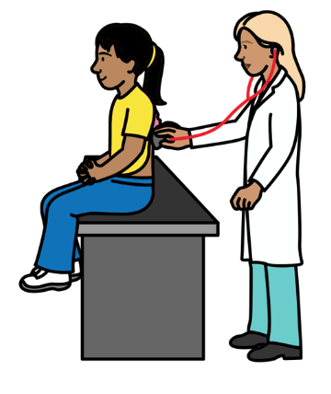
That means no one is left out.

- Good health care that everyone can get when they need it.

- Good and free education for all children.

Money and support also include:

- Healthy food that does not cost too much.

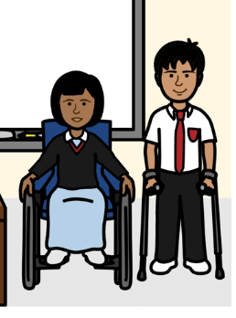
- Good enough housing.

- Extra money and support for children with disabilities or other children who might need it.

That includes extra money and support for children in an emergency.

It also means extra money and support for families.

For example:

- Extra money and support if parents cannot work because they are ill or have a disability.
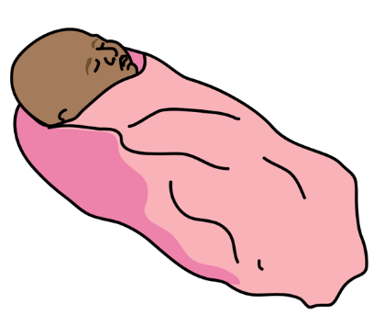

- Giving parents time off work if they have a new baby. Parents should still get paid for this.

- Information and support for parents about how to care for their children in the best way.

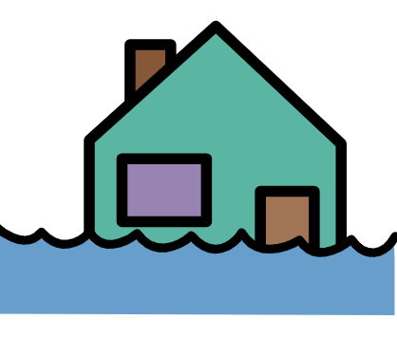
Countries should set up good ways to give money and support to children and their families.

That will help countries to give children money and support more quickly in an emergency.
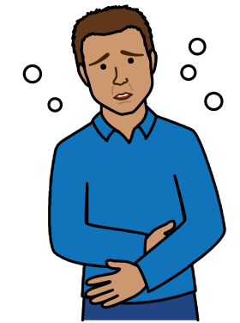

For example, many countries gave people extra support when there was a big illness in the world called Covid-19.

That showed what countries can do.
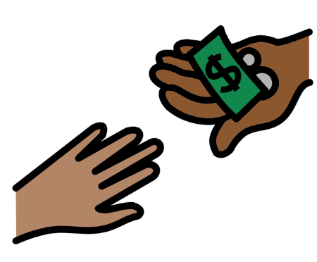

It should be easy for all children and their families to get the money and support they need.

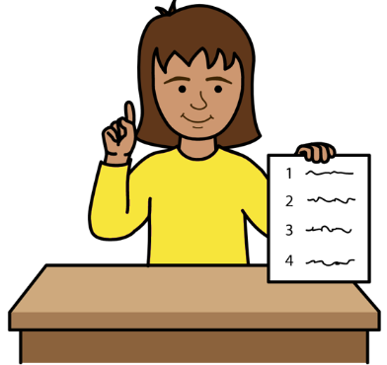

For example, all children and families should have information that is easy for them to understand.

The information should be about:

- The money and support they can get.

- How to complain and get help if they do not get the right money and support.
Countries should spend enough money to support children and their families all through their lives.

They should put enough money aside to spend on this.
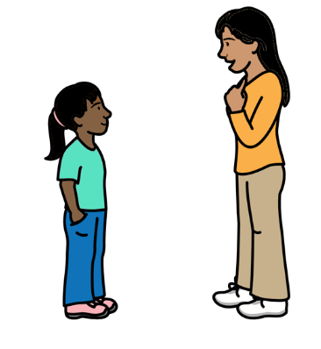

Countries should always work with children to make laws and plans about extra money and support.

That is to make sure the laws and plans work for all children.

Countries should get good information about extra money and support for children and how it is working.

That will help them to know how to give all children enough money and support.
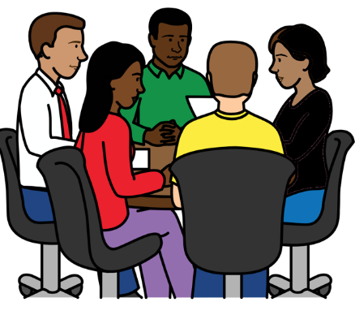

Countries should help each other to make sure that all children have enough money and support.

That will help all children in the world to have a good start in life.
Pictures by The Picture Communication Symbols ©1981–2016 by Mayer-Johnson LLC a Tobii Dynavox company. All Rights Reserved Worldwide. Thousands of resources available for free at www.boardmakeronline.com

