Autonomy, participation and human dignity of older persons with cognitive impairment

Government of Ireland submission to the call for inputs of the Independent Expert on the enjoyment of all human rights by older persons

The Government of Ireland recognises the importance of supporting the autonomy, participation and human dignity of older people with cognitive impairment, including dementia, and has given effect to this in numerous ways.

National Dementia Strategy
The Irish National Dementia Strategy (2014) was developed to improve dementia care so that people with dementia can live well for as long as possible, can ultimately die with comfort and dignity, and can have services and supports delivered in the best way possible.

The Strategy seeks to progress the dual and overarching principles of personhood and citizenship by enabling people with dementia to maintain their identity, resilience and dignity and by recognising that they remain valued, independent citizens who, along with their carers, have the right to be fully included as active citizens in society.

The Strategy contains various actions to give effect to these principles, including actions to raise awareness of dementia, improve information provision, and reduce the stigma that may be associated with the condition. The importance of training for health and social care staff, frontline staff in other settings, and family carers to communicate with, and respond appropriately to the needs of, people with dementia is also prioritised.

‘Dementia: Understand Together’ campaign
Dementia: Understand Together is a national campaign that promotes support, awareness, and stigma reduction for people living with dementia in Ireland. It encourages people across society to stand together with those affected by the condition. The campaign was initially funded through the National Dementia Strategy Implementation Programme that gave effect to several actions in the 2014 National Dementia Strategy. It is led by the Health Service Executive and supported by a coalition of organisations working with people living with dementia, including the Alzheimer Society of Ireland and Age Friendly Ireland. The campaign focuses on simple actions that everyone can take to create positive change. These actions are based on the real experiences and needs of people with dementia and their families.

‘Understand Together’ works with over 60 national partners from the public, private and voluntary sectors, including businesses, academics and national community groups who are raising awareness through their branch networks, conducting training for staff members, reviewing, and developing their services. This is in addition to 2,100 community champions at a grassroots level who do valuable work locally in mobilising existing community organisations and resources to support people with dementia.

The campaign aims to increase health and wellbeing for people affected by dementia by creating dementia inclusive communities across the country, in both urban and rural settings. The goal is to increase understanding of dementia amongst the general public and encourage people to take meaningful actions to support people to stay connected and engaged in their own community. Through the work with national and local stakeholders, the campaign is changing perceptions of dementia and increasing empathy towards people with dementia. The cross-sectoral collaboration supports sustainability and scalability of actions to create inclusive communities for all.

Model of Care for Dementia in Ireland
In 2023 Ireland’s Health Service Executive (HSE) published a Model of Care for Dementia in Ireland. The Model of Care aims to address system shortcomings, providing earlier recognition and intervention for those living with dementia, as well as their support networks. The Model provides an integrated framework to bring together a wide range of services into a coherent pathway for people living with dementia. It sets out a range of Targets and Practice Recommendations for the assessment and diagnosis of pre-dementia states (MCI) and dementia, and for the treatment, care and support of people currently living with dementia in Ireland.

Under the Model of Care, new dementia diagnostic/post-diagnostic support services have been developed, including Memory Assessment and Support Services for people with more typical presentations, Regional Specialist Memory Clinics for young onset or more complex/atypical dementias, and a National Intellectual Disability Memory Service.

The Model of Care places the person with dementia at the centre of care planning and decision-making, and is underpinned by five core principles which are intrinsic to the implementation of the Model of Care: citizenship, person-centredness, care integration, a personal outcomes focus, and timeliness (see Diagram 1 below and Model of Care pp. 24-25). These core principles are embedded throughout the Dementia Model of Care.

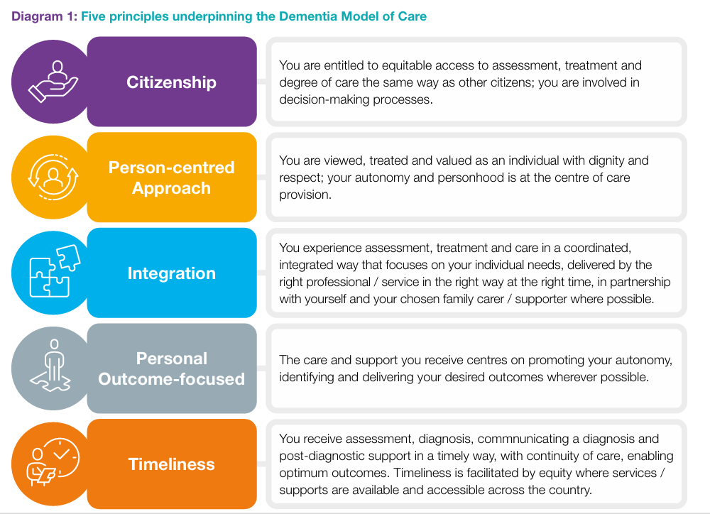

Assisted Decision Making (Capacity) Act
The Assisted Decision-Making (Capacity) Act 2015 (ADMC Act) establishes a modern statutory framework to support decision-making by adults who have difficulty in making decisions without help. The Act maximises a person’s right to make their own decisions, and marks a move away from the concept of acting in the person’s best interests to identifying their will and preferences. The Act is a key component of Ireland’s compliance with the United Nations Convention on the Rights of Persons with Disabilities (UNCRPD).

The Act is underpinned by a set of guiding principles which include supporting people as much as possible to make their own decisions, only intervening when necessary and in a manner that is least restrictive of a person’s rights and freedoms, and ensuring that the person has access to sufficient information, tailored to their needs, to enable them to participate in decision-making to fullest extent possible.

The Act provides for a functional approach to capacity, whereby capacity is assessed on an issue- and time-specific basis. This means that a person who may lack decision-making capacity in one area is not assumed to lack capacity in all areas.

The Decision Support Service (DSS), established under the Act, plays a vital role in ensuring that people who require assistance with decision-making can access the support they need while maintaining their rights and autonomy. This may include people with an intellectual disability, acquired brain injury, mental health difficulty or dementia. It also includes all people who want to plan ahead for a time when they might lose their capacity. The DSS helps to protect and uphold people’s rights to make their own decisions about their personal welfare, property and affairs.

Three types of decision support arrangements are available: decision-making assistance agreements, co-decision-making agreements, and decision-making representation orders issued by the Court. These are tiered from needing some support with decisions to having decisions made on one’s behalf, in line with the person’s known will and preferences. The DSS oversees decision support arrangements to ensure that they are operating as intended. Where a person has been deemed by the Court to lack capacity in respect of certain decisions, this declaration is kept under review by the Court.

In addition, two types of advance planning arrangements are available under the Act for those who currently have capacity: advance healthcare directives and Enduring Powers of Attorney (EPA).

The ADMC Act and the various types of support arrangements have particular relevance for people diagnosed with dementia. Under the Dementia Model of Care, the aim is to promote the person’s autonomy by working towards specific outcomes (goals and aspirations) identified by them, and where they are unable to express or communicate their desired outcomes, their will and preferences are sought, in line with the Assisted Decision-Making Act. As part of post-diagnostic support under the Dementia Model of Care, information about future planning should be provided to the person and their supporter, including in relation to decision-making arrangements, Enduring Powers of Attorney and advance healthcare directives.

