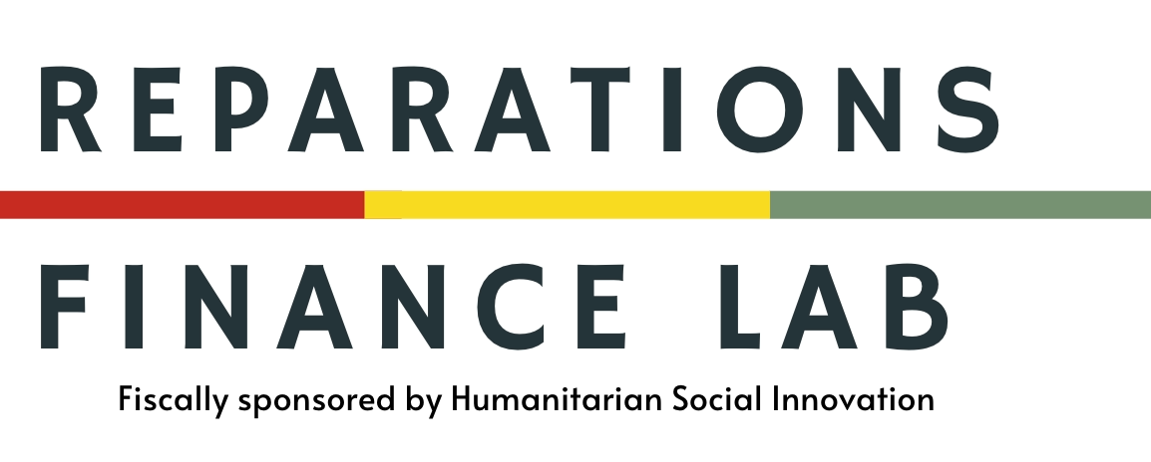

The Center for Reparations Finance and Practice
Advancing Global Strategies for Repair, Restitution, and Accountability

Background & Rationale
The global reparations movement has entered a period of unprecedented momentum. From the Caribbean to Africa, Latin America to Europe, communities are demanding truth, justice, and material repair for histories of enslavement, colonization, dispossession, and racialized exploitation. Governments, corporations, and civil society actors are increasingly engaging with reparations as both a legal and moral imperative.
Yet without coordinated infrastructure, the field remains fragmented. Advocates, academics, and practitioners often operate in silos without mechanisms for collaboration, strategy development, or rigorous policy design. This fragmentation risks duplication, slows progress, and leaves critical capital flows misaligned. There is a pressing need for a transnational, interdisciplinary hub that links research with an on-the-ground practice center that incubates innovative models for restitution, corporate accountability, and systemic repair.
The Center for Reparations Finance and Practice is being established to meet that need. Building on the work of the Reparations Finance Lab (RFL)—launched four years ago to pioneer mechanisms for financing repairs, the Center represents an evolution in scope, scale, and ambition. It responds to the movement’s call for durable, well-resourced, and globally connected infrastructure.

Vision
A global ecosystem where reparative finance and justice are embedded in the core of policy, corporate practice, and community development.

Mission
To serve as the leading hub linking reparations research, practice, and accountability frameworks—catalyzing durable models of repair across borders.

Core Objectives
• Shape capital flows through reparations finance models, impact assessments, and accountability frameworks for public and private institutions.
• Advance rigorous interdisciplinary research on reparations models, financing mechanisms, legal strategies, and historical accountability.
• Convene diverse actors—from grassroots organizers to legal scholars to policymakers to capital allocators—to co-develop reparative strategies.
• Train and support advocates and institutions through certificate programs, fellowships, and practitioner residencies (target: 200+ trained over 5 years).
• Advise public and private institutions through reparations impact assessments, consulting, and policy design.
• Document and disseminate global best practices, cases, and lessons learned across regions.

Activities & Services
The Center’s work will be structured around three service pillars:
1. Knowledge & Research — Digital library and data hub; publications including toolkits, white papers, and an annual 'State of Global Reparations' report.
2. Capacity & Training — Annual Global Reparations Summit, certificate programs, movement lawyering institutes; and fellowships.
3. Advisory & Accountability — Consulting services to cities, corporations, financial institutions, universities, and philanthropic institutions; development of reparations frameworks and reparative capital models.

Target Constituents
• Reparations advocates and social movements
• Academics and legal scholars
• Policymakers at municipal, national, and multilateral levels
• Corporations, financial and philanthropic institutions
• Cultural and educational institutions
• Transitional justice and human rights organizations

Founding Relationship & Evolution
The Center will be anchored in the experience of the Reparations Finance Lab (RFL), which has spent the last four years exploring the financial, legal, and institutional architecture required to make reparations actionable. This new iteration expands the work beyond financing to include broader forms of repair and accountability.
The Center is developing a partnership with the Georgetown University Law School Human Rights Institute, serving as a strategic academic anchor for credibility and collaboration.

Location & Structure
Headquartered in the United States with programmatic work in the Caribbean and global reach, the Center will operate as a hybrid institution: part research hub, part movement incubator, and part strategic consultancy. It will be led by a diverse team of scholars, organizers, and practitioners, guided by an international advisory council.

Sustainability & Funding
The Center is designed to be revenue-generating and financially sustainable. It will pursue a hybrid model including:
• Consulting and advisory fees
• Training and certification program revenues
• Philanthropic support (seed and core funding)
• Revenues from convenings and digital tools
• Institutional memberships and donor partnerships
Funding Pathway: Seed philanthropy will support launch operations and staffing in Years 1–2; blended revenues from memberships, advisory services, and training will cover an increasing share of costs in Years 3–5; by Year 5, the Center aims to achieve sustainability through a balanced mix of philanthropy and earned income.

Conclusion & Call to Partnership
The reparations movement is at a critical turning point. To succeed, it requires durable infrastructure. The Center for Reparations Finance and Practice will anchor this work—combining rigorous research, cross-border collaboration, and practical tools for change. We invite foundations, universities, corporations, and governments to partner with us to seed and scale this global institution, ensuring reparative finance and accountability become the standard for justice.
Contact:
Enith M. Williams
Founder/Executive Director, Reparations Finance Lab
Email: ewilliams@17AssetManagement.con
Tel: 773-837-5850

