Feedback to the the Committee on the Elimination of Racial Discrimination (CERD) on the first draft of a General Recommendation on reparations for the transatlantic trade in Africans for chattel slavery and the ensuing and continuing harms inflicted on people of African descent

Submitted by Siphiwe Baleka
November 7, 2025
balantasociety@gmail.com

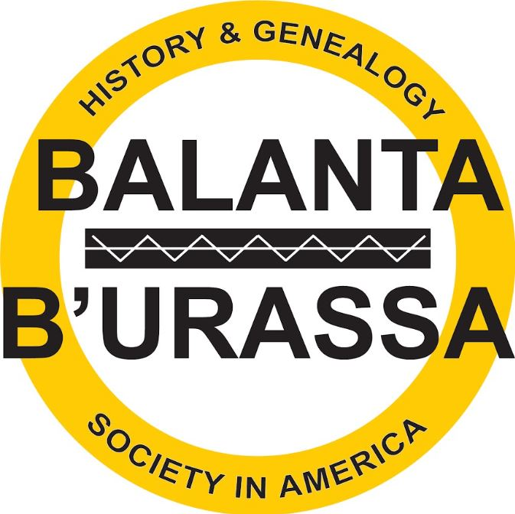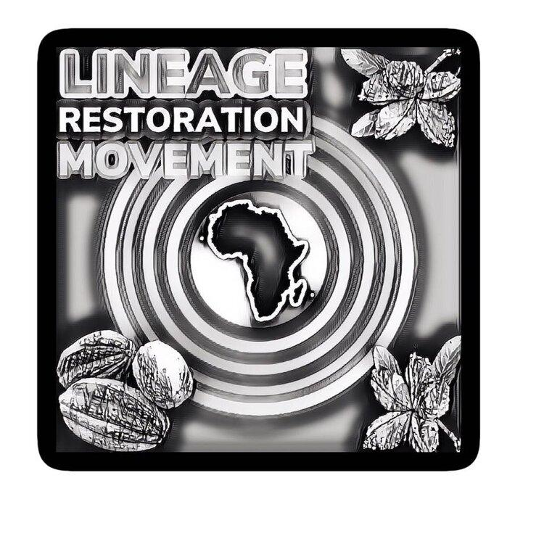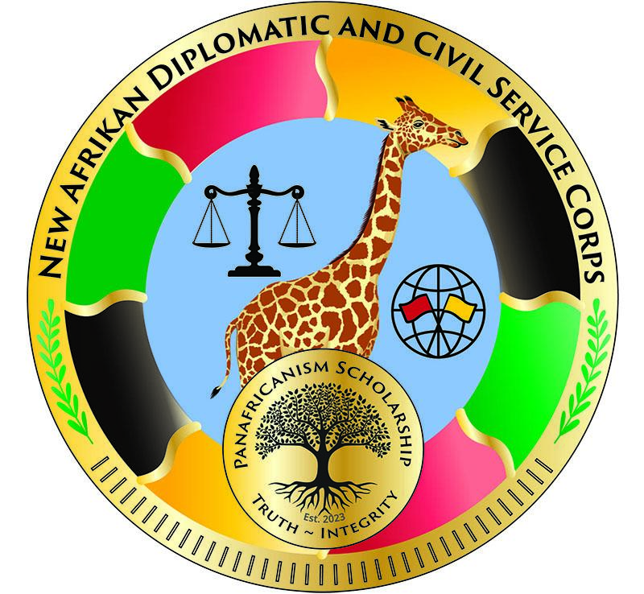
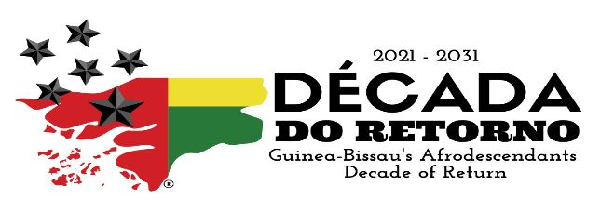

The first draft of a General Recommendation on reparations for the transatlantic trade in Africans for chattel slavery and the ensuing and continuing harms inflicted on people of African descent suffers from two glaring ommissions:

- Failure to state that the “transatlantic trade in Africans for chattel slavery and the ensuing and continuing harms inflicted on people of African descent” is the result of a declared war by the Dum Diversas Apostolic Edict issued by Pope Nicholas V on June 18, 1452.

- Failure to identify “ethnocide” as an original and ongoing harm.

The consequence of Failure 1

The consequence of the first ommission is that it prohibits Reparations efforts from properly framing chattel slavery as a result of a war and more importantly, a specific kind of warfare called “total war” which international law decrees has no statute of limitation.

The Dum Diversas Apostolic Edict was followed up with monopoly war contracts known as “Asientos'' that were variously granted by the Catholic Church to private merchants from 1518 to 1595, to Portugal from 1595 to 1640, to the Genoese (Italy) from 1662 to 1671, to the Dutch and Portuguese from 1671 to 1701, to France 1701-1713, the British 1713 to 1750, and the Spanish 1765 to 1779. The United States through its several colonies became combatants to the Dum Diversas War when they legalized slavery: Massachusetts in 1641; Connecticut in 1650; Virginia in 1657 and Maryland in 1663. Other colonies followed and the United States of America officially entered the Dum Diversas War trafficking after American independence in 1776 by virtue of Clause One, Section 9 of the First Article of the United States Constitution. The Asiento contracts defined the profit sharing agreement between its signatories and constituted the principal contractual means of enslaving people of African descent.

Identifying the Dum Diversas Apostolic Edict as the true origin of the “transatlantic trade in Africans for chattel slavery and the ensuing and continuing harms inflicted on people of African descent” allows for invoking the Geneva Convention which defines the Africans that were captured, trafficked and enslaved - and including their descendants until today - as “prisoners of war” entitled to “final release and repatriation.” This is quite possibly the strongest legal framework for reparations for war damage.
The consequence of Failure 2

The consequence of the second ommission is that one of the most serious and easily repaired ongoing harms is unidentified. The moment prisoners of war were trafficked from their families and homelands and enslaved across the Atlantic, maternal and paternal lineages were severed. Within a generation, mother-tongues and knowledge of one’s ancestral homelands were lost and identities were replaced by the “trademarks” of “slave”, “negro”, and “black” through laws that codified state-sanctioned ethnocide. The harm continues today - most Afrodescendants cannot identify their maternal and/or paternal ancestry - and official forms (such as the United States census for example) still require the descendants of the trafficked prisoners of war to identify as trademarks (such as “African American”) rather than their (lost) maternal and paternal identities. However, the advent of African Ancestry DNA testing provides an easy remedy for ethnocide and states now have an obligation to provide this remedy. Moreover, lineage restoration underscores that reparations are not exclusively or primarily monetary in nature. CERD should not miss the opportunity to recommend that DNA testing be provided, as a state obligation, to remedy the ongoing harm of ethnocide.

https://www.balanta.org/history/the-military-order-of-jesus-christ-in-portugal-started-the-misnamed-transatlantic-slave-trade
https://www.ohchr.org/sites/default/files/Documents/Issues/Racism/WGEAPD/Session26/WENA/siphiwe-baleka-complete-statement.pdf and https://www.balanta.org/news/making-a-reparations-claim-for-the-crime-of-ethnocide-resulting-from-enslavement and https://www.balanta.org/news/bbhagsia-president-siphiwe-baleka-presents-ethnocide-genocides-twin-sister-at-the-9th-annual-genocide-and-human-rights-research-conference
https://www.balanta.org/news/siphiwe-baleka-recommends-groundbreaking-dna-testing-lineage-restoration-repatriation-and-self-governing-territories-to-illinois-african-descent-citizens-reparations-commission
https://www.balanta.org/news/lineage-restoration-movement

