Step-by-step guide on the submission of NGO written statements on the new online registration platform “EVENTS”

Contents
Step-by-step guide on the submission of NGO written statements on the online registration platform “EVENTS” 1
Introduction 1
STEP 1 Selecting the relevant event and action point from the “List of Open Events” page 2
STEP 2 Creating your written statement(s) on the “EVENTS” platform 2
STEP 3: Registering your written statement as “Submitted” 5

Introduction
Further to the results of implementation on a pilot basis at the 56th session of the Council, non-governmental organizations (NGOs) with ECOSOC status may once again submit written statements for the regular sessions of the Human Rights Council through the online registration platform “EVENTS”, which is accessible at the following link: https://events.ohchr.org.

IMPORTANT:
- This step-by-step guide contains information on the process of submission of NGO written statements on the online registration platform “EVENTS”;
- For more information on the admissibility requirements and procedures in place for NGO written statements please consult “Human Rights Council - Guidelines on the submission of NGO written statements” available on the HRC information page for NGOs ;
- For more information on the process of creation of NGO accounts on the platform, you are encouraged to consult the guidelines on the process of account creation on the new online registration platform “EVENTS” which is available on the HRC information page for NGOs .

Step-by-step description of the written statement submission procedure
STEP 1: Selecting the relevant event and action point from the “List of Open Events”
STEP 2: Creating your written statement(s) on the “EVENTS” platform
STEP 3: Registering your written statement as “Submitted”

STEP 1 Selecting the relevant event and action point from the “List of Open Events” page

- Once successfully logged in, a list of events will appear on your welcome screen. Select the action point “Written statement”. Please make sure that you choose the right event namely the respective session of the Human Rights Council.

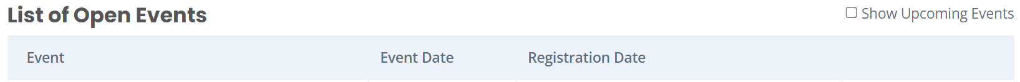
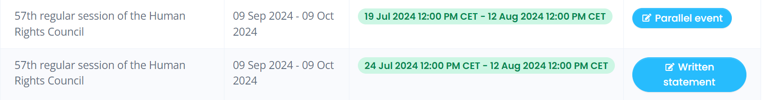

STEP 2 Creating your written statement(s) on the “EVENTS” platform

- Once you have clicked on “Written statement”, the screen as in the below image will appear. Please make sure to read the relevant information.

- Click on “Add new written statement” available at the bottom of the screen:
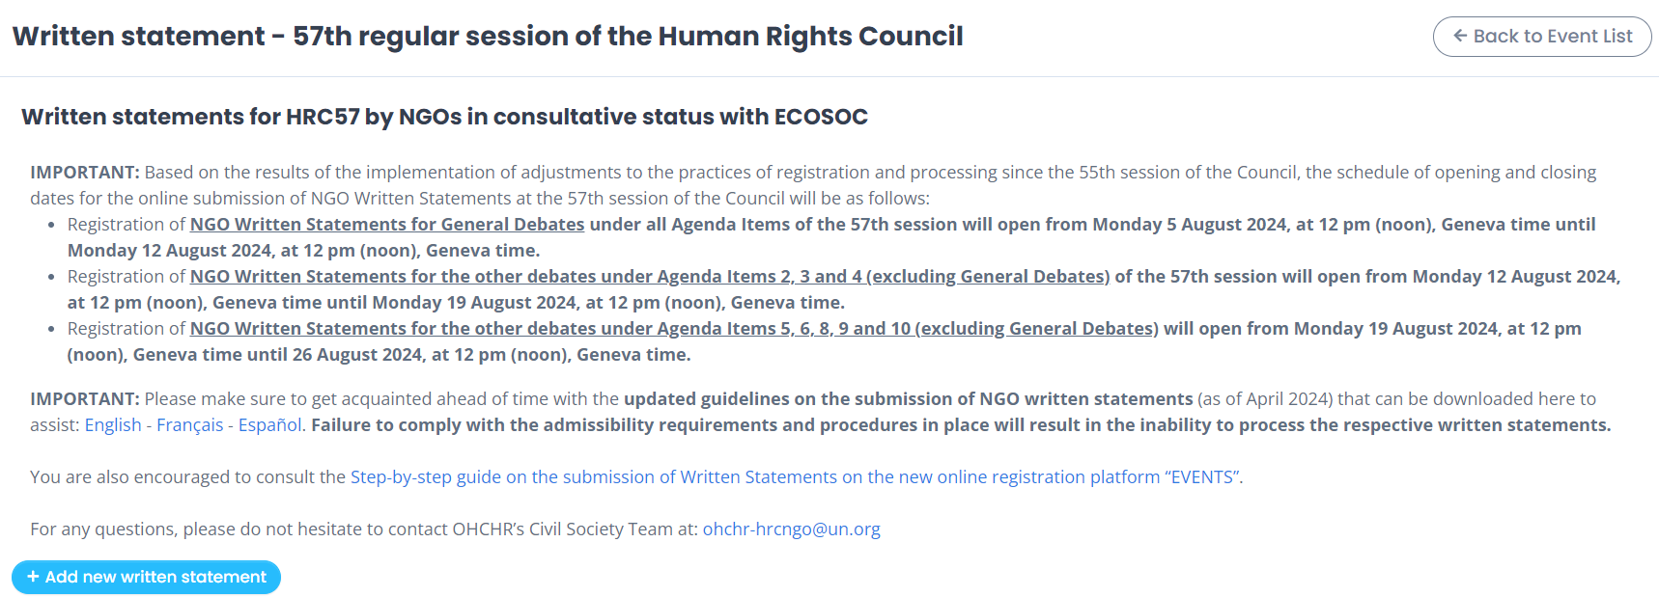

- To register a written statement, you must select the Segment and Debate from the session’s Programme of Work relevant to your statement from the drop-down list:

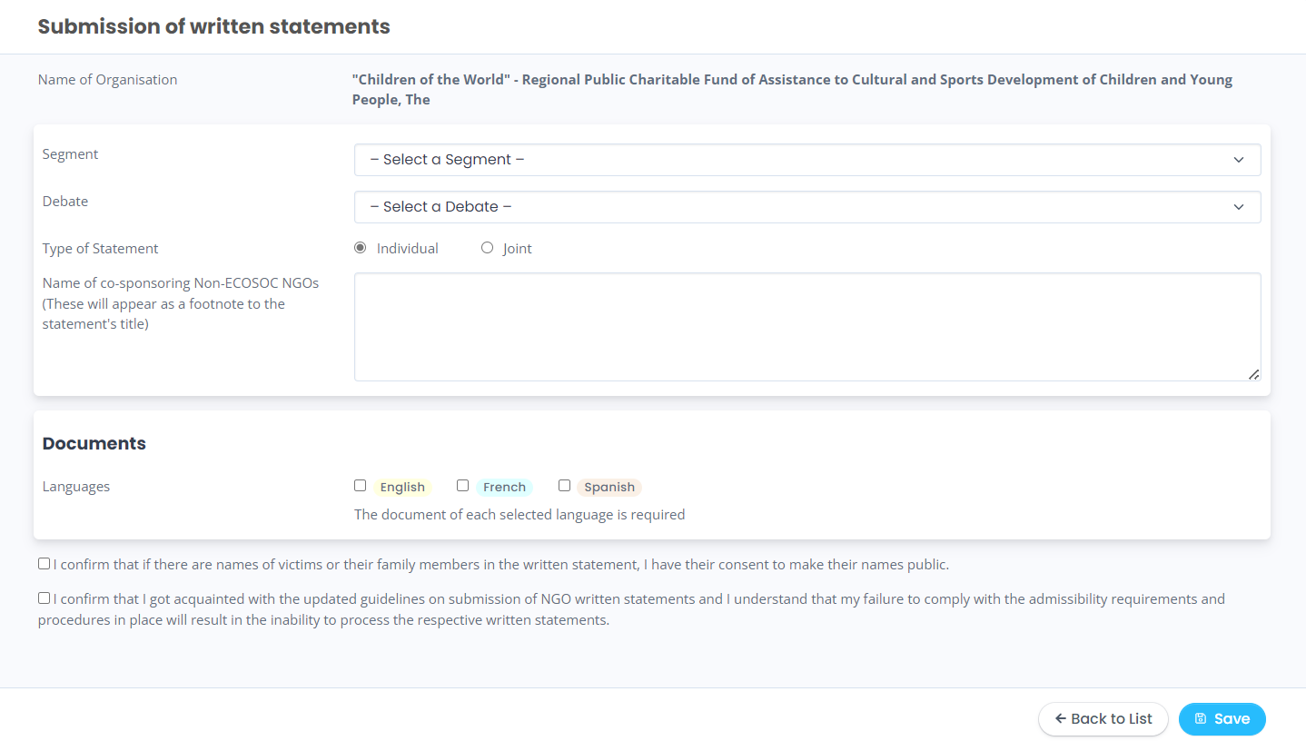

- If it is a joint statement, you will have to select the name of the co-sporing ECOSOC NGOs (#1) co-submitting the statement from the drop-down lists. Once you have selected (#1), click on the “Add” button.
- The names of NGOs without consultative ECOSOC status (#2), who share the views in an individual and/or joint statement, can be added in the box dedicated for this purpose. They will appear in a footnote at the end of the statement. It is your responsibility to enter the name correctly:

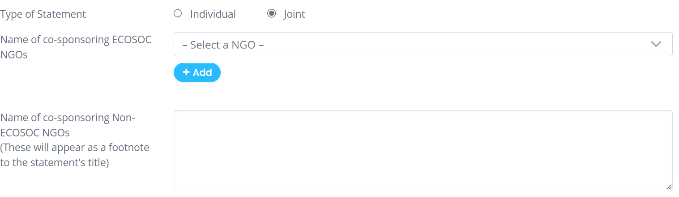
#1
#2

IMPORTANT – SUBMITTING A DOCUMENT IN SEVERAL LANGUAGES:

If you wish to submit a document in several languages, please submit all linguistic versions at the same time and not separately. Please see below for more detailed guidance:
- You must select the language of your statement (English, French and/or Spanish). If you are submitting your statement in more than one language, you must select all the relevant languages at this stage. Each language selection will generate three boxes:

- In the first box (#1), you must enter the title of your statement;
- In the second box (#2), you must enter the text of your statement;
- In the third box (#3), you must enter the endnote(s) of your statement, if any.

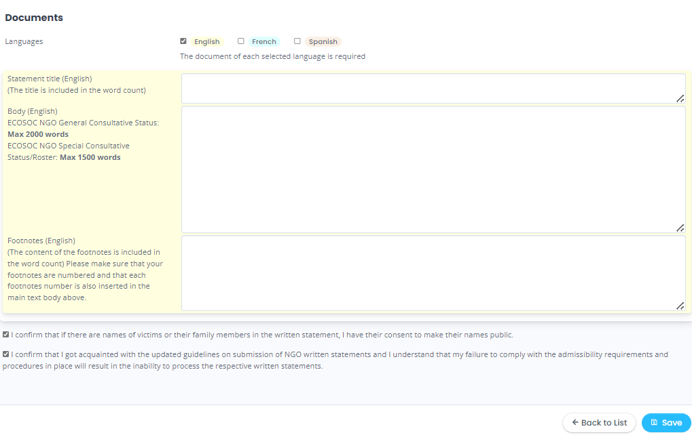
#1
#2
#3

NOTE:
- Please note that both the title and endnotes are included in the word count;
- Please do not enter HTML tags into the title, body, and endnotes; otherwise, the system will reject the document and an error will appear on the screen.

IMPORTANT – GUIDANCE ON TITLE:

- Each word of the title of the written statement in English should be capitalized except articles, conjunctions, and prepositions;
- Please avoid titles of the written statement that are identical to the title of the debate to which the statement is submitted or the title of the reports;
- Please also avoid titles of the written statement that explicitly reflect that it is the submission of the relevant NGO to the Human Rights Council.
Example: Titles such as “NGO Child Care Foundation Written Statement Submitted to the 55th Session of the Human Rights Council” should be avoided.

IMPORTANT – GUIDANCE ON SUBTITLES:

When you submit the text and want to make sure that the subtitles in your written statements are formatted in bold in the published version, please use the asterisk sign “*” at the beginning and the end of the subtitle in order for the platform to recognize it as such.
Each word of the subtitle of the written statement in English should be capitalized except articles, conjunctions, and prepositions;

IMPORTANT – USE OF ENDNOTES:

The submission platform does not allow the user to submit text with embedded endnotes (superscript). For this reason, you are invited to indicate references as follows, which will appear as endnotes in the published version:

- When you copy/paste the body of your statement into the second box, please manually insert a number at the end of each sentence to which an endnote should refer.

Examples:
… protesters began using message codes rather than verbally chanting during the assembly. (1)
… protesters began using message codes rather than verbally chanting during the assembly.1
… protesters began using message codes1 rather than verbally chanting during the assembly
… protesters began using message codes rather than verbally chanting during the assembly,1

- In the third box, please copy/paste your endnotes, reproducing the numbers you used in the body of your statement.
Example:
1 Link to webpage/Reference or
2 Link to webpage/Reference or
OR
(1) Link to webpage/ Reference
(2) Link to webpage/ Reference
(…)
Please ensure that all endnotes are numbered in consecutive order and are indicated in the body of the statement.

STEP 3: Registering your written statement as “Submitted”

- After you have filled in the three boxes, you must read the two acknowledgment carefully and tick the checkboxes. Then, you must click on “Save” at the right button of the page:

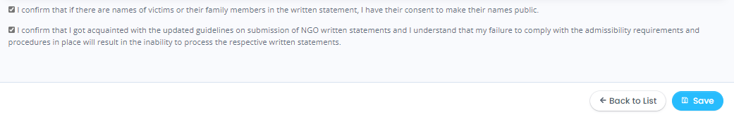
- Then, a pop-up message will appear, as shown below to remind you that your written statement(s) are not submitted yet:

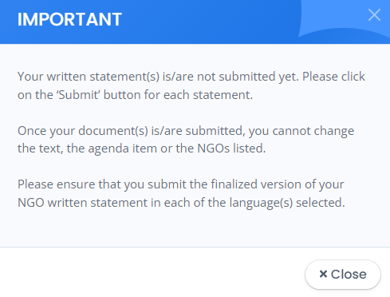
- After you click on “Close”, you will see your statement(s) listed on the following page. Here, you will find on display the statement that you have generated in the Word Document template in English, French and/or Spanish. You can click on the Word file(s) to download a copy of your statement(s) for your reference or to review it before submission;

- Click on “Edit” if you still want to make changes to your statement(s), or click on “Submit” to submit your statement(s). Please make sure you check your statement before clicking on “Submit”:

WARNING: If you do not click on “Submit”, your statement will not be registered as “Submitted” and hence will not be processed. Please note that it does not suffice only to register and/or generate your document; it must be formally submitted before the deadline to be processed by OHCHR for publication on the HRC web page.
Once you click on “Submit”, no further changes can be made to the text. Please therefore ensure that you checked and/or edited your document before and are submitting the final version.

- After you click “Submit”, you will see the status of your statement(s) marked as “Submitted” on the next page. If you wish to submit another statement(s), click on “Add new written statement” as the example below. Remember, after submitting your documents, please check that the “Status” of your statement indicates that it has been “Submitted”, otherwise the Secretariat will not be able to process your statement.

