63rd session of the Human Rights Council
Information note for Indigenous Peoples
(Last update: 07 September 2026 – Subject to change)

Introduction 1
1) Dates and important information 1
2) Accreditation to HRC63 2
3) Oral statements 3
Step-by-step guide for submission of oral statements in Events 3
STEP 1 Selecting the relevant event and action point from the “List of Open Events” page 4
STEP 2 Creating your Oral statement request(s) on the “EVENTS” platform 4
Speaking time limits 6
Recommended technical specifications for video messages 6
4) List of speakers on HRC Extranet 7
5) Confirmation of speaking slots 7
6) Reprisals 7
7) Programme of work, additional information and useful contacts 7
ANNEX I – CHECKLIST FOR ORAL STATEMENT BY INDIGENOUS PEOPLES 8

Introduction
The purpose of this document is to provide information to Indigenous Peoples participating in the 63rd session of the Human Rights Council. This is based on information available at this moment and could be revised and updated on a regular basis.
IMPORTANT: This document is subject to change. For updated information, consult the websites:
- The Human Rights Council Portal: https://hrcportal.ohchr.org/
- The Human Rights Council webpage: https://www.ohchr.org/en/hr-bodies/hrc/regular-sessions/session63/regular-session

Dates and important information
The 63rd session of the Human Rights Council is scheduled to take place from 7 September to 7 October 2026, in the Assembly Hall at the Palais des Nations located in Geneva, Switzerland.
In its resolution 60/13 on Human rights and Indigenous Peoples, the Council had requested the President “to continue to organize the participation of Indigenous Peoples’ representatives and institutions duly established by themselves from the seven Indigenous sociocultural regions, in consultation with the Expert Mechanism and with the support of the Office of the High Commissioner, for the interactive dialogues with the Special Rapporteur on the rights of Indigenous Peoples and with the Expert Mechanism and the annual panel discussion on the rights of Indigenous Peoples as of the sixty-third session of the Council”.
In that regard, for the interactive dialogues with the Special Rapporteur on the rights of Indigenous Peoples and with the Expert Mechanism on the Rights of Indigenous Peoples, a segment of 15 minutes for Indigenous Peoples’ representatives and institutions from the 7 Indigenous sociocultural regions will be added to the two interactive dialogues, following the lists of speakers for States and NHRIs and prior to the list of speakers for NGOs. The speaking time for interactive dialogues is set at 1 minute and 30 seconds. This will allow a maximum of 10 Indigenous Peoples’ representatives to take the floor in each of the IDs, including at least one Indigenous Peoples’ representative from each of the 7 Indigenous sociocultural regions. For the annual panel discussion on the rights of Indigenous Peoples, a segment of four Indigenous Peoples’ representatives and institutions will be added to each of the two segments of the list of speakers for the annual panel discussion on the rights of Indigenous Peoples, which would allow for a total of eight Indigenous Peoples’ representatives to take the floor during the panel discussion. The speaking time for the panel discussion is set at 1 minute and 30 seconds.
According to the Programme of Work, which is subject to change, the panel discussion on the rights of Indigenous Peoples will take place on Wednesday 23 September at 10 a.m. It will be followed by the interactive dialogue with the Special Rapporteur on the Rights of Indigenous Peoples that will start at 12 p.m. and continue after the break (from 1 p.m. to 3 p.m.) until 3:30 p.m. Then the interactive dialogue with the Expert Mechanism on the Rights of Indigenous Peoples will start at 3:30 until 5 p.m.
Please bear in mind that the timing is approximative, and the most updated information on the debates can be found on SCHED: https://hrc63session.sched.com/
Indigenous Peoples’ representatives wishing to intervene, either in-person or via video statement, in these debates, should register through the online registration system https://events.ohchr.org/ and fulfil all the relevant requirements (see Point 3 and Annex with checklist). All video messages should be uploaded via the same system. The method of participation can be amended at a later stage.

Accreditation to HRC63
All representatives will have to be duly registered and approved through INDICO, here: https://indico.un.org/event/1019476/. Indigenous Peoples’ representative should indicate “Other” under “Representation Type” and write the name of your entity:
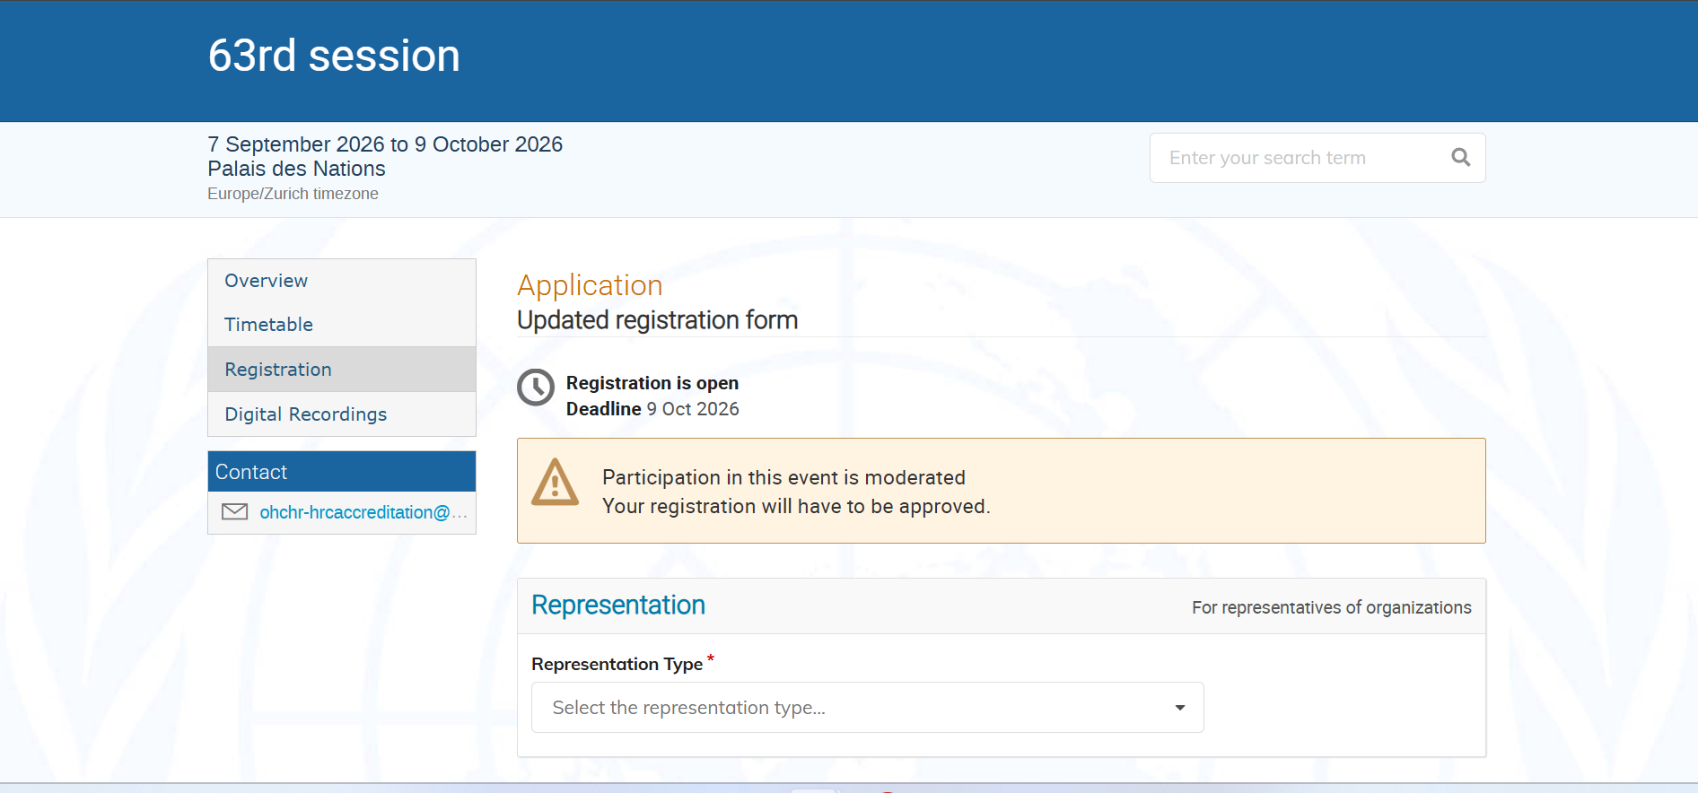
After filling all mandatory fields concerning your identity, you will be requested to fill the last section, under “Indigenous Affiliation” and fill all the relevant fields:
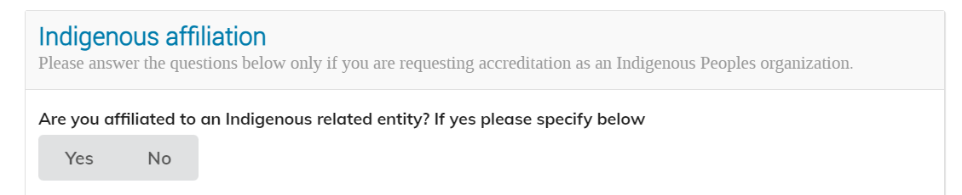
REMINDER: The accreditation through INDICO is mandatory for all representatives delivering a statement, including those participating by video statements. Failure to comply will result in the exclusion from the list of speakers. A nomination letter from the entity that you are representing is mandatory.
Digital badges: Starting September 1, 2023, all newly created conference and meeting events on Indico.un.org will default to the new UNOG digital badging system. Registered and accredited participants will receive a digital badge via email, which includes their photo, a QR code, and conference details. This digital badge functions similarly to an electronic boarding pass on a mobile device. To ensure smooth implementation, representatives should be in the Assembly Hall in advance to allow enough time for the Secretariat to verify their participation and scan their badges. For participants without mobile devices, there is an option to print a confirmation and obtain a paper badge at the Pregny Pavilion badging desk.
Logistical Arrangements for the Assembly Hall
Representatives of Indigenous Peoples should arrive in the Assembly Hall in advance to allow enough time for the Secretariat to verify their participation and scan their badges. For participants without mobile devices, there is an option to print a confirmation and obtain a paper badge at the Pregny Pavilion badging desk.
Seats for Indigenous Peoples will be located on the left-hand side as you enter the room. This will be clearly indicated in the room. The NGO helpdesk, which is also supporting Indigenous Peoples’ representatives, will be located on the right-hand side of the room, in the Secretariat section. For any additional information, the NGO Liaison office will be located on the 6th floor, and will be clearly indicated at the entrance.

Oral statements
The online registration platform for the 63rd session can be found on the following website: https://events.ohchr.org/ The system opens on Tuesday 1 September at 2 PM (Geneva time).
Please note that participants in person can only deliver their statement from the two seats allocated at the back of the Assembly Hall, marked “Peuples Autochtones”. The Secretariat staff will be there before the beginning of the debate to assist representatives, to check their accreditation and to organize the order of the speakers. You should arrive with sufficient time in advance to allow for it.

Step-by-step guide for submission of oral statements in Events

When creating your account, please make sure to select Indigenous Peoples under the representation type:
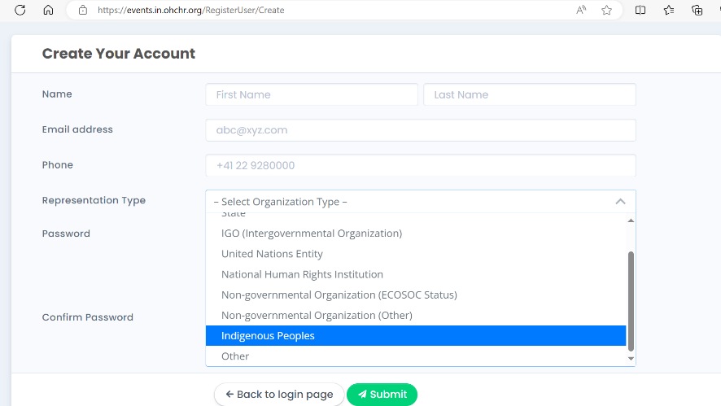

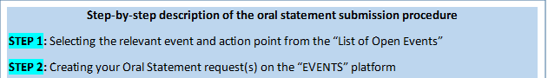

STEP 1 Selecting the relevant event and action point from the “List of Open Events” page

Only primary accounts are able to inscribe on any list of speakers. Secondary accounts can edit a registration (adding a speaker, uploading the statement or the video), co-sponsoring other statements or cancelling requests, but have no inscription rights.
Once successfully logged in, a list of events will appear on your welcome screen. Select the action point “Oral statement”. Please make sure that you choose the right event, namely the 63rd session of the Human Rights Council.

STEP 2 Creating your Oral statement request(s) on the “EVENTS” platform

Once you have clicked on “Oral Statement”, the screen as in the below image will appear. Please make sure to read the relevant information.
Click on “Register to a debate” available at the bottom of the screen:

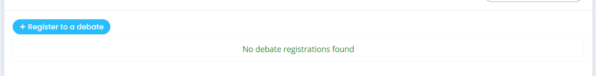
To register a new oral statement, you must fill all the relevant information from the drop-down list. You can upload your statement and other documents at a later stage. Please bear in mind that uploading a statement (or transcript) is mandatory for both in-person and video messages. Failure to comply before the deadline will result in the exclusion from the list of speakers.
Click on the “Save” button.
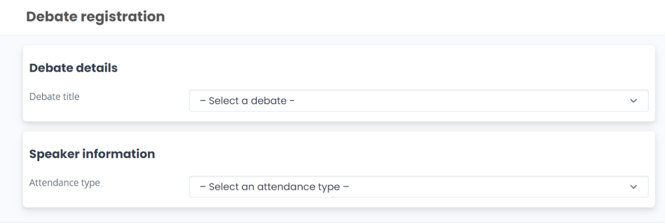
Your statement will appear as shown below, with the option of modifying it by clicking on “Edit/Upload” or deleting it by clicking on “delete”:
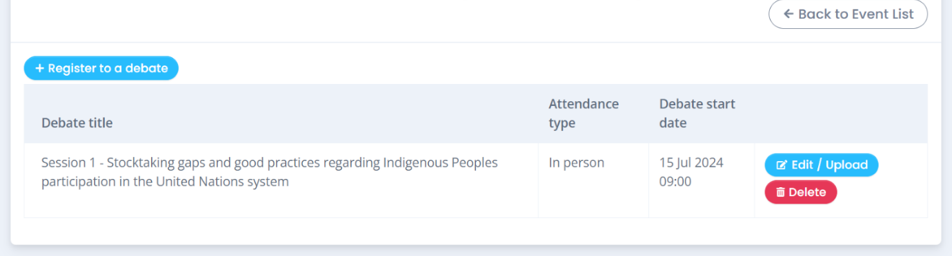
To upload your video-statement or your oral intervention, click on “Edit / Upload” and upload the relevant file(s) under “Documents”. You will be requested to provide the name of the speaker.
Please note that both steps mentioned above are mandatory. A video uploaded without the transcript will not be processed by the HRC Secretariat and the organization will be removed from the list of speakers.
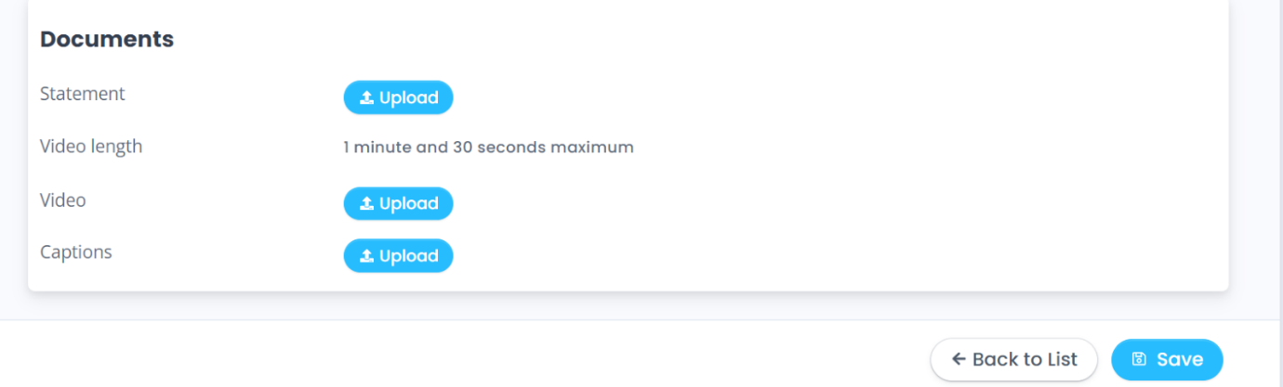
As recalled by the Bureau of the Human Rights Council, with the exception of an official representative of a UN Member State speaking in front of the national flag and/or the official picture of the Head of State/Government, the background of video-statements should be neutral without any flag, banner, flyer, picture or symbol. Failure to comply will result in the exclusion of the organization from the list of speakers.
The full official name of the organization should be displayed within the video.
Captioning of the video is strongly encouraged in order to ensure accessibility of persons with disabilities.
REMINDER: Uploading a transcript is mandatory for both methods of participation. Failure to comply before the deadline will result in the exclusion from the list of speakers.
Participants participating in person are responsible for being in the Assembly Hall on time for delivering their statement. If absent when called to deliver their statement, they cannot do it in another moment.

Speaking time limits

Type of discussion | Speaking time per intervention
Interactive dialogues | 1 minute and 30 seconds
Panel discussion | 1 minute and 30 seconds

Recommended technical specifications for video messages

Please note that video messages that do not comply with the speaking time limits or exceed the maximum file size (250MB) will not be accepted by the system.

When using a smartphone, record the video in landscape (horizontal) mode.
Please note that no professional equipment is required to record video messages. Most modern consumer electronics (smartphones, laptops, etc.) are capable of recording video that complies with the specifications.
All files will be played using VLC Media Player. Please note that the Secretariat does not bear responsibility if files that do not comply with the recommended specifications cannot be displayed in our audio-visual system. Depending on the quality of the video-statement, interpreters may stop interpretation. Please speak at a normal speed that allows the translators to understand the statement.
DISCLAIMER: By submitting a video statement to the HRC Secretariat for the purpose of screening it during an official meeting of the HRC, the video statement will become an official record of the HRC session and considered as a UN audio-visual asset that can be re-disseminated to media organizations worldwide on a non-commercial basis, in accordance with guidelines of the Department of Global Communications, and will be included in the webcast archive of the meeting on webtv.un.org.

List of speakers on HRC Extranet
The lists of speakers for the 63rd session will be made available on the HRC Extranet. Please check the time and date of the last update. You can find the draft final list of speakers affixed on a board in the Assembly Hall, near the seats reserved for Indigenous Peoples delivering a statement, a few minutes after the beginning of each debate.

Confirmation of speaking slots
All speakers are requested to confirm their speaking slots.
In-person participants are required to confirm their participation by uploading the transcript of their statement(s) on Events as per the deadline set (6 p.m. on the working day before the debate is scheduled to start). Please note that the speaking slots of those that have not confirmed their participation before the deadline will be removed from the list of speakers.
For participants through a video message, their participation will be confirmed once both their transcript and the video statement are uploaded on the online registration system as per the deadline set (6 p.m. on the working day before the debate is scheduled to start). Video-statements received past this deadline will not be displayed.

Reprisals
Any act of intimidation or reprisal for cooperation in the context of the HRC session should be promptly reported to the HRC Secretariat.

Programme of work, additional information and useful contacts
All relevant information on the 63rd session is made available on the HRC website (https://www.ohchr.org/en/hr-bodies/hrc/regular-sessions/session63/regular-session) and the HRC extranet (https://hrcportal.ohchr.org/).
The programme of work is subject to change. For updated information on the schedule, you are invited to consult the SCHED meeting calendar of the session, which reflects all changes in the schedule of the debates.
Taking pictures and videos inside the conference room is not allowed. This is also valid for organizations delivering a statement, even with their consent and even if done by someone from their group. Only people accredited as press (with a Press badge) are allowed to do so.
Questions relating to accreditation should be sent to the following addresses (please copy both): ohchr-hrcaccreditation@un.org and ohchr-ipaccreditation@un.org.
Other questions can be directed to ohchr-ngoconfirmation@un.org

ANNEX I – CHECKLIST FOR ORAL STATEMENT BY INDIGENOUS PEOPLES

This checklist is designed to facilitate Indigenous Peoples’ participation in the Interactive dialogues with the Expert Mechanism on the Rights of Indigenous Peoples and the Special Rapporteur on the Rights of Indigenous Peoples, and in the annual panel discussion on the rights of Indigenous Peoples by summarizing the mandatory steps that they are required to take to deliver oral statements (in-person or via pre-recorded video messages).
Checklist:
- You and/or the person who will deliver the statement on behalf of your institution /organisation is/are accredited and approved for the session in INDICO: https://indico.un.org/event/1019476/registrations/27661/
- You have registered to deliver an oral statement through the online registration system (https://events.ohchr.org/)
- You have checked your position on the list of speakers uploaded on the HRC Extranet: https://hrcportal.ohchr.org/
- For video statements: You have made sure that your video statement(s) abide by the rules applicable for video statements, i.e. the background should be neutral without any flag, banner, flyer, picture or symbol and the full official name of the institution/organization displayed in the video. You have confirmed your participation by uploading your video statement and the transcript of your statement to the online registration system before the deadline.
- For in-person participants: You have confirmed your participation by uploading the transcript of your statement to the online registration platform before the deadline. You are planning sufficient time to arrive at the Assembly Hall and allow for the Secretariat to check your accreditation and to organize the order of the speakers.

