Thirty-seventh meeting of Chairs
of the human rights treaty bodies
Geneva, 2–6 June 2025
Item 3 of the provisional agenda
Adoption of the agenda and organization of work

Compliance by States parties with their reporting obligations to international human rights treaty bodies

Note by the Secretariat
Summary
At their twenty-sixth meeting, the Chairs of the human rights treaty bodies decided to include the issue of States parties’ compliance with their obligations to report to the treaty bodies as a standing item on the agenda of their annual meetings. The present note contains an overview of States parties’ reporting compliance as at 27 May 2025. Reporting is a dynamic process and the data included in the present note are regularly updated on the website, and the treaty body database, of the Office of the United Nations High Commissioner for Human Rights (OHCHR).

I. Background
1. States parties have an obligation to report periodically, or to provide additional information when requested by the Committee on Enforced Disappearances (see para. 5 below), under the nine core international human rights treaties and two optional protocols:
- International Convention on the Elimination of All Forms of Racial Discrimination (1965)
- International Covenant on Civil and Political Rights (1966)
- International Covenant on Economic, Social and Cultural Rights (1966)
- Convention on the Elimination of All Forms of Discrimination against Women (1979)
- Convention against Torture and Other Cruel, Inhuman or Degrading Treatment or Punishment (1984)
- Convention on the Rights of the Child (1989)
- International Convention on the Protection of the Rights of All Migrant Workers and Members of Their Families (1990)
- Optional Protocol to the Convention on the Rights of the Child on the involvement of children in armed conflict (2000)
- Optional Protocol to the Convention on the Rights of the Child on the sale of children, child prostitution and child pornography (2000)
- Convention on the Rights of Persons with Disabilities (2006)
- International Convention for the Protection of All Persons from Enforced Disappearance (2006)
2. The Chairs of the human rights treaty bodies, at their twenty-fifth annual meeting, in May 2013, expressed deep concern over late reporting and non-reporting by a number of States parties to the international human rights treaties. The Chairs decided to include the issue as a standing item on the agenda of the meeting.
3. The present note contains an overview of the reporting compliance by States parties as at 27 May 2025. Reporting is a continuous process; the data included in the note are regularly updated on the OHCHR website. The data are extracted from the treaty body database, which contains all public documents adopted or received by the human rights treaty bodies. All efforts are made to reflect the most updated information, and any inaccuracies should be brought to the attention of the secretariat.
4. With regard to State party reporting, in 2024, there were:
- 21 ratifications of/accessions to human rights treaties and optional protocols thereto;
- 10 States parties that submitted common core documents;
- 91 reports received from States parties;
- 1,416 documents received for the reviews of State party reports from United Nations agencies, national human rights institutions and civil society organizations.

II. Reporting obligations of States parties under international human rights treaties
5. Once a State has acceded to or ratified a human rights treaty, it is required to submit an initial report within one or two years after the entry into force of the treaty and, thereafter, periodic reports at intervals specified in the relevant treaty or by the treaty body. In most cases, the treaty explicitly sets out a timetable for the submission of initial and periodic reports, commonly referred to as the “reporting periodicity”, based on the date of entry into force of the treaty for the specific State party. The International Convention for the Protection of All Persons from Enforced Disappearance does not provide for periodic reports, however the Committee on Enforced Disappearances may, pursuant to article 29 (4) of the Convention, request States parties to provide additional information on the implementation of the Convention. The regular reporting periodicity, by treaty, is presented in table 1.

Table 1
Reporting periodicity, by treaty
Treaty | Initial report due (following the entry into force of the treaty for the State party concerned) within: | Periodic reports due thereafter every:
International Convention on the Elimination of All Forms of Racial Discrimination | 1 year | 2 years
International Covenant on Economic, Social and Cultural Rights | 2 years | 5 years
International Covenant on Civil and Political Rights | 1 year | 8 years
Convention on the Elimination of All Forms of Discrimination against Women | 1 year | 4 years
Convention against Torture and Other Cruel, Inhuman or Degrading Treatment or Punishment | 1 year | 4 years
Convention on the Rights of the Child | 2 years | 5 years
Optional Protocol to the Convention on the Rights of the Child on the sale of children, child prostitution and child pornography | 2 years | With the next report under the Convention on the Rights of the Child; or 5 years, if the State party has ratified the Optional Protocol only
Optional Protocol to the Convention on the Rights of the Child on the involvement of children in armed conflict | 2 years | With the next report under the Convention on the Rights of the Child; or 5 years, if the State party has ratified the Optional Protocol only
International Convention on the Protection of the Rights of All Migrant Workers and Members of Their Families | 1 year | 5 years
Convention on the Rights of Persons with Disabilities | 2 years | 4 years
International Convention for the Protection of All Persons from Enforced Disappearance | 2 years | As requested by the Committee on Enforced Disappearances (art. 29 (4) of the Convention)

III. Reporting compliance by States parties as at 27 May 2025
16. The data are extracted from the treaty body database, which contains all public documents adopted or received by the human rights treaty bodies as of 27 May 2025. https://tbinternet.ohchr.org/_layouts/15/TreatyBodyExternal/LateReporting.aspx

A. List of States parties without overdue reports
17. As at 27 May 2025, 46 of the total of 197 States parties had no overdue reports under the relevant international human rights treaties and protocols. That is equivalent to 23.3 per cent of States parties. Reporting compliance decreased significantly in 2025; in 2023, there were 54 States parties without overdue reports (see chart 1 below).

Table 2
States parties that had no overdue reports as at 27 May 2025
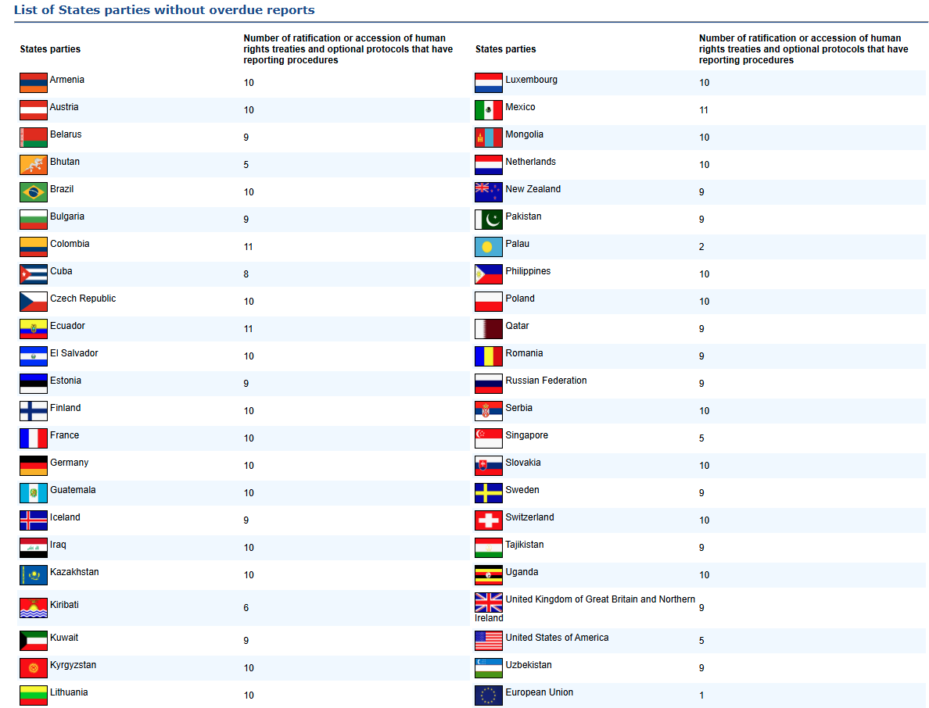

Comparison of reporting compliance by States parties from 2015 to 2025 (May 2025)
Comparative table of the number of States parties without overdue reports (2015 to 2025)
Year | Number of States parties without overdue reports | Percentage of States parties (rounded to whole numbers)
2015 | 29 | 15
2016 | 25 | 13
2017 | 36 | 18
2018 | 34 | 17
2019 | 37 | 19
2020 | 36 | 18
2021 | 30 | 15
2022 | 37 | 18
2023 | 54 | 27
2024 | 51 | 26
2025 (20 May) | 45 | 23

Chart 1

B. List of States parties with overdue reports
Details of the List of States parties with overdue reports is in the Annex and on the link - https://tbinternet.ohchr.org/_layouts/15/TreatyBodyExternal/LateReporting.aspx
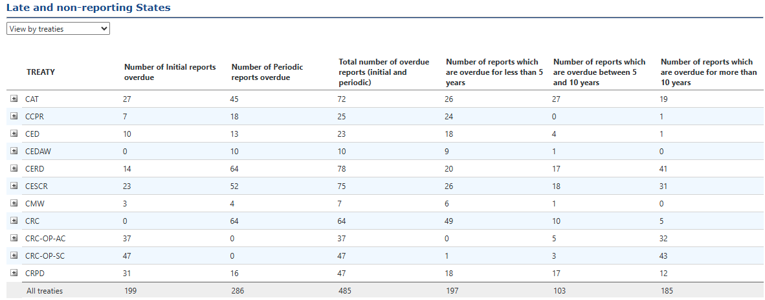

IV. Reports received and yet to be considered as at May 2025
CERD | CESCR | CCPR | CEDAW | CAT | CRC | CRC - OPAC | CRC - OPSC | CMW | CRPD | CED | TOTAL
34 | 41 | 11 | 33 | 42 | 51 | 7 | 11 | 6 | 56 | 23 | 315

V. Status of State Parties who have opted in/out for the simplified reporting procedure.
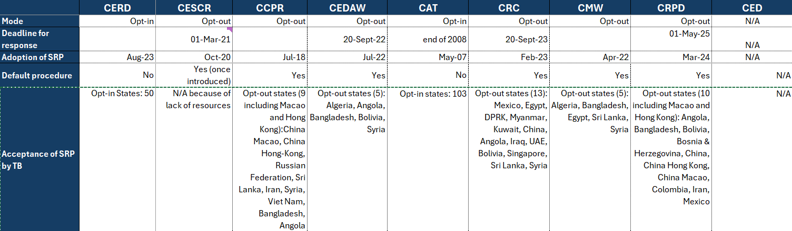

A/68/334, para. 47.
See https://tbinternet.ohchr.org/_layouts/15/TreatyBodyExternal/LateReporting.aspx.
These figures have been retrieved from the human rights treaty body database.

