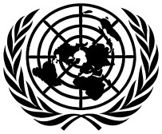
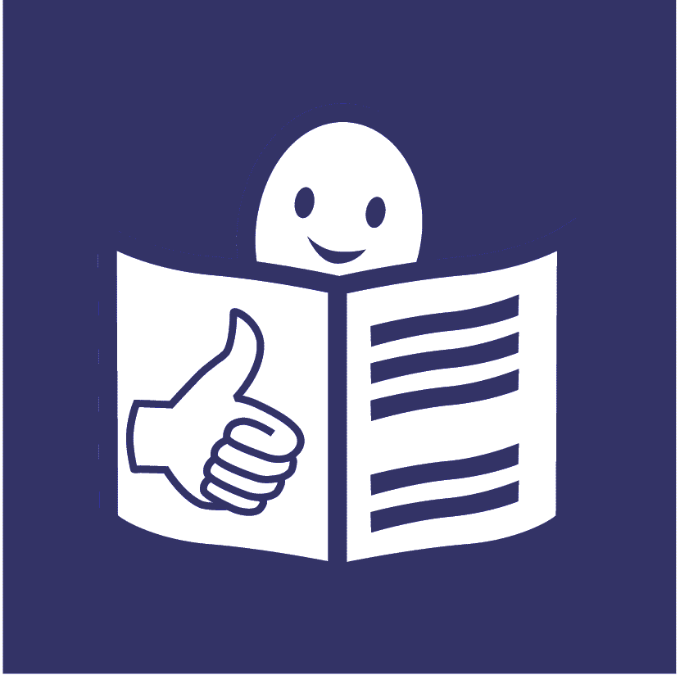
United Nations Office of the
High Commissioner for Human Rights
Easy to read
What our part of the United Nations has done to include people with disabilities in 2025

This is about our work on the United Nations plan to include people with disabilities
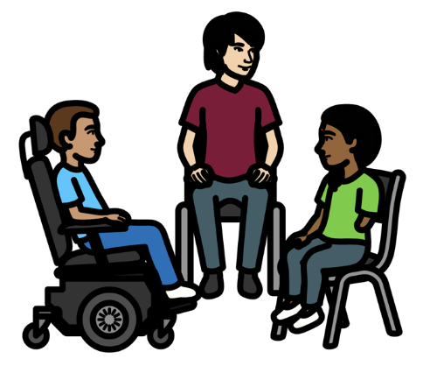

Progress report on the UN Disability Inclusion Strategy

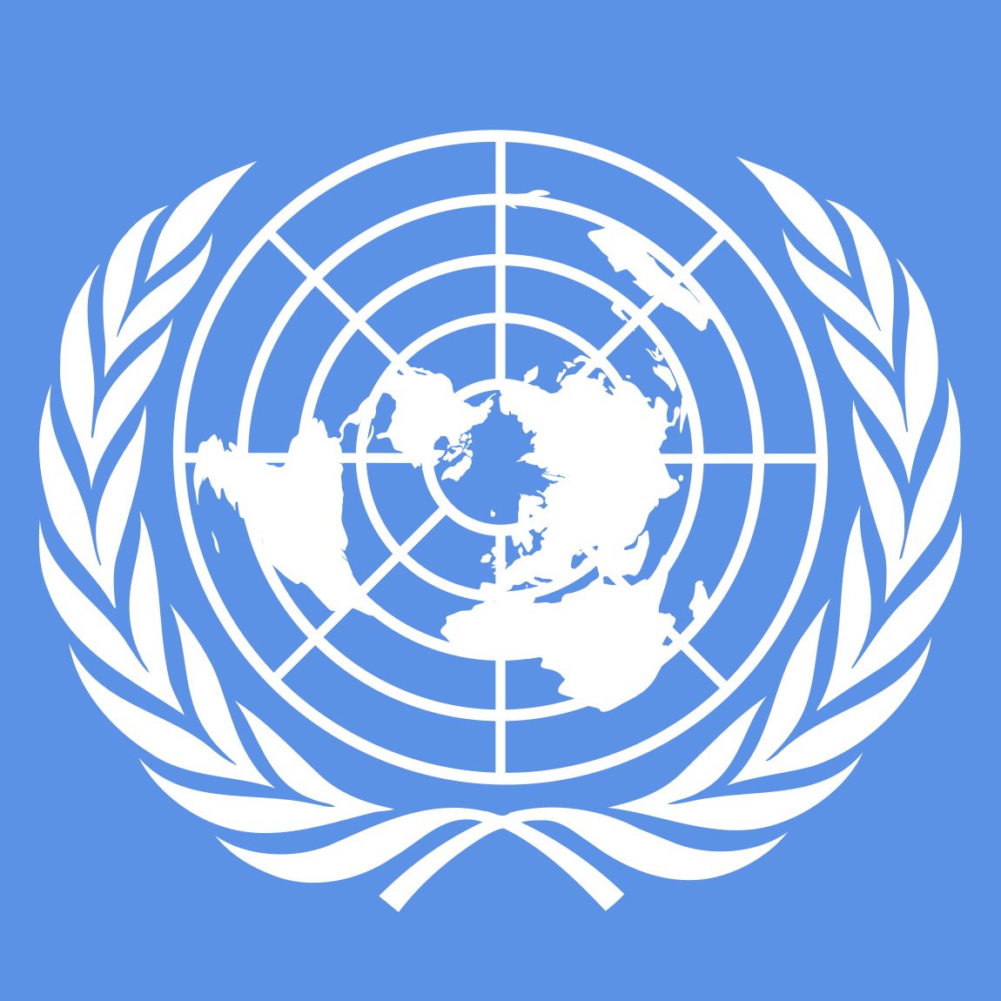
About us

We are called the Office of the High Commissioner for Human Rights.

Or OHCHR for short.
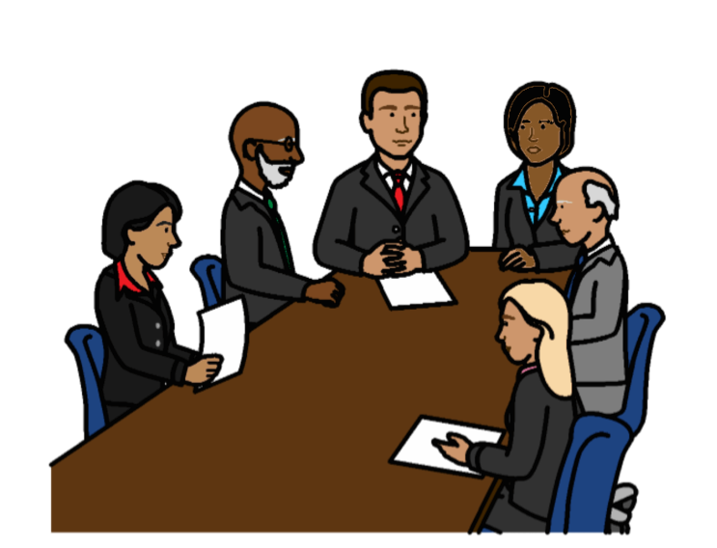

We are part of the United Nations.

The United Nations is a group of countries that work to make the world better and safer.

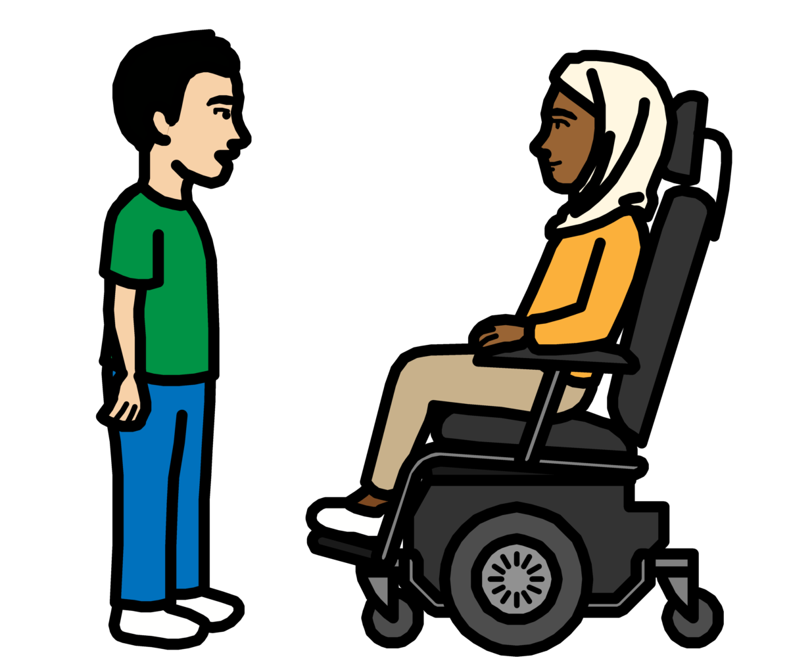
About this report

The United Nations wants people with disabilities to be part of everything it does.

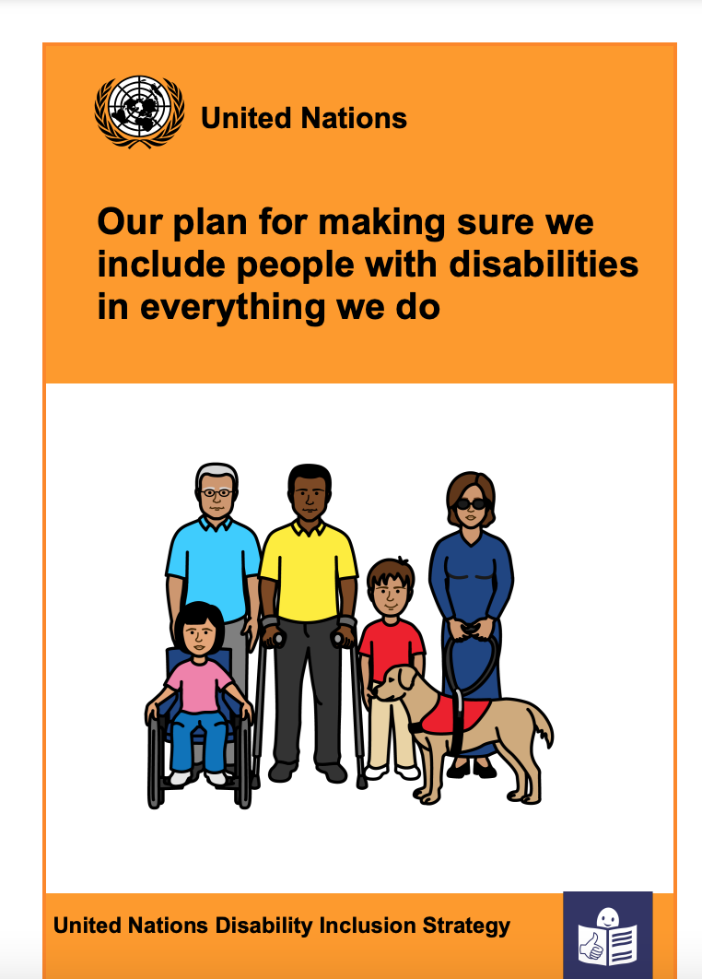
That means people with disabilities should not be left out.

The United Nations has a plan about how to include people with disabilities.

The plan is called the
Disability Inclusion Strategy.
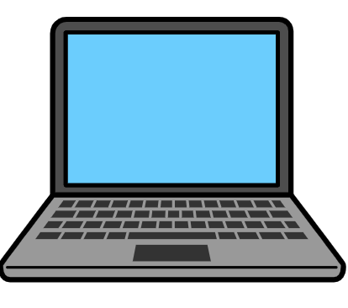
The plan is on our website:

www.un.org/en/content/disabilitystrategy/assets/documentation/Easy_to_Read.pdf

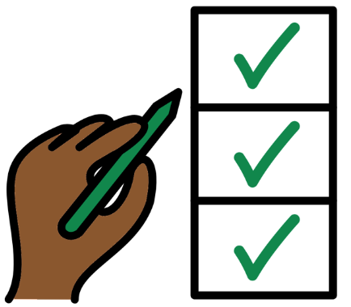

Different parts of the United Nations should say how they are doing with the plan every year.

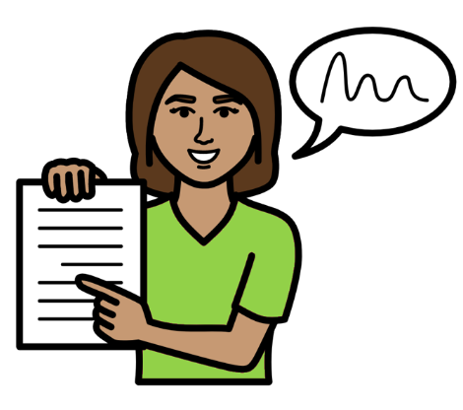

This report tells you what we have done to include people with disabilities in 2025.

There are 15 areas of work that we had to look at.
We had to say how well we are doing for each area that we work on.

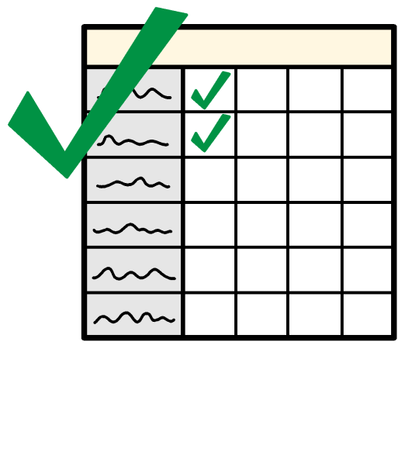

This report tells you more about what we are doing well on.

And what we need to do more on in 2026.
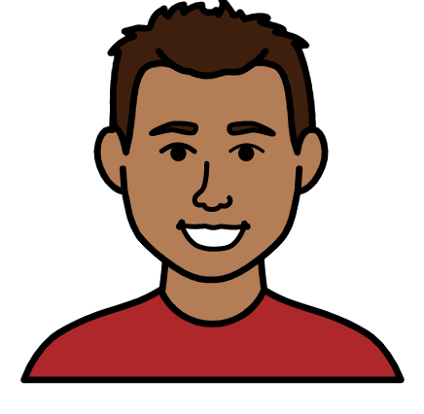
How we are doing so far to include people with disabilities

- We are doing even better than we need to on some things

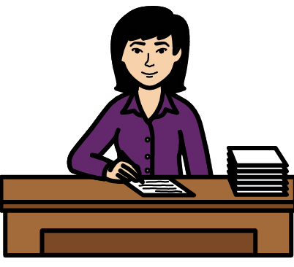
We are doing even better than we need to on the areas of work below:

Making sure that senior managers
make the United Nations plan about people with disabilities happen.
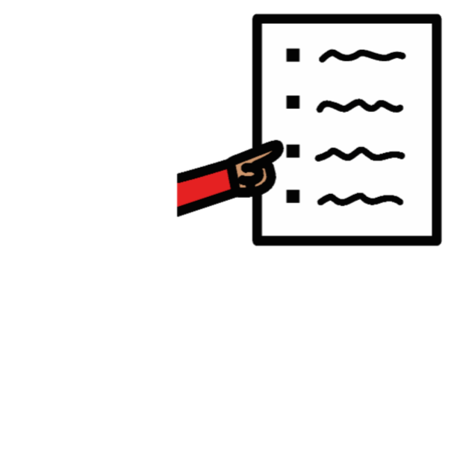
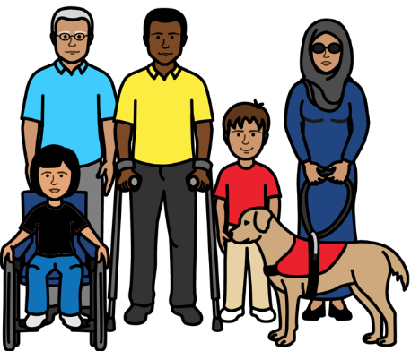

Making sure that the main plan about our work talks about people with disabilities and their rights.
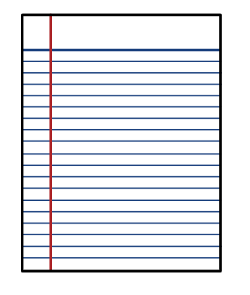

Making sure that we have a plan about how to include people with disabilities.

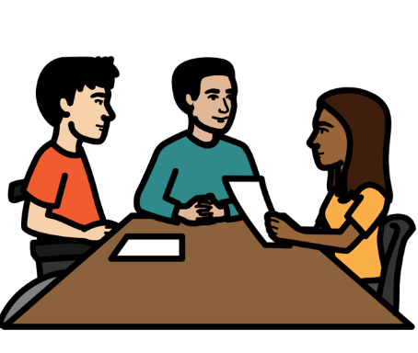
Making sure there are people who know about disability and human rights.

And making sure that people can meet to talk about disability.
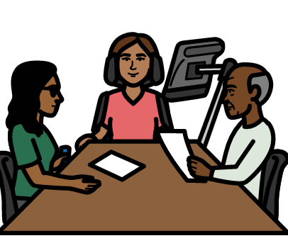

Making sure that people with disabilities get the right support to take part and say what they think.

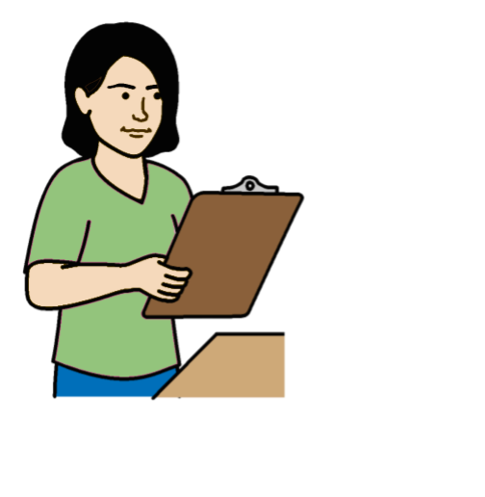

Making sure that people check how projects are working for people with disabilities and their rights.

Working with other parts of the United Nations to include people with disabilities.

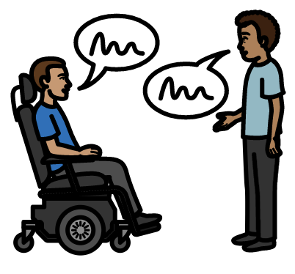
Some examples of our work:

In 2025 our senior managers met with some adults and young people with disabilities.

They talked about how to include people with disabilities more.

The main plan about our work talks about people with disabilities and their rights.

That means making people with disabilities part of our work for everyone.

It also means doing some work just about the rights of people with disabilities.

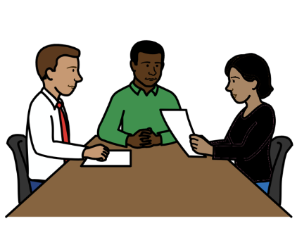

We made a plan in 2020 about how we will include people with disabilities.

Senior managers check the plan every year.

In 2025 many people checked the plan to see if anything needed to change.
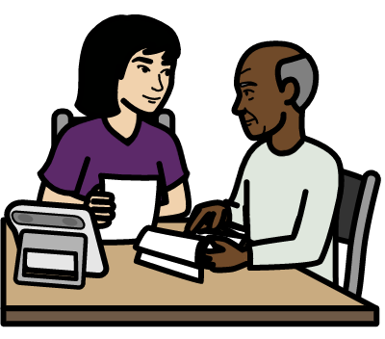
We have 2 people to make sure that we include people with disabilities in our work.

They work with lots of people like:
- The United Nations.
- People with disabilities.
- Governments and other organizations.

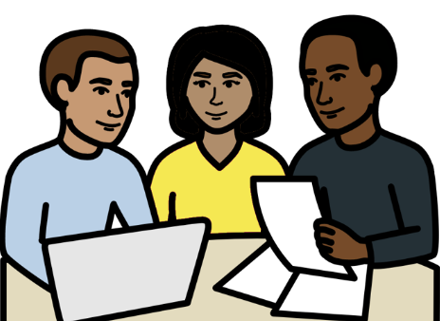

We started a new way for the United Nations to work together to include people with disabilities.

It means people can share information, work and training about the rights of people with disabilities.

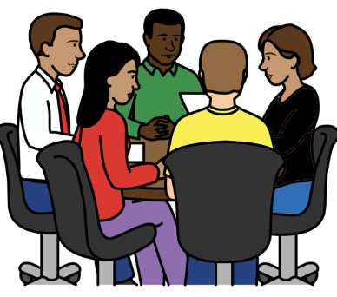

We had a meeting in 2025 with different parts of the United Nations.

We talked about how to include people with disabilities more in our work.

We also shared some good work that different parts of the United Nations are doing.

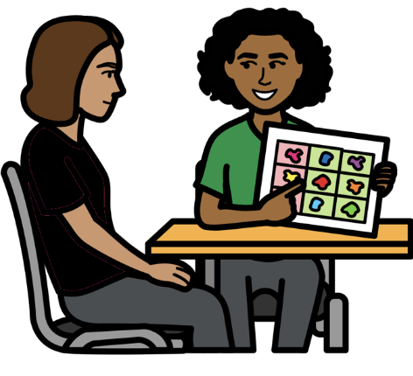
We have a plan about how to give people with disabilities extra support if they need it.

That includes our staff with disabilities.

For example, people may need support to say what they think or support to travel.
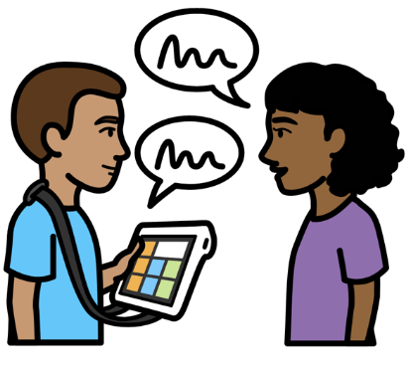

We have a way to check the extra support we are giving people.

We checked how well this was working in 2025. And we will keep checking it.

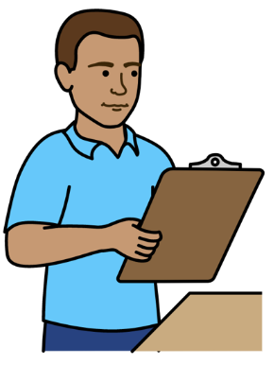
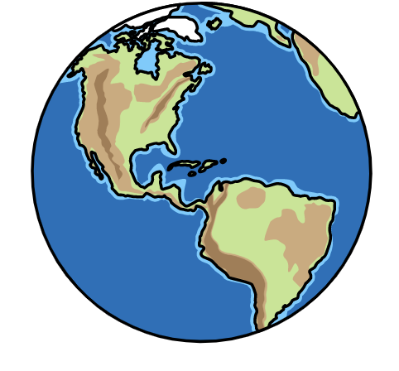
We are checking some of our projects in different countries.

This is to see how they are working for people with disabilities.

The people who take part in this work include:

- People with disabilities.

- People who know how to include people with disabilities.
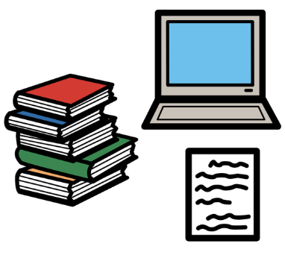
We did some big work to check how our projects in different countries are working for people with disabilities.

We looked at all the information we had about that.

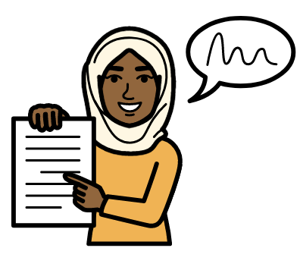

That helped us to make better plans about what to do next.

We will check our projects like that again in 2027.

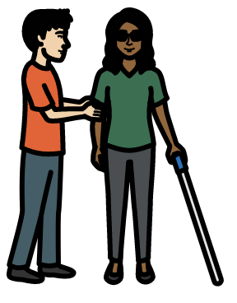

We have done lots of work with the United Nations and other organizations on the rights of people with disabilities.

For example, we are part of 2 projects about making care and support better.

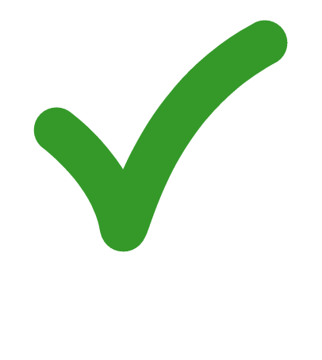
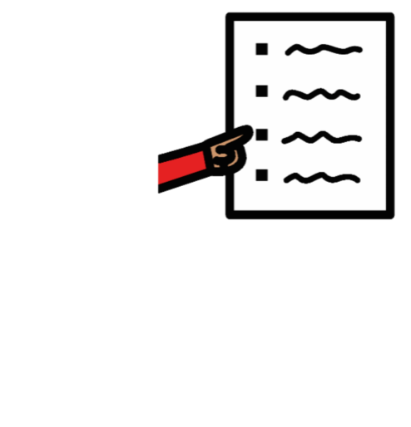
- We are doing everything we need to on some things

We are doing everything we need to on the areas of work below:
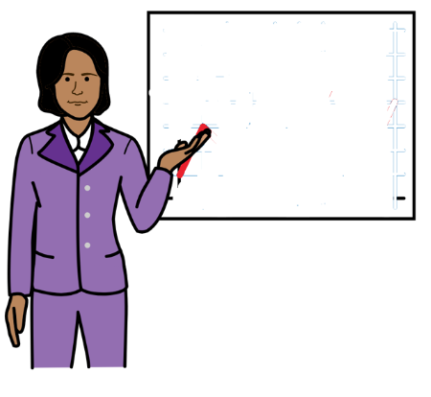

Making sure that staff get information and training about how to include people with disabilities.

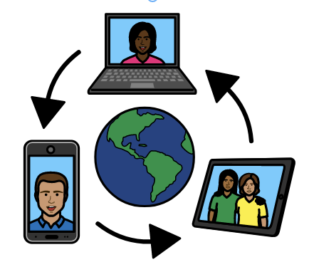

Making sure the United Nations:

- Talks about people with disabilities in the right way.

- Helps people to know about people with disabilities and their rights.

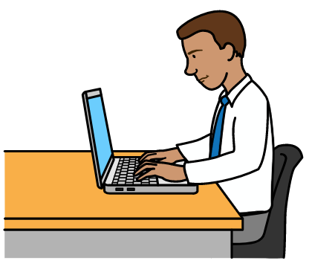
Some examples of our work:

There is some training about the United Nations plan to include people with disabilities.

All staff have to do this training.

We are making sure that happens.

In 2025 we looked at the information we give people.

That means information we give people in the United Nations and around the world.

That includes lots of information.

For example, stories and information on social media and websites.

We looked at how we show people with disabilities in our information.

We looked at what is working well and what needs to change.

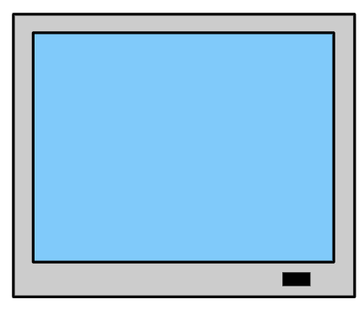
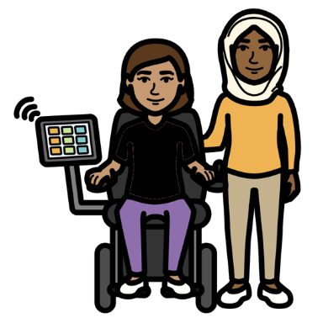

We will see if we can do a big piece of work for the public in 2026.

This will help people to know why it is important to include people with disabilities.

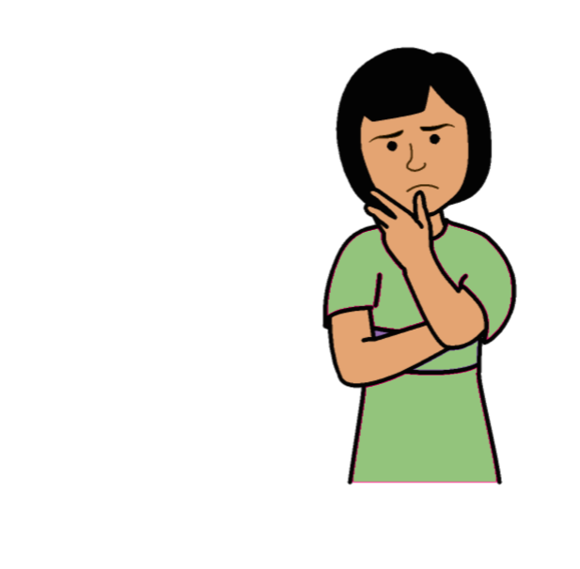
3. We are not doing everything we need to yet on some things

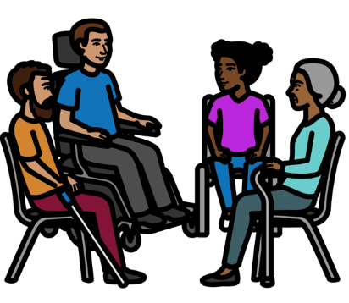
We are not doing everything we need to yet on the areas of work below:

Working with people with disabilities and making sure they can say what they think.
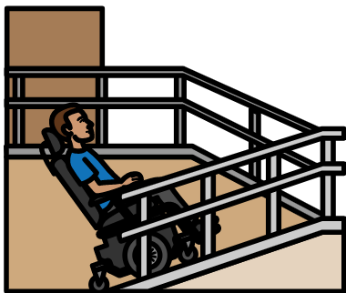

Making sure that everything is easy for people with disabilities to use and take part in.
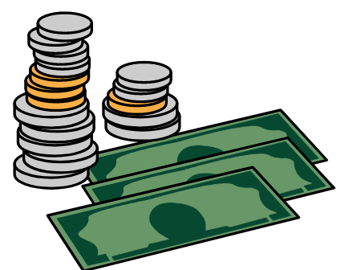

Making sure that new services
and things that we buy work well for people with disabilities.
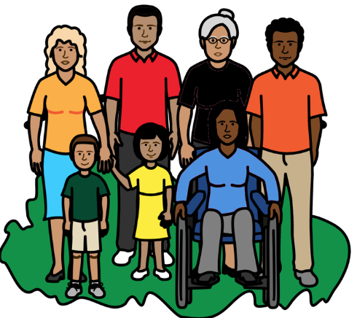

Making sure that projects include the rights of people with disabilities and what they need.

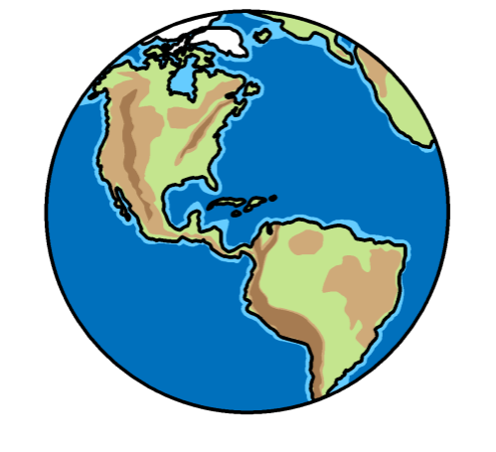

Making sure that we include people with disabilities in our work in different countries.
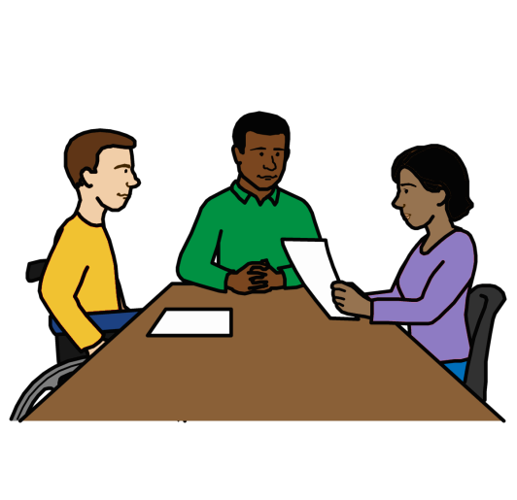
Helping more people with disabilities to work for the United Nations and do well.

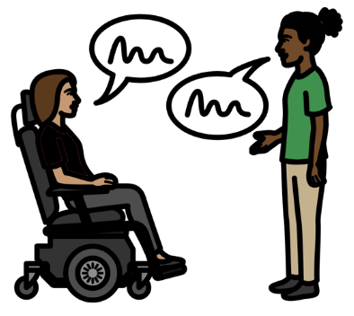

Some examples of our work:

We often work with people with disabilities to find out what they think about things to do with disability.

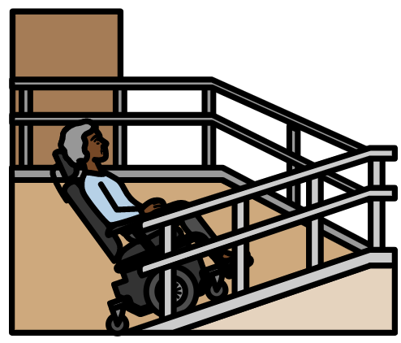
We want to make things easier for people with disabilities to use or take part in.

For example, we are working to make our offices and our events better for people with disabilities.
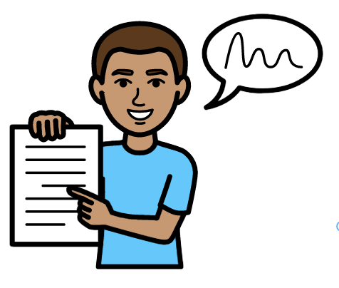

We sometimes ask for money for our projects.

We made some information about how to include people with disabilities when we ask for money.

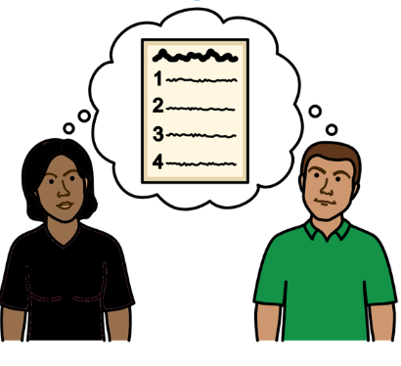
We have some rules about our projects in different countries.

We made people with disabilities part of the rules.

That means people doing the projects have to check what people with disabilities need.

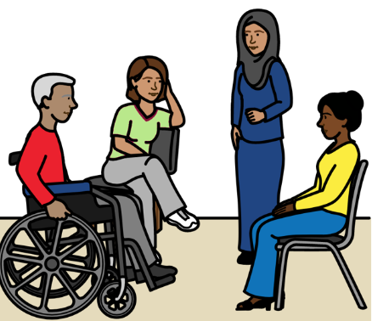
We want to make it easier for people with disabilities to work for us and do well.

For example, we want to make it easier for people to get a job with us and take part in training.

.
But there is more that we need to do in 2026.

We will find better ways to check how people with disabilities are taking part in our work.

We want to make more things easy for people with disabilities to use and take part in.

We will look at new ways to get money for this work.

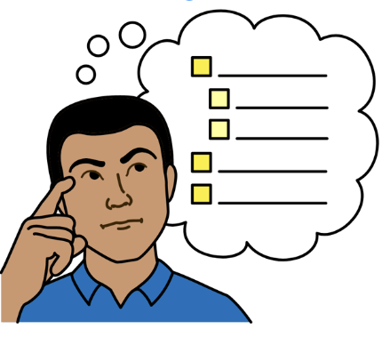

We will decide how many projects should include people with disabilities.

This could be general projects.

Or projects just about people with disabilities.

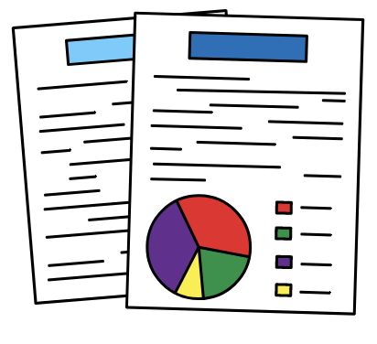

We want to get better information about the work we are doing on the rights of people with disabilities.

For example, how much work we are doing.

And how much money and time we are spending on this work.

The Picture Communication Symbols ©1981–2016 by Mayer-Johnson LLC a Tobii Dynavox company. All Rights Reserved Worldwide. Thousands of resources available for free at www.boardmakeronline.com

