

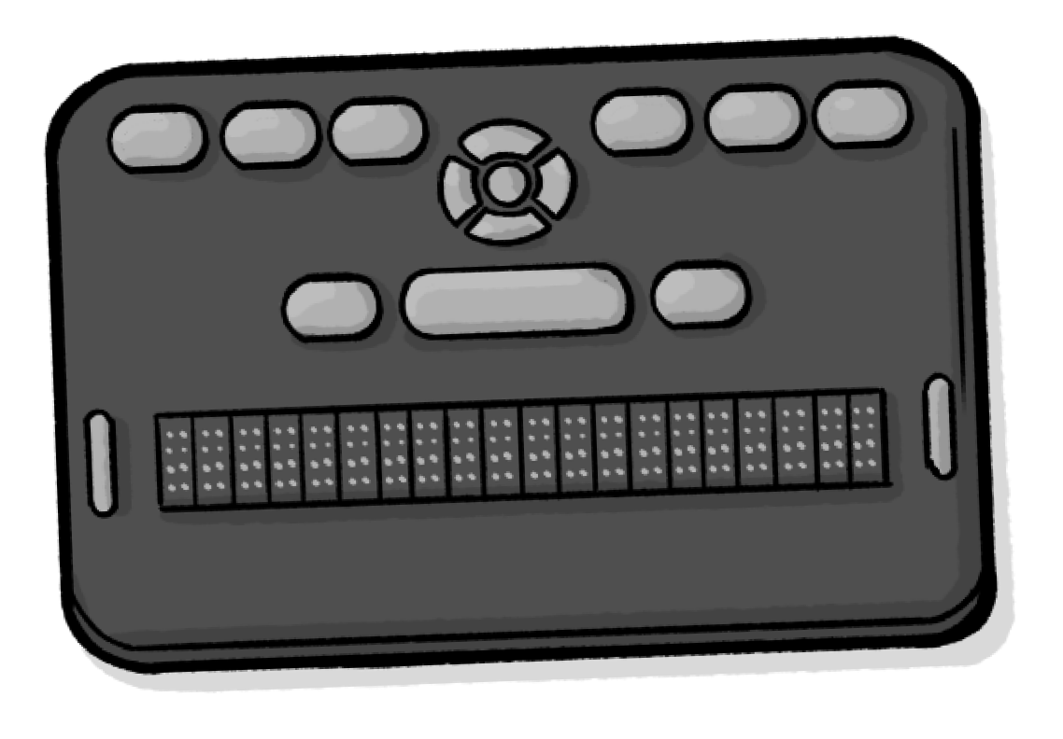

Easy Read

How technology affects the rights of people with disabilities

Easy Read
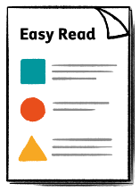
This is an Easy Read version of some information. It may not include all of the information but it will tell you about the important parts.

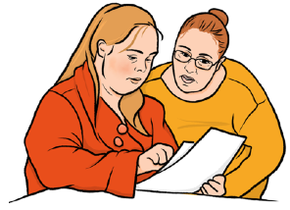
This Easy Read booklet uses easier words and pictures. Some people may still want help to read it.


Some words are in bold - this means the writing is thicker and darker.

These are important words in the booklet.

This word
means….

Sometimes if a bold word is hard to understand, we will explain what it means.

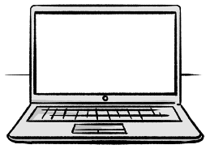

Blue and underlined words show links to websites and email addresses. You can click on these links on a computer.

links

What is in this booklet
About this report 4
How technology affects human rights 6
Using technology today 14
Care and support 22
What we think should happen 26



About this report
This report is from the Office of the United Nations High Commissioner for Human Rights. Or OHCHR for short.


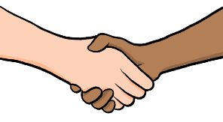
We are part of the United Nations (UN).
The United Nations is a group of countries that work to make the world better and safer.
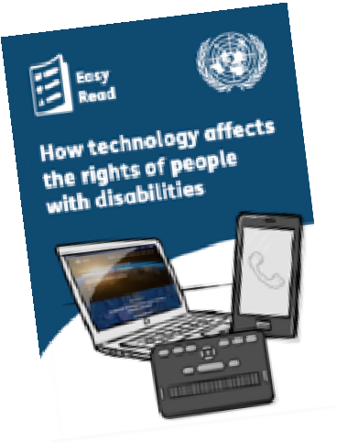

This report is about how technology can affect the human rights of people with disabilities.


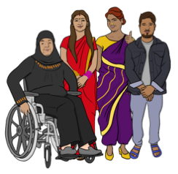

Human rights are the things that every person should have or be able to do, by law.


This includes your right to privacy or your right to be treated fairly.

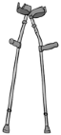



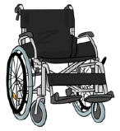
This report will explain:

- How different kinds of technology can affect the human rights of
people with disabilities.

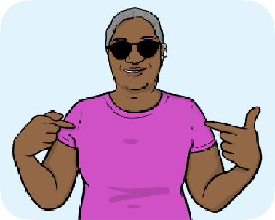

Why it is important to use technology to support people with disabilities.
•



- What governments should do to make sure that technology supports
people with disabilities.

How technology affects human rights
We looked at 2 different kinds of technology to help us write this report:
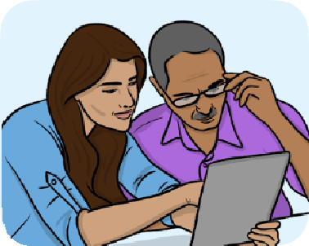
- Digital technology - This is electronic devices and computer
programs.


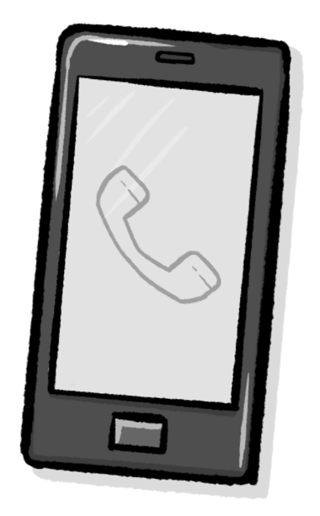
Digital technology includes things like mobile phones, computers and websites.


- Assistive technology is gadgets and equipment that helps people with disabilities.

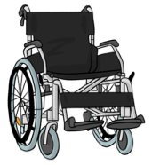

Assistive technology includes wheelchairs, hearing aids and white canes for blind people.

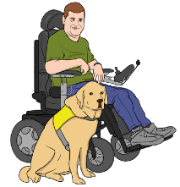
Digital technology

Digital technology can help people live better lives.

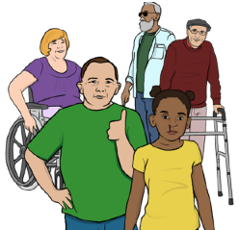
It is important to make sure that digital technology:
- Includes everyone.


- Protects human rights, like the right to privacy.

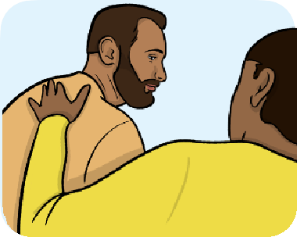
But some digital technology can hurt your human rights.


This is often because people and organizations care more about making money than protecting human rights.



If digital technology does not respect human rights, people with disabilities may face more discrimination.
Discrimination is when you are treated badly or unfairly because of your gender, race, religion, disability, health condition or sexual orientation.

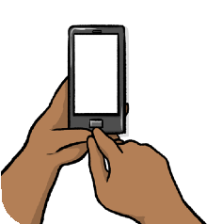
For example, people with disabilities may face more discrimination if:

- Their personal information is not kept safe and private.


AI
- New digital technology like artificial intelligence (AI) uses information
in an unfair way.
AI is technology that can do tasks and learn how to do them better.



The Convention on the Rights of Persons with Disabilities is an important document about the rights of people with disabilities.
UNCRPD

This legal document says that countries should:


- Make sure that new technology is easy for people with disabilities to
use.

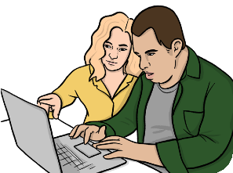
- Make sure that people with disabilities can use new technology
to take part in things, like voting.

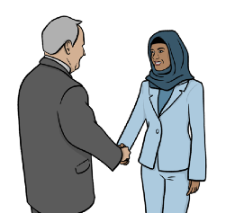
- Share information about assistive technology with other countries.


The Committee on the Rights of Persons with Disabilities are a group of experts in the UN.

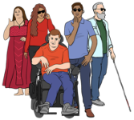

They are in charge of checking that people with disabilities get their rights.


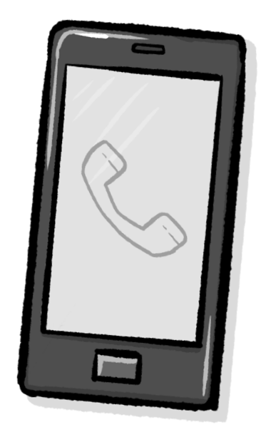
The committee says that digital technology can help governments share information and provide services.


This can make it easier for people with disabilities to get the support and information they need.

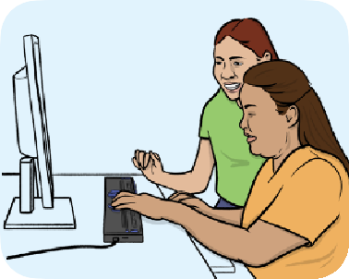
Other teams and staff who work for the United Nations have looked at:

- How to help more people with disabilities to use digital technology.


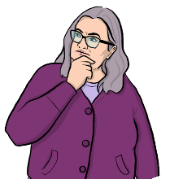
- How to use digital technology to stop people from believing untrue
things about people with disabilities.

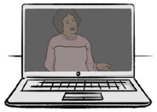
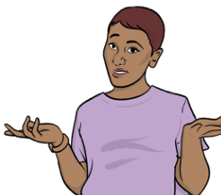
- How some digital technology can make it harder for people with
disabilities to get the right support.


- How countries should make more rules about technology to help
people with disabilities.

Assistive technology

Remember, assistive technology is gadgets and equipment that help people with disabilities.

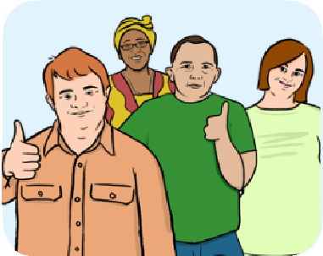

Everyone has the right to use assistive technology if they need it.

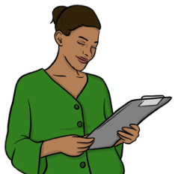
The Convention on the Rights of Persons with Disabilities says that countries should:

- Find out more about assistive technology.

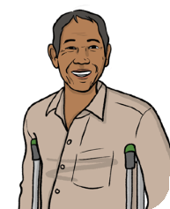

- Make sure that it is easy for people with disabilities to get assistive
technology.


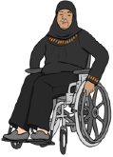
Countries should also make sure that people with disabilities can get assistive technology to help them move around.

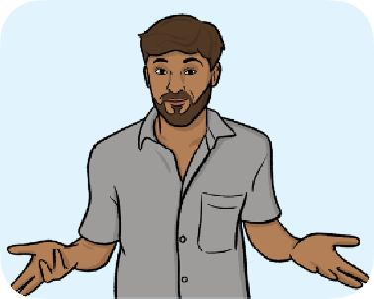
The Committee on the Rights of Persons with Disabilities is worried about problems like:

- Not enough staff and people with disabilities know about assistive
technology.


- Many people with disabilities find it too hard to get and use assistive
technology.


- People with disabilities often do not have enough money to pay for
assistive technology.

Using technology today


E-governance programs
E-governance programs are online programs that governments use to provide services and share information with the public.

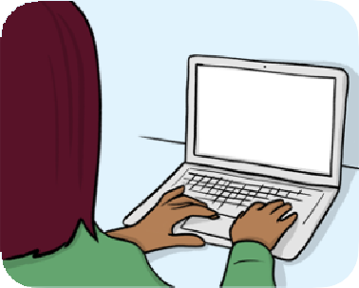
E-governance programs can do things like:

- Send alarms and information to people when emergencies happen
to help them stay safe.



- Let people vote online or fill in online surveys.

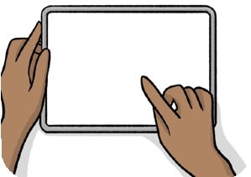
- Give people information about their rights.
My rights

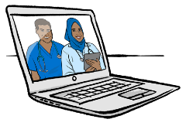

E-governance programs can also:

- Let people book appointments or find out information about their
health online.



- Make it quicker and easier for people to get information, support
and services.


- Give people with disabilities more power over their lives.

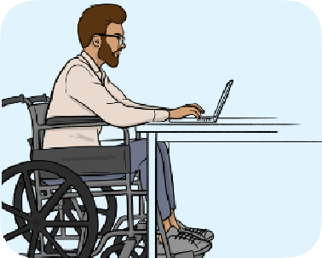
People with disabilities are more likely to use e-governance programs than other people.

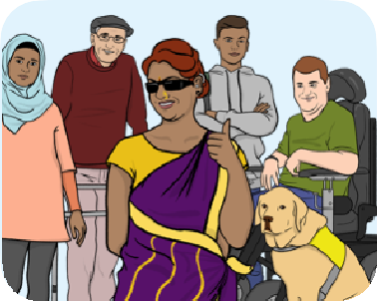
So it is important to make sure these programs are fair and easy for people with disabilities to use.

Using digital technology
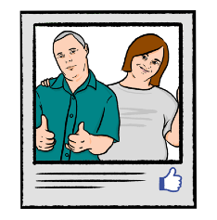
People with disabilities can use websites like social media and online shops to:

- Speak with other people and get involved in their local area.


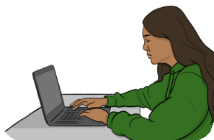
- Get jobs or run their own businesses online.

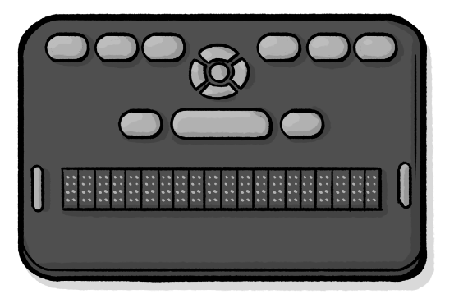

Digital technology can turn assistive technology into smart devices.
Smart devices are devices that can share information and connect with other devices.

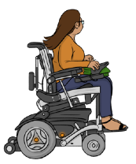
For example, smart wheelchairs and canes use digital technology to help people move around safely.

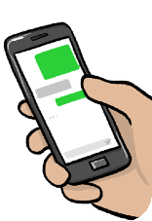
Some smartphones have assistive technology like text-to-speech.
Text-to-speech is technology where a device reads words on the screen out loud.

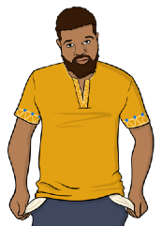
But many people with disabilities do not use assistive technology on their phones because:

- They cannot afford to buy a phone that has the technology.


- They do not know about the technology.



- The technology is not available in their language.


Using assistive technology

Assistive technology can help people with disabilities to:
- Move around, and do more for themselves.

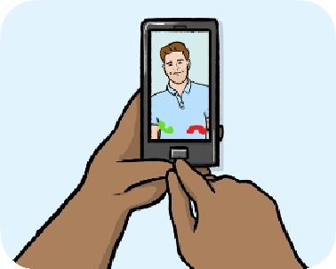
- Talk with other people.


- Learn and get jobs.



Assistive technology can also:

- Save time for people supporting people with disabilities.

- Help governments raise and save more money.


Problems with getting assistive technology
Lots of people with disabilities do not get the chance to use assistive technology.

This may be because:

- It is too expensive.


- There is not enough assistive technology for everyone who needs
it.



- They cannot get the technology where they live.

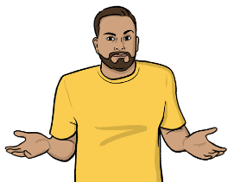
- They do not know about different assistive technologies.

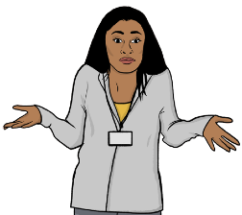
Some people with disabilities may not get the chance to use assistive technology because:

- Service staff and other professionals do not know how the technology
works.

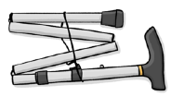

- Lots of assistive technology is not safe or does not work well.


- There is not enough assistive technology for children with
disabilities.


- Some assistive technology for adults is only made for men.


This can mean that assistive technology does not work well for women with disabilities.

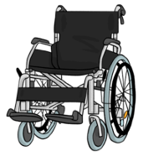

It is important for businesses to make and sell assistive technology that is cheap and works well.

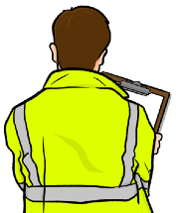

But businesses should also test assistive technology before selling it.


Some countries give people support with paying for assistive technology.

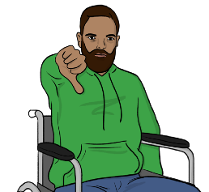
But most people with disabilities in the world do not get this support.

Care and support

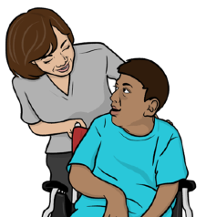
Lots of people with disabilities need support to help them in their daily lives.


But public services do not always provide enough care and support.



This means that support persons of people with disabilities must do lots of unpaid care and support work.


Most of the people who do unpaid care and support work are women.



This can make it harder for women to get jobs and be treated fairly.



Digital technology can make care and support services faster and better.

This can save time and money for people with disabilities, persons who support them, and governments.


Digital technology that helps people manage their health can save time with going to the doctor.

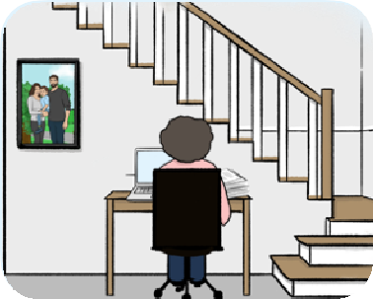
Digital technology can also help people with disabilities and the persons who support them to work from home.


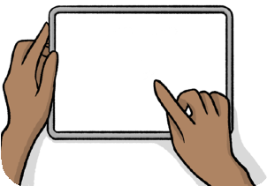
Smart home devices can help save time on doing everyday tasks, like going shopping.

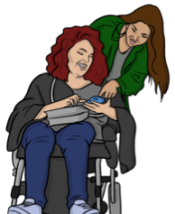
Good assistive technology can help people with disabilities and their support persons to live better lives.


It can also help governments to save time and money on care and support services.

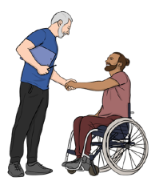
But it is important to make sure that people can still get help from humans.

This is because:

- We still need people to show care and support and make good
choices.


- Some people with disabilities find it hard to use technology.

It is also important to make sure that:


Public transport like buses and trains are more accessible.
•
Accessible means easy to use and suitable for people with different needs.


- Buildings like homes and offices are more accessible.



What we think should happen

Governments should make sure that technology helps protect the human rights of people with disabilities.


This part of the report will explain how we think governments should do this.

Digital technology
We think that governments should:

- Make e-governance programs that respect human rights.
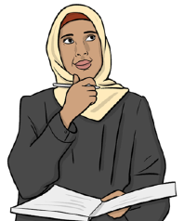
Remember, e-governance programs are computer programs that governments use to provide services and share information.

- Write and follow laws that make sure that e-governance programs
respect human rights.

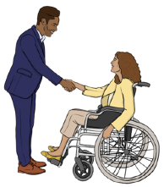
Governments should also:

- Work with people with disabilities to help write laws and rules.

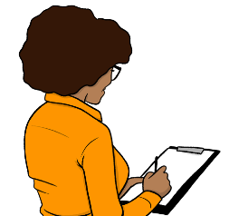
- Check how well their e-governance programs follow these laws.

Assistive technology

Governments should:

- Share information about assistive technology and why it is important.


- Tell people with disabilities about different assistive technology they
can get to help them make good choices.



Governments should also:

- Help more people with disabilities to get assistive technology.

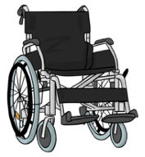
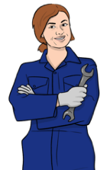
- Help businesses make and provide more assistive technology.

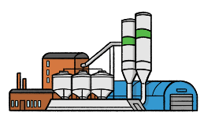

- Help local factories make better assistive technology that is right for
people in the local area.


- Work with countries that have less money to help them make and
provide more assistive technology.


- Have rules that say that assistive technology needs a certificate to

Certificate
show that it is safe and works well.

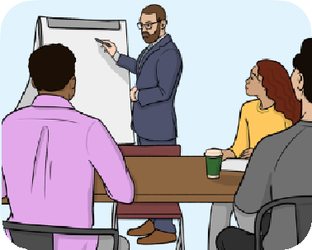
Governments should also:

- Give staff training about how to make sure that assistive technology
fits and works for longer.


This training should include how to help assistive technology work better for women.


- Share information and ideas about assistive technology with other
countries.

Care and support
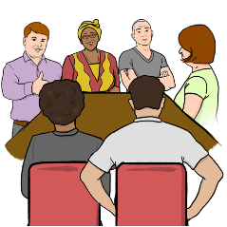
When governments make programs and websites to provide care and support services, they should:

- Include people with disabilities and their human rights.



- Make sure that the programs and websites are easy to use.

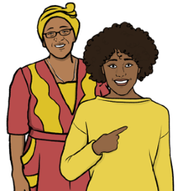
- Make sure that people can get help from humans as well as technology.

- Make sure that people can get all the services and information they
need from 1 program or website.


Governments should also:

- Respect that people with disabilities can make their own choices about
the support they get.


- Include assistive technology in plans about care and support
services.


- Think about giving more support to organizations in other countries to
help them respect disability rights.


- Have more rules about how different organizations should
respect human rights.

- Raise more money to spend on technology that includes people

More
with disabilities.

