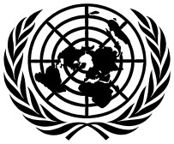
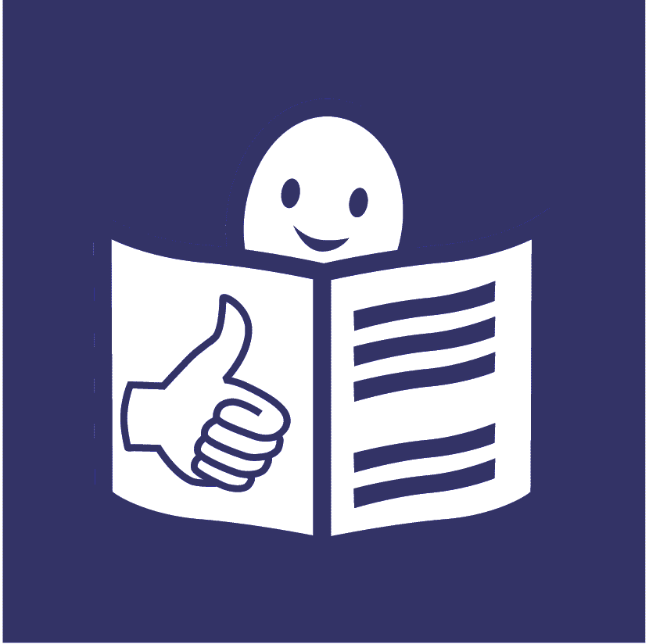
United Nations Office of the
High Commissioner for Human Rights
Easy to read
What our part of the United Nations has done to include people with disabilities in 2024

This is about our work on the United Nations plan to include people with disabilities
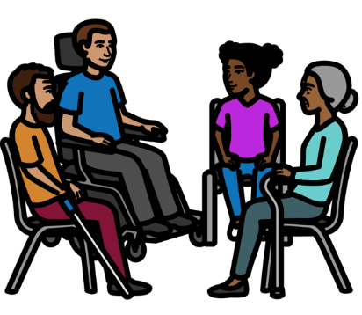

Progress report on the UN Disability Inclusion Strategy

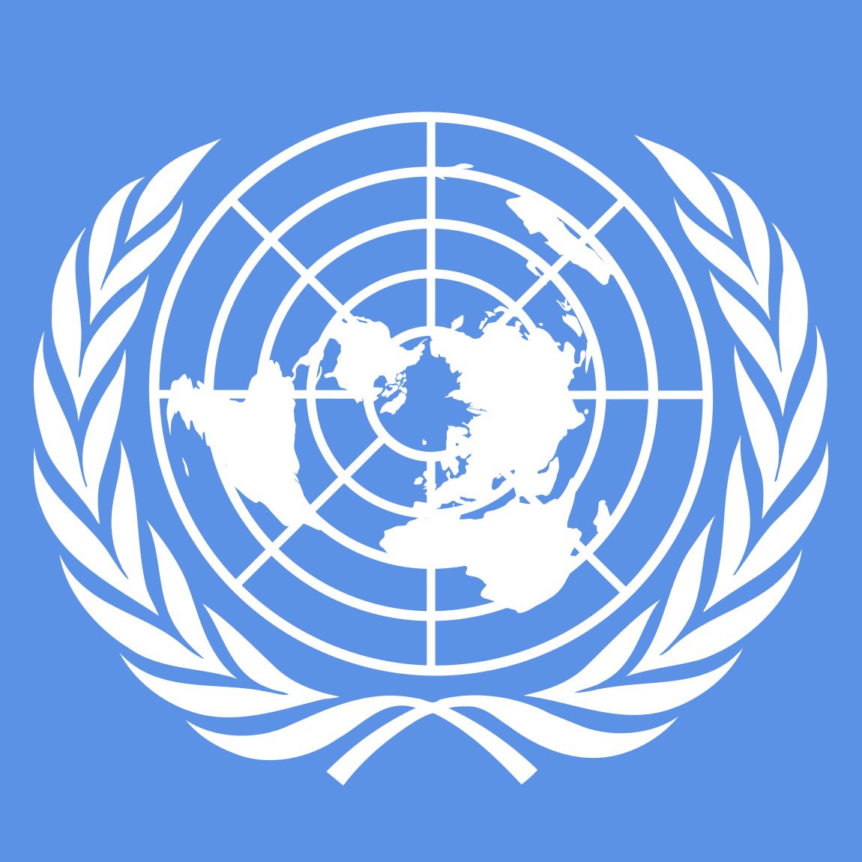
About us

We are called the Office of the High Commissioner for Human Rights. Or OHCHR for short.
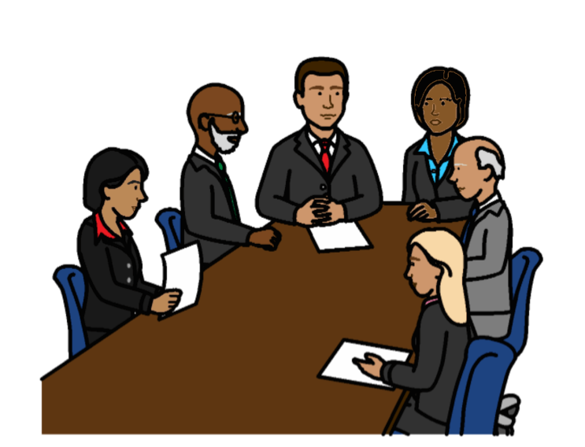

We are part of the United Nations.

The United Nations is a group of countries that work to make the world better and safer.

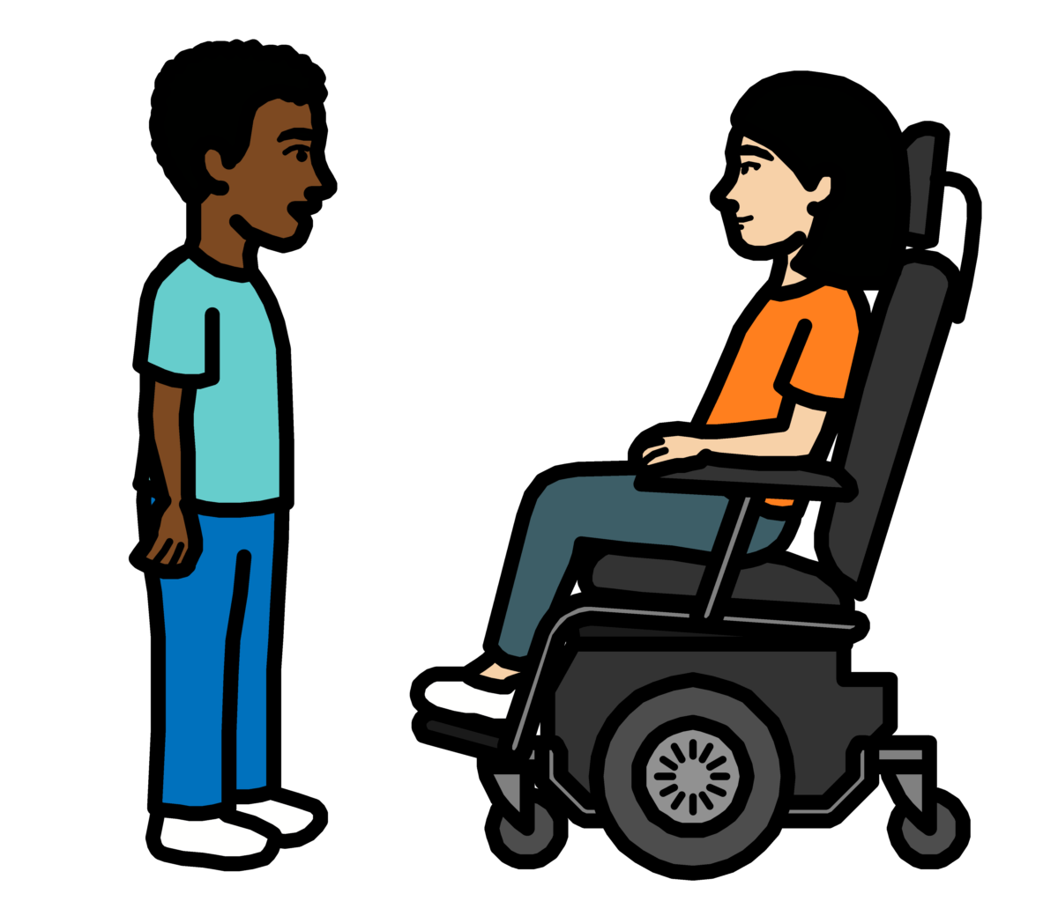

About this report

The United Nations wants people with disabilities to be part of everything it does.

That means people with disabilities should not be left out.
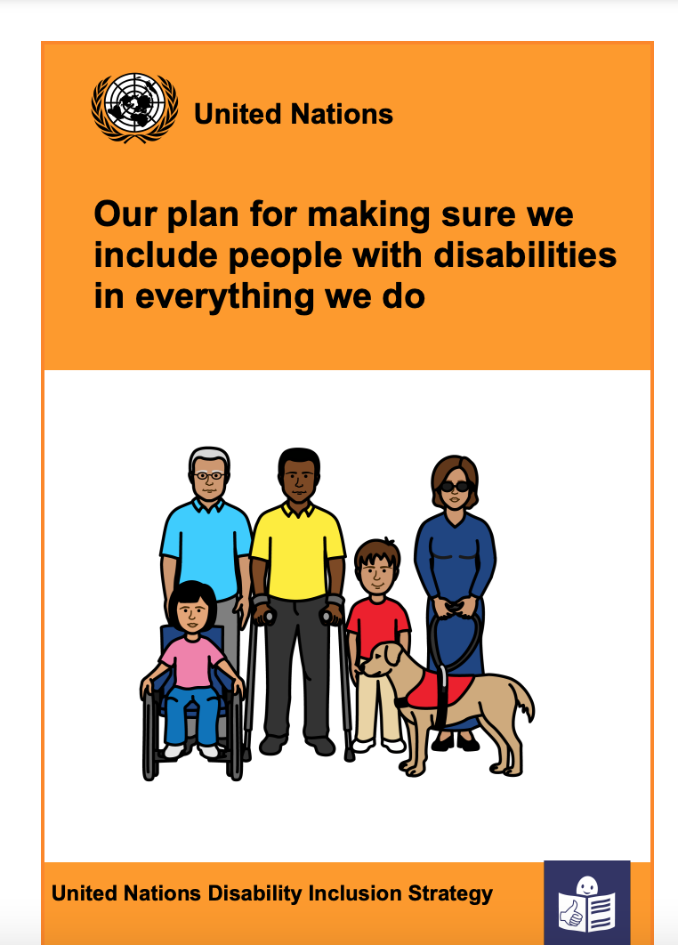

The United Nations has a plan about how to include people with disabilities.

The plan is called the
Disability Inclusion Strategy.


The plan is on our website:
https://www.un.org/en/content/disabilitystrategy/assets/documentation/Easy_to_Read.pdf

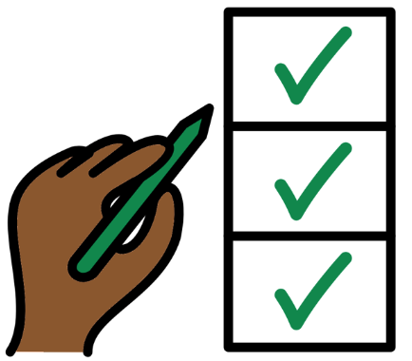

Different parts of the United Nations should say how they are doing with the plan every year.

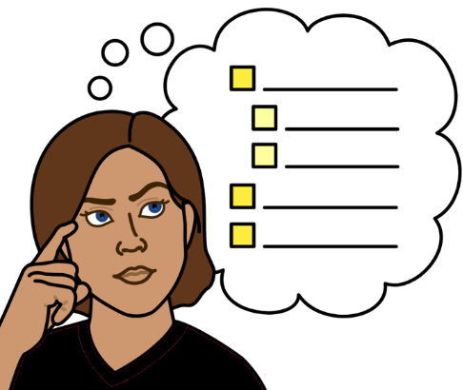
This report tells you what we have done to include people with disabilities in 2024.

There are 15 areas of work that we had to look at.
We had to say how well we are doing on each area that we work on.

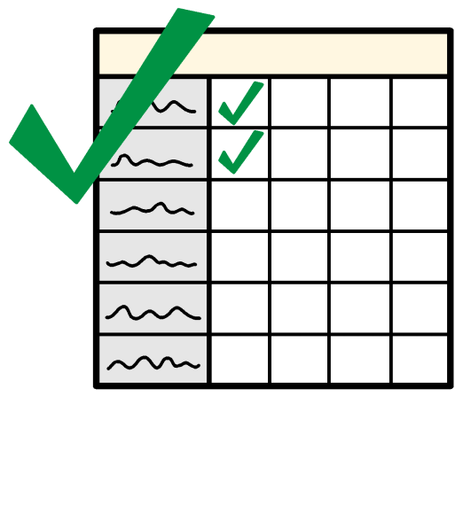

This report tells you more about what we are doing well on.

And what we need to do more on in 2025.
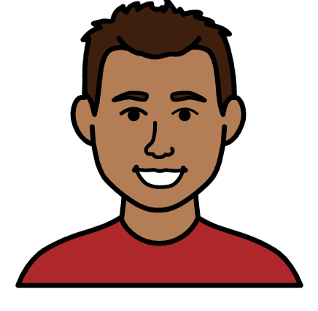
How we are doing so far to include people with disabilities

- We are doing even better than we need to on some things
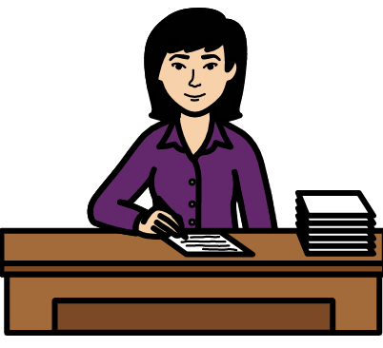

We are doing even better than we need to on the areas of work below:

Making sure that senior managers
make the United Nations plan about people with disabilities happen.
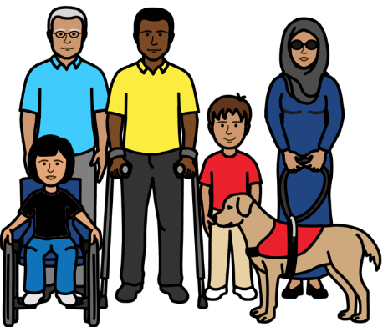
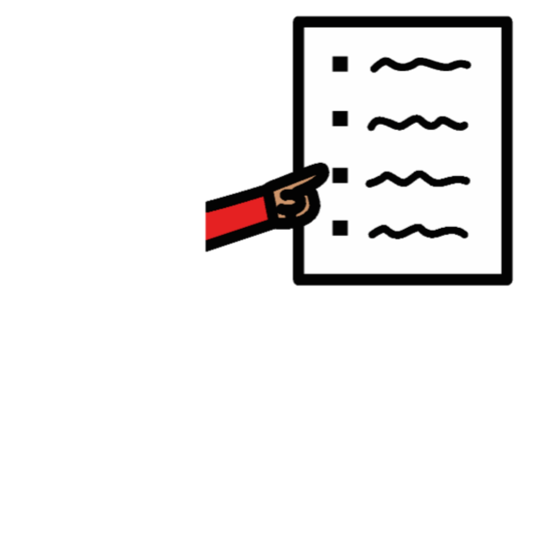

Making sure that the main plan about our work talks about people with disabilities and their rights.
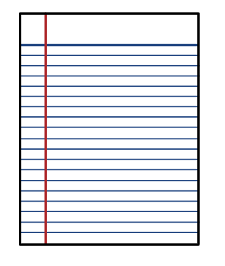

Making sure that we have a plan about how to include people with disabilities.
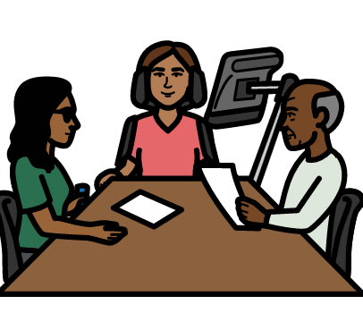

Making sure that people with disabilities get the right support to take part and say what they think.
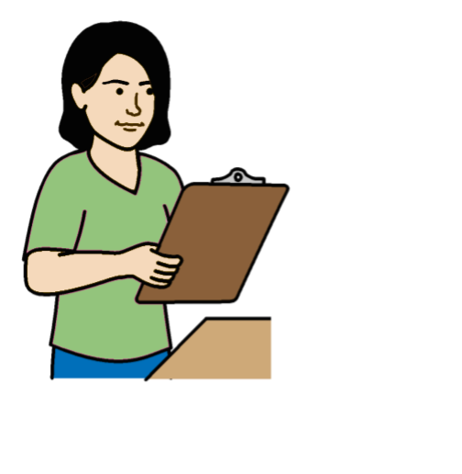
Making sure that people check how projects are working for people with disabilities and their rights.

Working with other parts of the United Nations to include people with disabilities.

Some examples of our work:
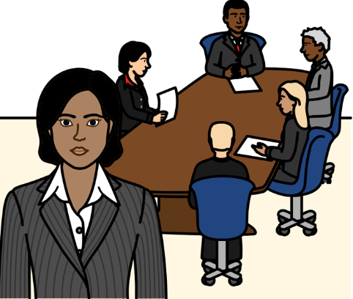

We have people in charge of
human rights work for the United Nations.

They are doing a lot to support our work about people with disabilities.

And we want them to do more in the future.

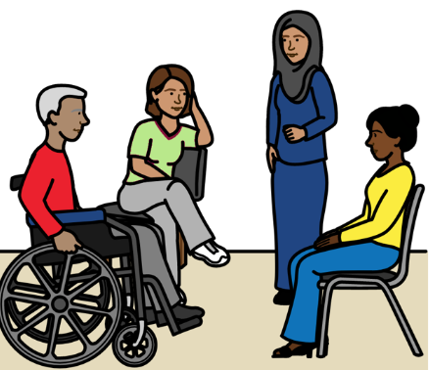

For example, our senior managers went to meetings in different countries.

The meetings were about making life better for people with disabilities.

Our senior managers also met with organizations of people with disabilities.
The main plan about our work talks a lot about people with disabilities and their rights.

That means making people with disabilities part of our work for everyone.

It also means doing some work just about the rights of people with disabilities.

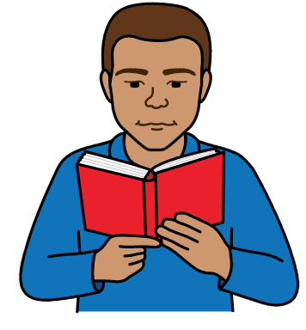

We have a plan about how we will include people with disabilities.

We will make the plan a bigger part of our work in 2025.

For example, we will share the plan with more people.

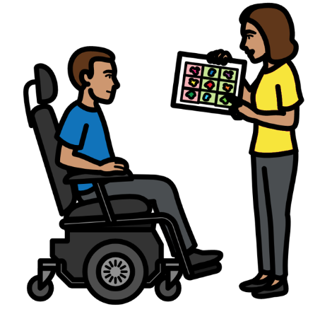
We have a plan about how to give people with disabilities extra support if they need it.

For example, people may need support to say what they think or support to travel.

We will keep checking the plan to see if we need to change anything.
We are checking some of our projects in different countries to see how they are working for people with disabilities.

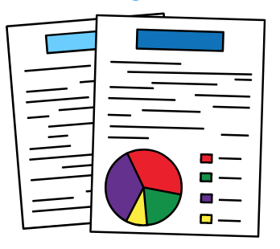
We also did some big work to check how our projects in different countries are working for people with disabilities.

We looked at all the information we had about that.

We will check again in 2027.

We have done lots of work with the United Nations and other organizations on the rights of people with disabilities.
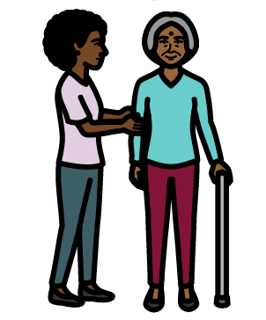

For example, we were part of 2 projects about making care and support better.

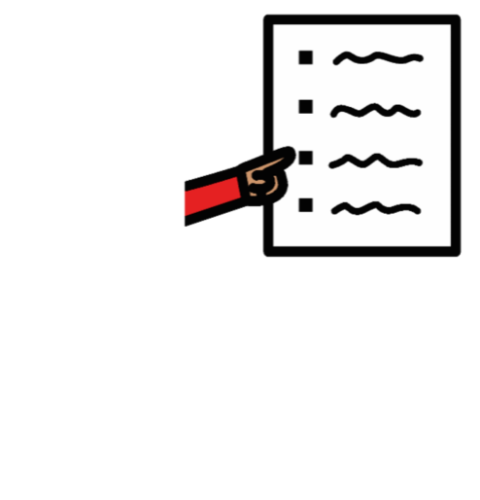

- We are doing everything we need to on some things

We are doing everything we need to on the areas of work below:
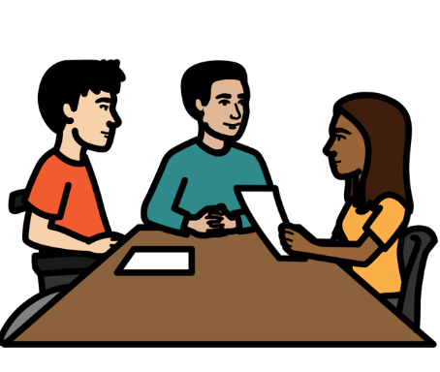

Making sure there are people who know about disability and human rights.

And making sure that people can meet to talk about disability.
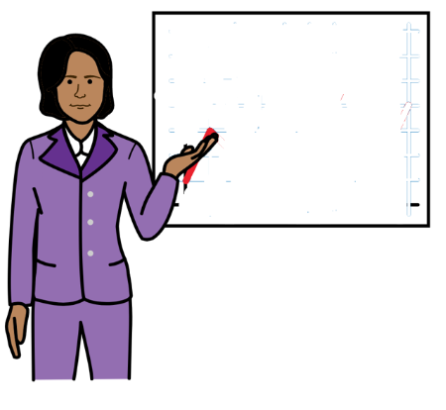

Making sure that staff get information and training about how to include people with disabilities.

Some examples of our work:
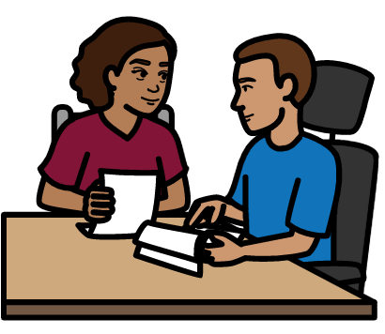

We have 2 people to make sure that we include people with disabilities in our work.

They work with the United Nations.

They also work with people with disabilities, governments and other organizations.

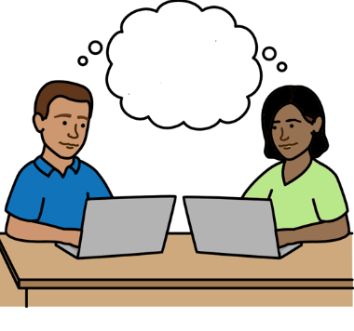
We set up a new way for the United Nations to work together to include people with disabilities.

It means people can share information, training and work about the rights of people with disabilities.

We will work more on that in 2025.

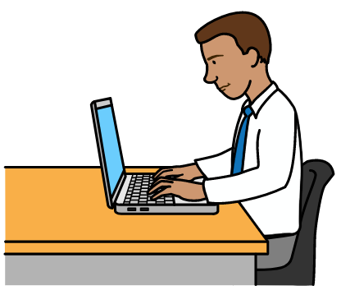

Our staff have to do some training on the internet.

It is about how to include people with disabilities.

We checked who has done the training and how it has been used.

There is some training about the United Nations plan to include people with disabilities.

The training is about how to make the plan happen.

All staff now have to do this training.

We will check to make sure that happens.
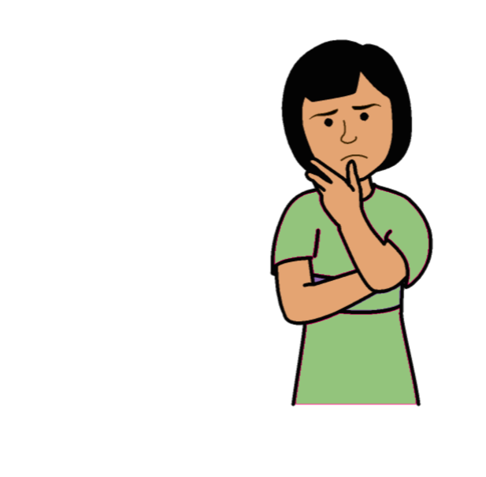
We are not doing everything we need to yet on some things

We are not doing everything we need to yet on the areas of work below:

Working with people with disabilities and making sure they can say what they think.
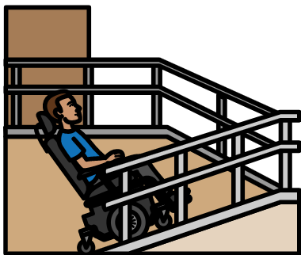

Making sure that everything is easy for people with disabilities to use and take part in.
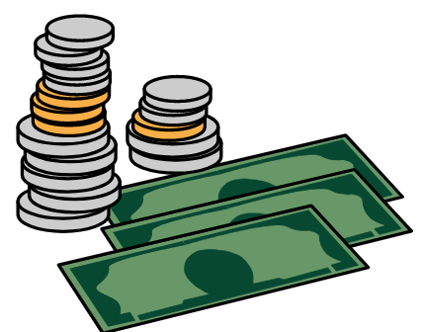

Making sure that new services
and things that we buy work well for people with disabilities.
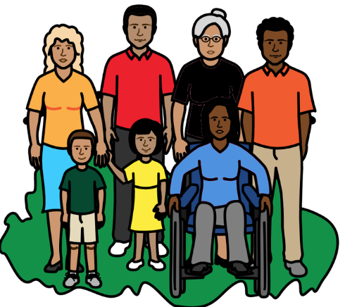

Making sure that projects include the rights of people with disabilities and what they need.

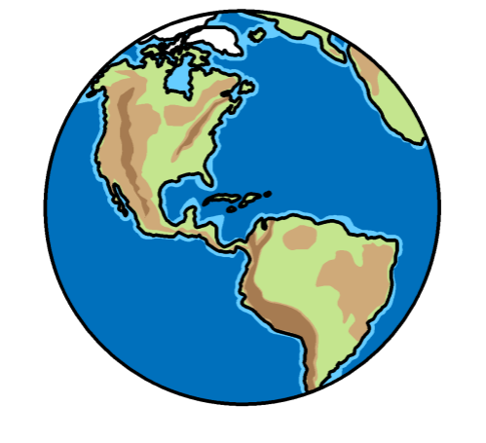
Making sure that we include people with disabilities in our work in different countries.
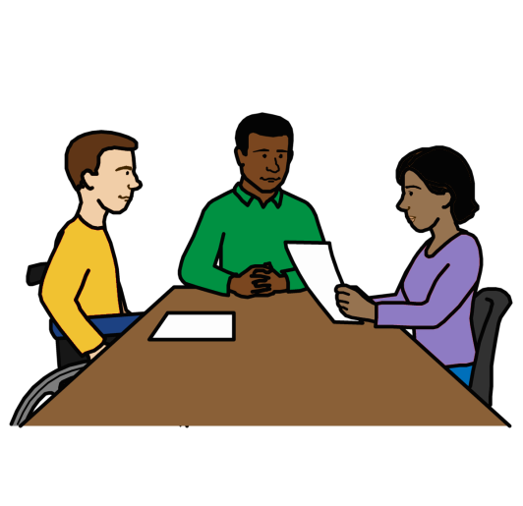

Helping more people with disabilities to work for the United Nations and do well.
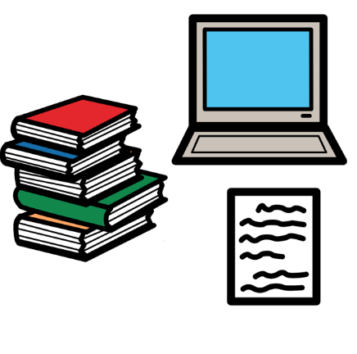

Making sure that the United Nations:

- Talks about people with disabilities in the right way.

- Helps people to know about people with disabilities and their rights.
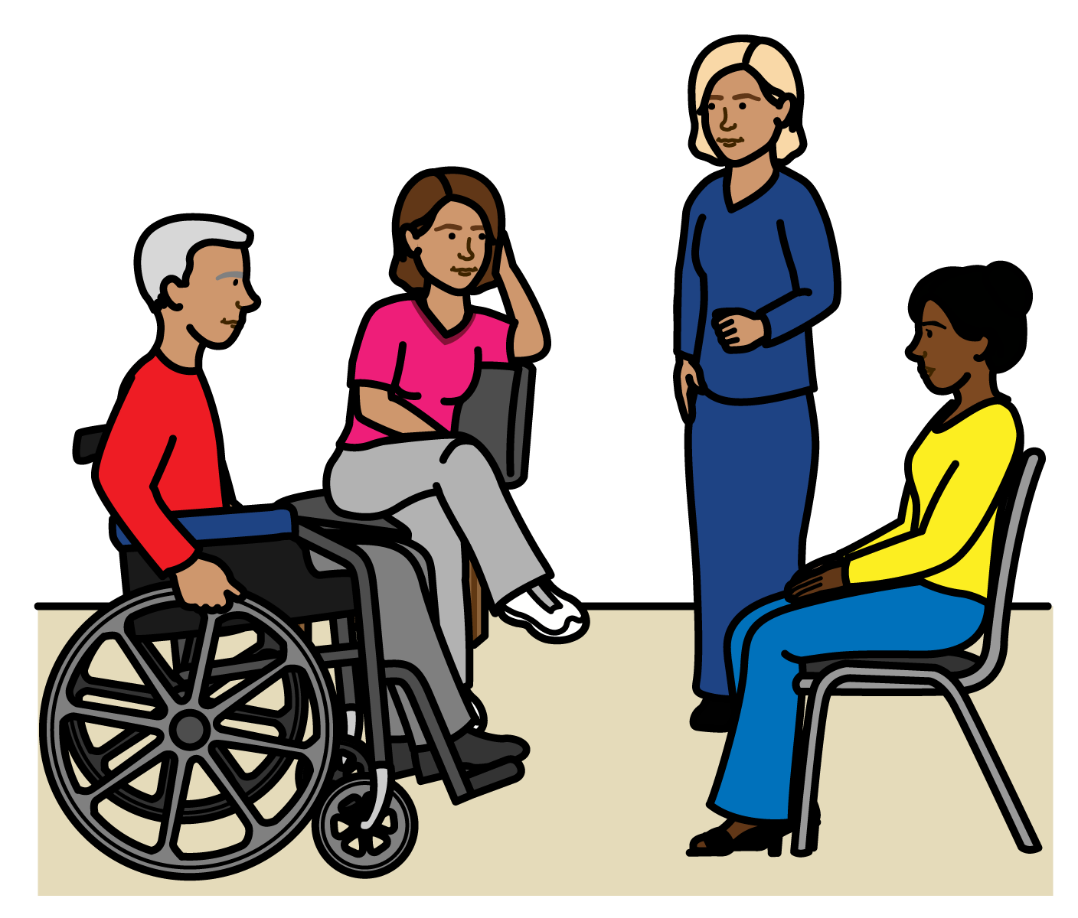

Some examples of our work:

We often work with people with disabilities to find out what they think about things to do with disability.

We follow some rules about how to work with people with disabilities.
This is to make sure we work with people with disabilities in the right way.
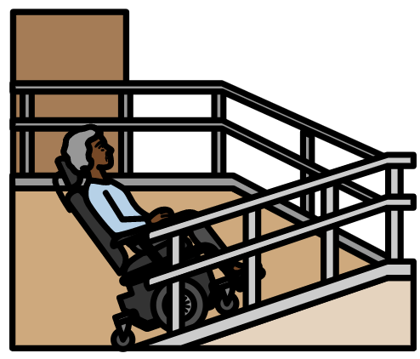
We looked at how to change some of our offices to make them easier for people with disabilities to work in.
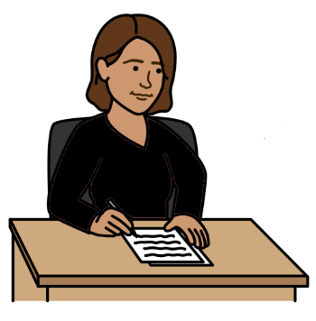

We sometimes ask for money for our projects.

We made some information about how to include people with disabilities when we do that.

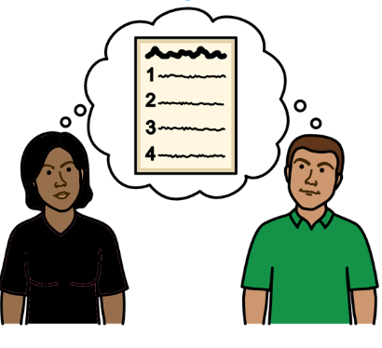
We have some rules about our projects in different countries.

We made people with disabilities part of the rules.

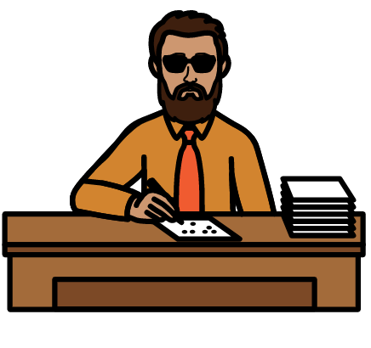
That means people doing the projects have to check what people with disabilities need.

We want to make it easier for people with disabilities to work for us and do well.
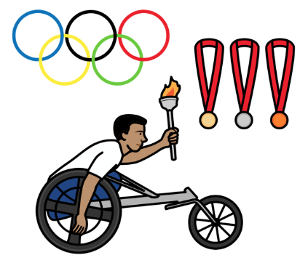
We worked on a project with a big sports organization.

The project was about people with disabilities and their rights.

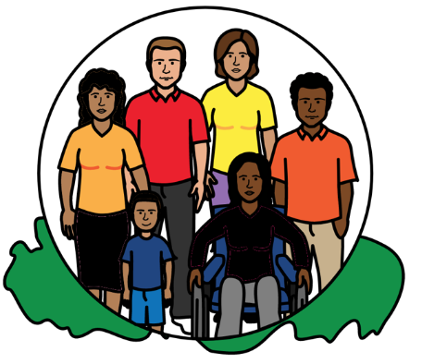

There was a big United Nations project about human rights.

It was about how human rights can make the world better now and in the future.

We made sure people with disabilities were part of this project.

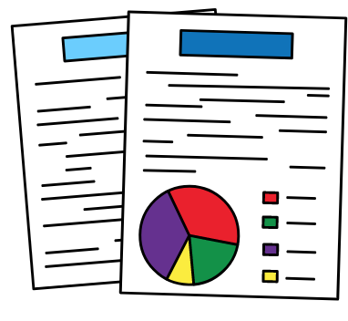
But there is more that we need to do in 2025.

For example:

We will work with other parts of the United Nations to get better information about people with disabilities.
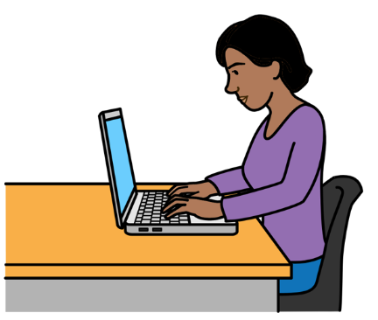

We will look at better ways to check
how our work about people with disabilities is going.

There is a computer system that can help with that.
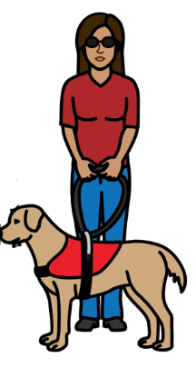
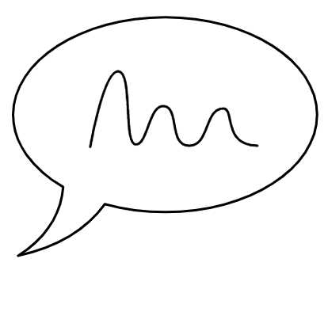
We will find better ways to check how people with disabilities are taking part in our work.

We want to make things easy for people with disabilities to use and take part in.

We will look at new ways to get money for this work.
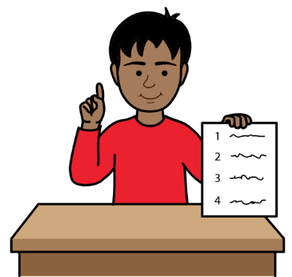

We will decide how many projects we should have to include people with disabilities.

This could be general projects.

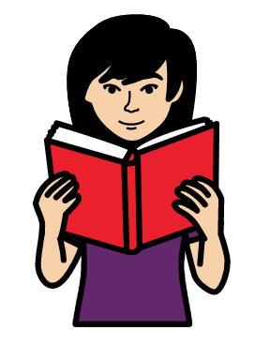
Or projects just about people with disabilities.

We will look at how to make our information better for people with disabilities and their rights.

The Picture Communication Symbols ©1981–2016 by Mayer-Johnson LLC a Tobii Dynavox company. All Rights Reserved Worldwide. Thousands of resources available for free at www.boardmakeronline.com

