Annex I- Air pollutants and impacts on health

To the report of the Special Rapporteur on the human right to a clean, healthy and sustainable environment, Astrid Puentes Riaño, titled ‘Priority actions towards breathing clean air, protecting public health and a healthy environment’ (A/HRC/61/47)

This annex to the report to the Human Rights Council seeks to explain, in simple but complete terms, the most important air pollutants that affect human health: what they are, how they harm human health, where they stem from and some of the sources States must control to safeguard clean air, as one of the substantive elements of the human right to the right to a clean, healthy and sustainable environment.

By better understanding and emphasizing the correlation between air pollution, sources, and health outcomes in policy-making processes, States can more effectively prevent, reduce, or remediate the impacts of air contamination on public health, the environment and our global climate.

We are all born into the air we breathe. With more than 20,000 breaths each day – more than seven million breaths every year – we fill our lungs to bring life-sustaining oxygen into our bodies. Unfortunately, in far too many places, those breaths also bring dangerous pollutants into our lungs and blood. Pollutants that can affect every organ in our body, every day of our lives, including in utero. When the air quality is poor, these contaminant-laden breaths harm our health and lower life-expectancy. Maintaining the air quality so that the air we breathe is clean, thus becomes a fundamental responsibility inherent to the duty to protect the human right to a healthy environment.

Sometimes, people who live in contaminated air do not understand the degree of contamination or the health harms it brings. For them, the air simply is the way it is. Because the impacts of unhealthy air are cumulative, with diseases and symptoms mostly developing slowly over time, adverse health outcomes may not be intuitively linked to the contamination. Thus, it may not be until the pollution finally ends that people realize the sky can be blue or that their throat and chest should not burn with every breath.

Both outdoor and indoor air pollution affect human health. In urban or wealthier areas, filters, fans, advanced technologies and changed practices can help improve indoor air quality. Meanwhile, outdoor air quality generally varies with distance from sources such as industrial sites or highly trafficked areas. In both cases, economically disadvantaged populations tend to bear the brunt of the burden of unhealthy air.

Priority Air Pollutants

The most critical classes of contaminants to consider as States undertake this work are described in Table 1.

Priority air pollutants | Description
Particulate Matter (PM₁₀, PM₂.₅, UFP) | Inhalable particulate matter (PM) is one of the most harmful and pervasive pollutants, consisting of a mixture of solid and liquid particles of organic compounds, metals, dust or soil particles, and acids. There are three types of PM, depending on the particle size:  - Coarse PM₁₀ has a diameter less than 10 microns, is often visible as smoke or dust that settles, and largely affects the upper respiratory system.  - Fine particles smaller than 2.5 microns (PM_{2.5}) stay suspended in the air and can travel many kilometers, increasing human exposure both with distance and time. Compared to PM₁₀, PM_{2.5} goes deeper into the lungs and can enter the blood stream.  - Ultra Fine Particles (UFP, PM_{0.1}) are “nanoparticles” less than 0.1 micron wide. Research on UFP is just emerging, but these particles more easily pass into human blood and organs and have very large surface areas, making them potentially highly reactive. Further research on the impacts of UFP is needed.
Ground-Level Ozone (O₃) | Ozone (O₃) is a colourless gas that can be damaging or beneficial depending on where it is found.  At ground level, harmful “tropospheric ozone” forms when other common air pollutants (NOx, CO and VOCs) react in the presence of sunlight. Ground-level ozone is most prevalent on hot, sunny days in urban environments, but can reach unhealthy levels year-round and is easily transported long distances by wind. Ozone is a main component of smog and is highly reactive, inflaming airways and causing respiratory issues.  Meanwhile, beneficial “stratospheric ozone” exists naturally in the upper atmosphere far from the Earth’s surface, where it forms a protective layer and blocks harmful UV rays. It is important to protect this ozone layer from the destructive effects of other air pollutants, such as halogenated refrigerants and propellants.
Nitrogen Oxides (NO_{x}) | Nitrogen Oxides (NO_{x}) is a generic term referring to compounds of nitrogen and oxygen.  Nitrogen Oxide (NO) is a colourless gas released as a byproduct of fuel combustion. While toxic in itself at high concentrations, NO relatively rapidly reacts with air to produce other more harmful pollutants: Nitrogen Dioxide (NO₂), fine particulate matter PM_{2.5}, and ozone (O₃).  Nitrogen Dioxide (NO₂) is a reddish-brown, pungent gas formed either directly from the burning of nitrogen-containing fuels or from the reaction of NO with air. Because it is a strong oxidant, NO₂ causes severe respiratory harm. Its chemical reactions in air are complex, with NO₂ also being a precursor to ozone, fine particulate matter, smog and acid rain.
Sulphur Dioxide (SO₂) | SO₂ is a colourless gas with a strong odour. It enters the atmosphere from the burning of fuels contaminated with sulphur, the roasting of sulphur-metal ores and volcanic activity. SO₂ harms human health directly, increases PM_{2.5} concentrations and causes acid rain.
Carbon Monoxide (CO) | Carbon Monoxide (CO) is a colourless, odourless, and tasteless gas that can be deadly at high concentrations. CO is largely produced through the incomplete combustion of carbon-based fuels, both indoors and outdoors.
Heavy Metals (Lead, Cadmium, Mercury, etc.) | Airborne heavy metals are toxic, persist in the environment and bioaccumulate in the food chain. Emitted from industrial activities, peak concentrations occur near the source, though fine metal particles also remain in the air as PM_{2.5}, traveling thousands of kilometres to affect remote populations. Exposure occurs through direct inhalation of contaminated air or by ingestion. After entering the bodies, heavy metal concentrations build up and cause harms ranging from organ damage and developmental impairment to cancer. The metals of greatest concern for long-range air pollution are lead, mercury, cadmium, and arsenic, with chromium, zinc, nickel, copper and other metals also posing risks.
Volatile Organic Compounds (VOCs) | The term “Volatile Organic Compound” refers to a group of carbon-based, human-made chemicals that easily evaporate into the air. They range from very volatile (gaseous) to semi-volatile substances like oils. Different VOCs cause various direct health harms. Some are known carcinogens, others cause asphyxiation or explosions, and some, such as pesticides and fire retardants, pose long-term toxicity risks. VOC concentrations can be much higher indoors, emanating from fuels, paints, cleaning agents, furnishings and personal care products. Outdoors, VOCs react with other air pollutants to create ozone.
Short Lived Climate Pollutants (SLCP) (Methane, Black Carbon, HFCs, Tropospheric Ozone) | Short Lived Climate Pollutants are powerful climate forcers that trap much more heat but remain in the atmosphere for significantly shorter periods of times than Carbon Dioxide (CO₂) does. Controlling these “super-polluting” emissions is thus critical to the fight against climate change. The most common SLCPs are methane (CH₄), black carbon, hydrofluorocarbons (HFCs) and ozone, all of which also impact human health directly.
Persistent Organic Pollutants (POPs) | POPs are toxic, organic chemicals that are extremely long-lived and accumulate in organisms to bring severe health risks. Some POPs are air pollutants and can travel long distances in the atmosphere. POPs of particular concern as air pollutants are dioxins and furans emitted from combustion and industrial processes, pesticides. Polycyclic Aromatic Hydrocarbons (PAHs) and Polychlorinated Biphenyls (PCB) along with other highly chlorinated, brominated or fluorinated substances.

II. Health Impacts

The global impact of diseases associated with air pollution on premature mortality rates is more than three times greater than the impact of malaria, tuberculosis and AIDS combined. It is 15 times more than the impact of wars and violence. The vast majority of those impacts are seen in low and middle- income nations.

Each air pollutant is associated with a range of symptoms and diseases, with the level and duration of exposure, age, underlying health conditions, and the availability of medical care affecting the final health outcome. Some contaminants, such as lead particles, cause unique impacts, while others act both individually and in concert to cause cumulative damage. Not every contaminant causes every harm, but together, the effects of polluted air on human health and life are substantial.

Air pollution can bring both immediate and long-term health problems. Some of the symptoms experienced acutely include nausea, coughing, asthma attacks, seizures and even death upon exposure to high levels of contamination. Meanwhile, serious health conditions like strokes, lung damage, heart disease, or neurological harms develop over time with persistent exposure. While the causal link may not be as easy to establish in cases of long-term exposure as in acute situations, innumerable epidemiological studies have shown the strong direct link between air pollutants and these health harms, particularly in the case of PM_{2.5}.

Air pollution also worsens other pre-existing health problems by making it more difficult for human organs to recover from and respond appropriately to other conditions, and to function optimally with age. While many of these health harms are non-communicable diseases, air contamination also weakens human’s ability to fight and recover from infectious diseases like pneumonia or COVID.

As a result, air pollution levels are now one of the leading environmental determinants of morbidity and premature mortality worldwide. A more detailed description of various health conditions caused by contaminated air follows.

Figure 1: Air pollution affects human vital organs - WHO

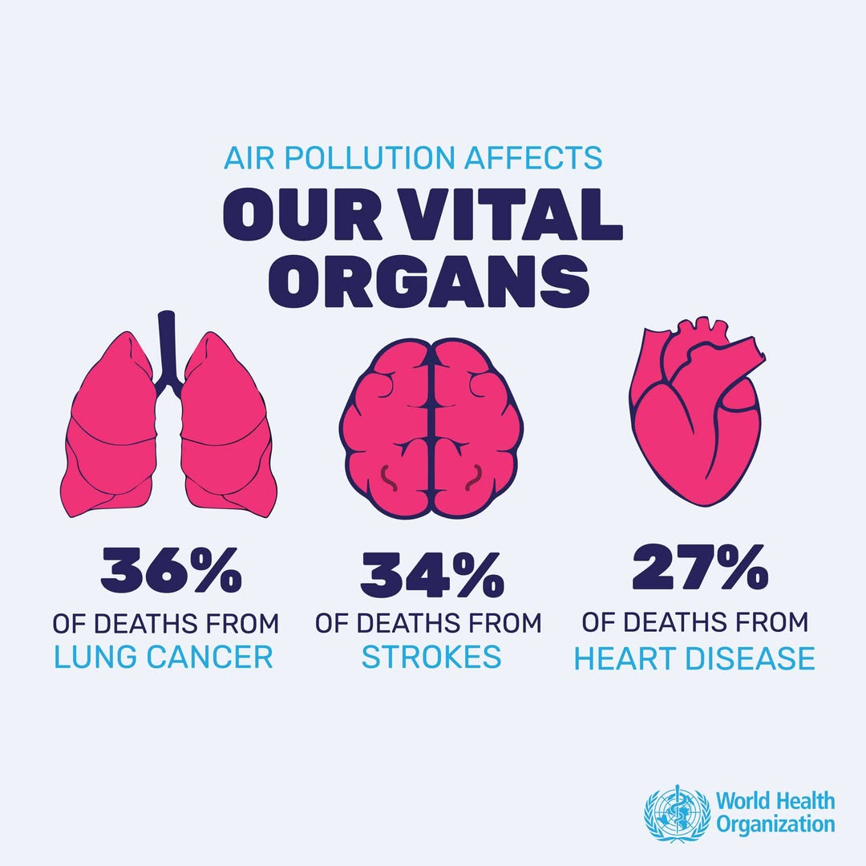
Air pollution affects our vital organs (2022). World Health Organization

Cardiovascular disease (heart and blood vessel harms)
Air pollution is a major contributor to diseases of the heart and blood vessels, and associated deaths worldwide. PM₂.₅ pollution is very strongly linked to cardiovascular problems with the fine particles passing from the lungs into the blood stream, causing blood clotting, plaque buildup and harming blood vessel walls among other impacts. Short- and long-term exposure to PM₂.₅ is associated with increased risks of strokes, heart attacks, heart failure, hypertension, and cardiovascular death, accounting for a substantial proportion of global coronary heart disease and stroke mortality. Even modest short-term increases in PM₂.₅ are linked to rises in hospital admissions for heart attacks and heart failure.

Air pollution not only worsens existing cardiovascular disease but also contributes to its development, with a direct link to exposure to PM₂.₅. Exposure to traffic-related pollutants such as CO, NO₂, and SO₂ has also been associated with stroke and cardiac arrhythmias, particularly in individuals with pre-existing heart disease.

Respiratory diseases
Common air pollutants have well-established, direct impacts on respiratory health. Particulate matter, NO₂, SO₂, and O₃ penetrate and irritate the respiratory tract, impairing normal lung function and weakening respiratory defences by causing inflammation, oxidative stress, and epithelial damage, among other harms. Short- and long-term exposure is strongly associated with the onset and exacerbation of asthma, chronic bronchitis, and chronic obstructive pulmonary disease (COPD), as well as increased susceptibility to respiratory infections, including pneumonia.

PM₂.₅ can penetrate deep into the lungs, facilitating bacterial infections and contributing to higher rates of hospitalization and mortality, particularly among older persons and individuals with pre-existing respiratory or cardiovascular conditions. Ground-level ozone damages lung epithelial cells, worsening symptoms of chronic respiratory disease, while nitrogen oxides and sulphur dioxide irritate airway mucosa and promote chronic inflammation.

Long-term exposure to air pollution is also associated with impaired lung growth and reduced lung function in children who are particularly vulnerable due to ongoing lung development and higher breathing rates relative to body size and with an increased risk of lung cancer through exposure to carcinogens such as polycyclic aromatic hydrocarbons (PAHs).

Neurological damage
Air pollution has been increasingly linked to a wide range of neurological and neuropsychiatric outcomes, including cognitive impairment, dementia, Alzheimer’s disease, Parkinson’s disease, depression, and ADHD. Both epidemiological and experimental studies suggest that long-term exposure to PM₂.₅, NO₂, O₃, and other pollutants accelerates brain aging and is associated with declines in cognitive function and increased risk of dementia, potentially through mechanisms involving systemic neuroinflammation, oxidative stress, metabolic dysfunction, insulin resistance, amyloid accumulation, mitochondrial damage, and grey matter atrophy.

Mental health effects have also been reported. Long- and short-term exposure to PM₂.₅, PM₁₀, NO₂, SO₂, and CO has been associated with higher risks of depression and exacerbation of schizophrenia, possibly mediated by activation of the hypothalamic–pituitary–adrenal axis, elevated cortisol levels, neuroinflammation, and impaired neurogenesis. Evidence also links air pollution to neurodevelopmental disorders, with prenatal and early-life exposure to PM₂.₅ and traffic-related pollutants associated with ADHD, behavioural changes, and structural brain alterations. Finally, toxic components of particulate matter (heavy metals and organic pollutants) may disrupt fetal brain development and lead to long-term cognitive deficits.

Cancers
Outdoor air pollution is classified as carcinogenic to humans by the International Agency for Research on Cancer. Long-term exposure to particulate matter, NO₂, O₃, and diesel exhaust is associated with increased risks of lung cancer and other malignancies through mechanisms including DNA damage, oxidative stress, inflammation, and epigenetic alterations. Heavy metals and metalloids emitted in industrial processes include both known and suspected carcinogens like cadmium, arsenic, mercury and lead. Evidence also links traffic-related air pollution and polycyclic aromatic hydrocarbons to cancers of the bladder, kidney, colorectal tract, and stomach. Moreover, prenatal and early-life exposure to benzene and fine particulate matter has been associated with an increased risk of childhood leukemia and certain brain tumours, underscoring the heightened vulnerability of children to air-pollution-related carcinogenic effects.

Increased bone loss and osteoporosis.
Emerging evidence indicates that long-term exposure to ambient air pollution increases bone loss and the risk of osteoporosis, particularly among older persons and postmenopausal women. Epidemiological studies have shown that chronic exposure to PM₂.₅ and other criteria air pollutants such as lead is associated with reduced bone mineral density (BMD) and an elevated risk of fractures, findings that have been consistently replicated across diverse populations and supported by experimental animal studies. Air pollution is believed to affect bone health through systemic inflammation, oxidative stress, and endocrine disruption, which can accelerate bone resorption, impair bone formation, and exacerbate age-related bone loss. Lead is known to accumulate in bones over time, reducing calcium absorption, and weakening the bone structure.

Anemia, obesity and diabetes risk
Growing evidence indicates that air pollution contributes to anemia, obesity, and increased diabetes risk through systemic inflammatory and endocrine pathways. Long-term exposure to fine particulate matter and NO₂ has been consistently associated with lower haemoglobin levels and increased rates of anemia. Chronic exposure induces persistent systemic inflammation which can disrupt iron and reduce red blood cell synthesis, thereby increasing anemia-related morbidity and mortality.

Additionally, particulate matter has been linked to metabolic syndrome and its components, including obesity, dyslipidemia, hypertension, impaired glucose regulation, and type 2 diabetes. Pollutants can enter the bloodstream and promote insulin resistance, oxidative stress, and chronic low-grade inflammation, interfering with glucose metabolism and lipid homeostasis. Epidemiological evidence indicates that air pollution contributes substantially to the global burden of diabetes, with increased risk observed even at pollution levels currently considered safe. The problem disproportionately affects low- and middle-income countries where exposure is high and access to preventive health care is limited.

Dermatitis and eye irritation
Air pollution has well-documented adverse effects on the skin and eyes, primarily through direct exposure to ambient and indoor pollutants. Particulate matter, NOx, O₃, and other combustion-related pollutants cause irritation and lead to eye redness, dryness, and conjunctivitis. Chronic exposure contributes to more serious conditions such as dry eye disease, cataracts, glaucoma, retinal thinning, and age-related macular degeneration. Indoor air pollution from tobacco smoke, cooking and heating with polluting fuels, and poor ventilation further exacerbates these risks.

Air pollution also affects skin health, with growing evidence linking ambient and indoor pollution to inflammatory skin conditions, particularly atopic dermatitis. Pollutants generate reactive oxygen species that impair the skin barrier and increase susceptibility to allergens and infections. Epidemiological studies show more health care visits for atopic dermatitis among populations exposed to elevated air pollution levels.

Menstrual disorders, pregnancy problems, and reproductive toxicity
Growing evidence indicates that air pollution adversely affects reproductive health in women and men, contributing to menstrual disorders, reduced fertility, adverse pregnancy outcomes, and reproductive toxicity. Exposure to particulate matter and SO₂, has been associated with alterations in menstrual cycle characteristics that may impair implantation and increase the risk of infertility and early pregnancy loss.

Epidemiological studies further demonstrate that higher ambient concentrations of particulate matter are associated with decreased fertility rates, defects in sperm and egg formation, and reduced success of assisted reproductive technologies, with adverse effects observed even following short-term exposure. NO₂, O₃, and particulate matter have been linked to impaired ovulation, disrupted fertilisation, and lower embryo implantation rates. Air pollution also affects male reproductive health, with studies reporting reduced sperm motility, declining sperm count and seminal volume, and increased sperm DNA damage, which may contribute to infertility and adverse pregnancy outcomes. This illustrates the role of air pollution as a significant but often overlooked determinant of reproductive outcomes.

Figure 2: Cumulative air pollution impacts from fossil fuels on the human body
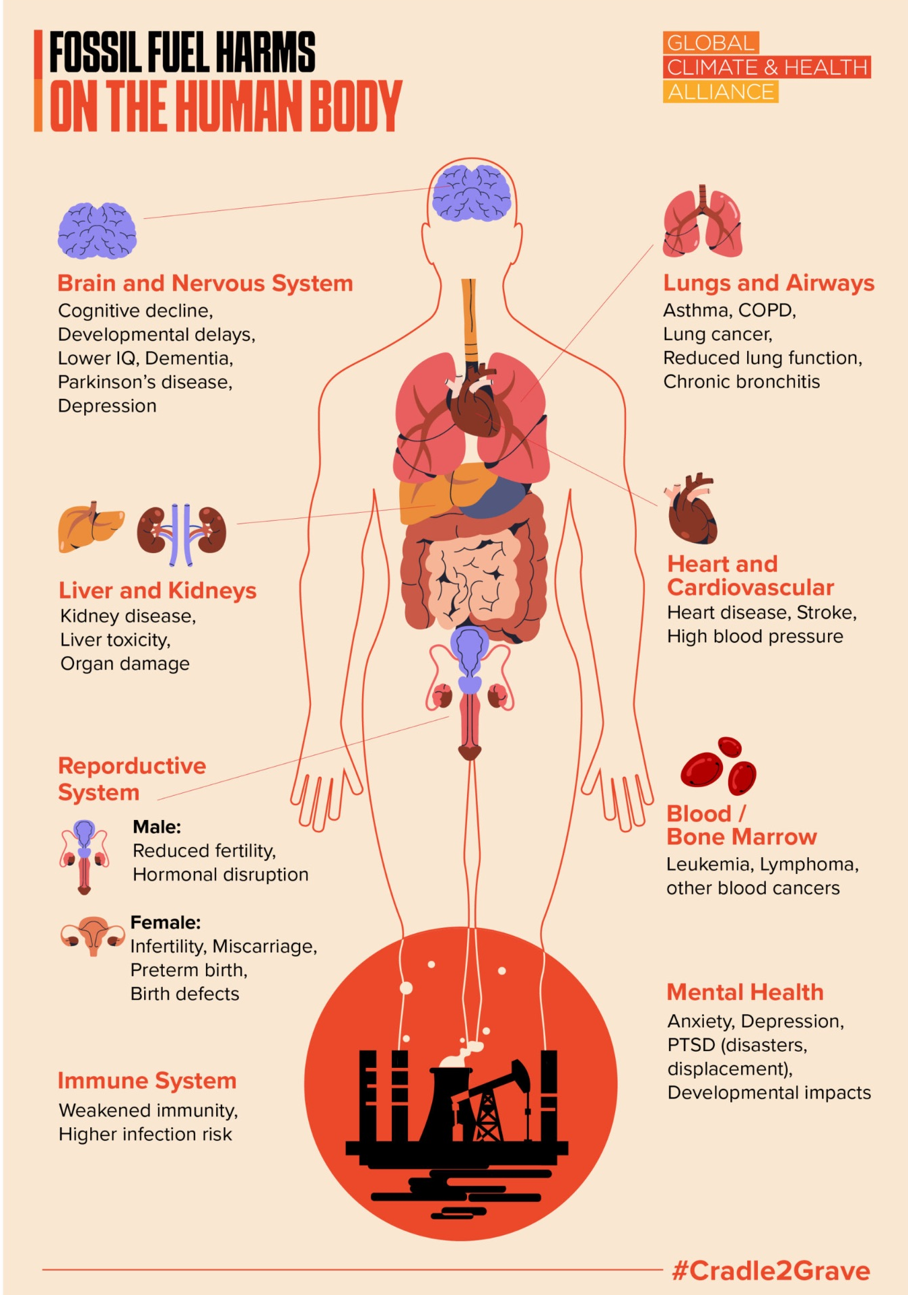
Cradle to Grave (2025). Global Climate & Health Alliance.

III. Primary sources of priority air pollutants

Air pollution is driven predominantly by anthropogenic activities, particularly the continued reliance on fossil fuels for transportation, electricity generation, and industrial production, as well as domestic fuel combustion for cooking and heating, inefficient agricultural practices, and forest fires often associated with deforestation. These activities release a range of harmful pollutants that degrade air quality in both indoor and outdoor environments and pose substantial risks to human health. The most critical classes of contaminants and their primary sources as shown in Table 2.

Priority air pollutants | Primary sources
Particulate Matter (PM₁₀, PM₂.₅, UFP) | Particulate Matter stems primarily from the combustion of fuels in power generation, industry, transport, or waste burning. These processes also produce PM₁₀ which also comes from wind-blown dust, agriculture, wood burning, construction and even sea spray.  The main source of UFP is combustion processes in transportation (vehicles, aviation, shipping), industrial and power plants and residential heating.
Ground-Level Ozone (O₃) | O₃ is formed through photochemical reactions between NOₓ and VOCs. These reactions occur when emissions from vehicles, power plants, industrial boilers, refineries, chemical facilities, and other sources interact in the presence of sunlight.
Nitrogen Oxides (NO_{x}) | The main source of NO_{x} is vehicular emissions (fossil fuel combustion), industrial processes, wildfires, and power plants.
Sulphur Dioxide (SO₂) | SO₂ stems from fossil fuel combustion in power plants, smelters, heavy industry, flaring, and residential heating. SO₂ pollution is concentrated around major industrial and energy-production hubs, with hotspots are found near major industrial hubs. It can also have long distant impacts, causing for example acid rain.
Carbon Monoxide (CO) | CO results from the use of wood, coal, kerosene and other polluting fuels in open fires, inefficient stoves, and motor vehicle emissions.
Heavy Metals (Lead, Cadmium, Mercury, etc.) | Major sources of elemental toxins include: battery recycling, aviation fuel use, paint, and industrial emissions (lead); metal smelting, battery production and disposal, and waste incineration (cadmium); coal-fired power plants, artisanal and small-scale mining, and waste incineration (mercury); mining activities, coal combustion, and contaminated groundwater (arsenic); and oil refining and metal processing (nickel).
Volatile Organic Compounds (VOCs) | Primarily from solvent-based products and fuels, with indoor concentrations often higher than outdoor levels. For example, paints, varnishes, lacquers and paint strippers; cleaning, disinfecting, cosmetic and degreasing products; pesticides; building materials and furnishings; office equipment and associated supplies; adhesives, glues, permanent markers and craft materials; fuels and fuel combustion; and stored household and hobby products containing organic solvents.
Short Lived Climate Pollutants (SLCP) (Methane, Black Carbon, HFCs, Tropospheric Ozone) | Major sources of climate-related air pollutants include: fossil fuel production, agriculture and livestock farming, waste management, and natural processes (methane); incomplete combustion of fossil fuels and solid fuels such as wood, charcoal, and kerosene (black carbon); synthetic greenhouse gases used in air conditioning, refrigeration, solvents, fire suppression systems, and aerosols (hydrofluorocarbons, HFCs); and photochemical reactions involving sunlight, methane, and emissions from vehicles and industry (tropospheric ozone).
Persistent Organic Pollutants (POPs) | POPs originate, predominantly, from human activities, including industrial production, pesticide use, waste burning, and fossil fuel combustion. They can also be emitted by volcanoes and wildfires.

See: www.nature.com/articles/s12276-020-0403-3
doi:10.1016/B978-0-12-803678-5.00320-9
See: www.who.int/teams/environment-climate-change-and-health/air-quality-and-health/health-impacts/types-of-pollutants
See: https://kunakair.com/sulphur-dioxide/
See: https://www.who.int/teams/environment-climate-change-and-health/air-quality-and-health/health-impacts/types-of-pollutants.
See: https://jksus.org/impact-of-heavy-metals-on-the-environment-and-human-health-novel-therapeutic-insights-to-counter-the-toxicity/
See: https://pmc.ncbi.nlm.nih.gov/articles/PMC8700805/
See: https://www.ccacoalition.org/content/short-lived-climate-pollutants
See: https://www.epa.gov/international-cooperation/persistent-organic-pollutants-global-issue-global-response
See: https://pmc.ncbi.nlm.nih.gov/articles/PMC6959193/
See: https://pmc.ncbi.nlm.nih.gov/articles/PMC9370264/#B3-nanomaterials-12-02656
See: https://www.epa.gov/air-research/air-pollution-and-cardiovascular-disease-basics
See: https://doi.org/10.1016/j.chest.2018.10.041
See: https://doi.org/10.1016/j.cdtm.2020.05.004
See: https://ippez.pl/en/effects-of-air-pollution-on-lung-health-as-smog-damages-our-respiratory-tract/
See: https://doi.org/10.3389/fpubh.2022.988242
See: https://ippez.pl/en/effects-of-air-pollution-on-lung-health-as-smog-damages-our-respiratory-tract/
See: https://doi.org/10.3389/fpubh.2020.575330
Ibid.
See: https://doi.org/10.1145/3759972.3760142
See: https://www.iarc.who.int/wp-content/uploads/2018/07/pr221_E.pdf
See: https://doi.org/10.1016/j.chest.2018.10.041
See: https://pmc.ncbi.nlm.nih.gov/articles/PMC11499323/
See: https://doi.org/10.1016/j.eclinm.2023.101864
See: https://pmc.ncbi.nlm.nih.gov/articles/PMC1913605/
See: https://doi.org/10.1016/j.envint.2017.01.017
See: https://doi.org/10.7570/jomes24036
See: https://medicine.washu.edu/news/air-pollution-contributes-significantly-to-diabetes-globally/#:~:text=The%20study's%20senior%20author%2C%20Ziyad%20Al%2DAly%2C%20MD%2C,lost%20in%202016%20due%20to%20pollution%2Dlinked%20diabetes
See: :https://doi.org/10.4209/aaqr.2020.03.0098
See: https://doi.org/10.3390/ijerph19031186
See: https://doi.org/10.3390/ijerph20032526
See: https://doi.org/10.1186/s12889-025-23733-w
See: https://doi.org/10.3390/ijerph14070816
See: https://doi.org/10.1016/j.preghy.2025.101204
See: https://www.who.int/teams/environment-climate-change-and-health/air-quality-and-health/health-impacts/types-of-pollutants.
Ibid.
See: https://www.epa.gov/ground-level-ozone-pollution/ground-level-ozone-basics
See: https://www.stateofglobalair.org/pollution-sources/nitrogen-dioxide
See: https://www.who.int/publications/i/item/9789240034228.
See: https://www.who.int/teams/environment-climate-change-and-health/air-quality-and-health/health-impacts/types-of-pollutants.
See: https://evs.institute/environmental-chemistry/heavy-metals-environment-sources-effects-safety/#google_vignette
See: https://www.epa.gov/indoor-air-quality-iaq/what-are-volatile-organic-compounds-vocs
See: https://doi.org/10.3390/agriculture13040873

