

HUMANITARIAN ORGANIZATION FOR MIGRATION ECONOMICS

Submission on concept paper for the CERD-CMW Joint General Comment/Recommendation on Obligations of State Parties on public policies for addressing and eradicating xenophobia and its impact on the rights of migrants, their families, and other non-citizens affected by racial discrimination

MARCH 2024

(2499 words)

Introduction

Singapore, renowned for its economic success and multiculturalism, grapples with the complex issue of xenophobia, including with migrant workers. While migrant labour has been integral to Singapore's development, tensions and prejudices against them persist.

There are currently approximately 1.5 million foreign work pass holders in Singapore. Singapore adopts a tiered work visa system (known as the work pass system) which categorises employees in terms of their qualifications and salary earned.

Low-wage workers, or those who have been categorised as “semi-skilled” or “low-skilled, are issued a “Work Permit” (WP); there is no minimum wage requirement. Typically, migrant workers earn about SGD 20-30 (USD 15-20) per day. Low-wage work in Singapore is largely performed by migrant workers. Most recognise that they perform jobs which many locals shun yet which are integral to sustaining Singapore’s economy.

This report delves into how xenophobia manifests towards the migrant worker community on work permits, and suggests recommendations to foster inclusivity and negate the harms caused by xenophobic sentiments and policies towards migrant workers.

Policies and practices that perpetuate xenophobia towards migrant workers

Segregation of the migrant worker population

The vast majority of Singapore’s migrant workers from construction, marine and process (CMP) sectors live in dormitories. Dormitories that are listed on the Ministry of Manpower’s (MOM) website show that a vast majority of the dormitories are located away from the main residential and commercial areas of Singapore, thus minimising interaction with and segregating them from the resident Singapore population.

Recreation centres (RCs), which offer migrant workers a place to congregate and rest during time off work, are also placed in the outskirts of the city. These RCs are mostly surrounded by dormitories, hardware stores and industrial facilities, while being spatially isolated from residential communities and commercial areas.

In addition, many private clubs and condominiums within Singapore have been known to enact restrictions that explicitly ban migrant workers, particularly MDWs from entering, even if invited by members and residents as their guests. There have been several reports of MDWs being disallowed from using the facilities of the condominium they reside in; however, statutory redress for such discrimination is not available. These policies are expressly discriminatory and only serve to reinforce negative prejudices against non-residents.

Marginalisation of South Asian migrant workers

On 8 December 2013, an accident occurred at Little India, a location in Singapore where non-domestic workers originating from India, predominantly from the construction industry, congregate on their day off. The accident led to Singapore’s first riot in 44 years. Alcohol was cited as a key contributor to the riot by the State in the wake of the riot. In Singaporean society, the stereotype that ethnic Indians are prone to alcoholic behaviour is deeply entrenched.

In the aftermath of the riot, the Liquor Control Act was passed. Geylang and Little India, were designated as Liquor Control Zones — places with a “higher risk of public disorder associated with excessive drinking”. Under this Act, all sale of take-away liquor (and public drinking) was limited, and in Liquor Control Zones, can only take place between 7am and 10.30pm from Mondays to Fridays, and between 7am to 7pm on Saturdays, Sundays and public holidays. A person found committing an offence in the Liquor Control Zones also may face enhanced punishments than that which has been prescribed in the law. These measures stigmatise male Indian migrant workers as having a propensity for excessive alcohol consumption and subjected them to greater marginalisation and disenfranchisement.

The Liquor Control Act, and the heightened punishments for contravening its provisions, remain in force today.

Racial stereotyping did not stop with the passing of the Liquor Control Act. In 2015, the Singapore Civil Defence Force, the Singapore Police Force, amongst others, conducted an emergency exercise simulating a riot at a workers’ dormitory. South Asian workers were recruited to participate in a staged riot to demonstrate how the Singapore police and Singapore Civil Defence Force should react in riot situations. Such acts allowed public authorities to promote racial stereotypes of South Asian male workers as potential security threats.

In 2016, Ms Denise Phua, a Member of Parliament, stated in Parliament that the crowds in Little India were "[w]alking time bombs and public disorder incidents waiting to happen." These comments were made in the same speech wherein she announced the establishment of a high-level task force to mitigate the risks of large crowds returning post-riot, and fencing around the communal areas of residents in Little India, “[s]o that the [local] old and the young get to use the space meant for them."

To this day, there remains a heavy presence of auxiliary police within Little India and Geylang, particularly during the weekends. The extent of this reinforcement can further exacerbate the distrust and negative stereotypes held of migrant worker populations amongst the Singaporean public.

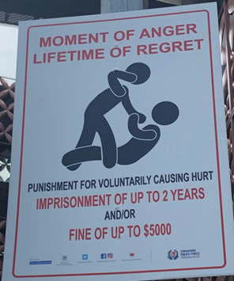
Figure 1: A poster in Little India warning individuals against causing hurt to others

Movement restrictions for migrant workers during COVID-19

It is no secret that the COVID-19 pandemic heavily and disproportionately affected Singapore’s migrant worker population, and inflicted harm and trauma that was felt for a prolonged period of time. The vast majority of Singapore’s initial wave of COVID-19 cases came from the migrant worker population, particularly those who lived in dormitories.

COVID-19 cases amongst migrant workers in dormitories were disproportionately higher than the rest of the population; the dormitories were cramped and crowded, and had poor ventilation. The mass-sharing of basic amenities in many dormitories made safe distancing and segregation impossible, leading to the rampant spread of the disease.

On 5 April 2020, migrant worker dormitories began to be gazetted “isolation areas”. “Essential” migrant workers, in environmental services, key infrastructure or critical supply chains, were moved to alternate locations. On 21 April 2020, by ministerial fiat, all migrant workers in dormitories were prohibited from leaving their premises. Gazetting individual dormitories became moot: workers as a population were discriminated against based on their work pass.

On 2 June 2020, the Employment of Foreign Manpower (Work Passes) Regulations (EFMR) was amended to confine workers in their accommodation and to enable their employers and dormitory operators to confine them. Exceptions were made only for pre-approved medical and other essential appointments, or if specifically permitted by the authorities on an individual basis, or if directed to evacuate. This applied to all premises housing seven or more workers.

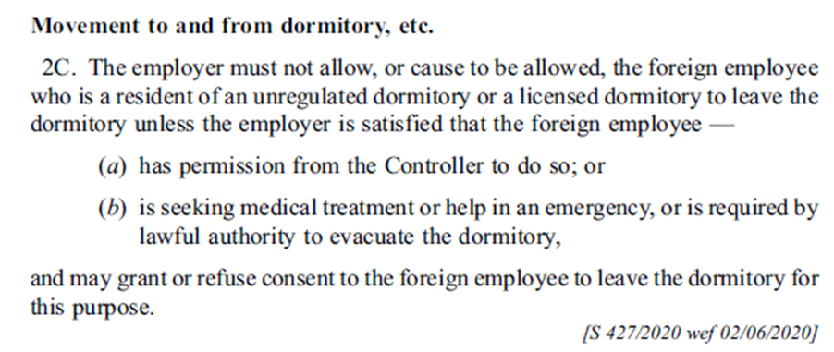
Figure 2: Provision of EFMR that prevented workers from leaving dormitories without employers’ permission

These restrictions remained in force till June 2022, with only superficial semantic changes to the regulations. Punishments for migrant workers breaching them were harsh, including revocation of their work pass and permanent disbarment from employment in Singapore. Unscrupulous employers also threatened to report workers for leaving the dormitories when they sought help for injuries, unpaid wages, or lack of food. This effectively cut them off from assistance, especially in the smaller dormitories and living quarters where there was no team from the ministries stationed.

From June 2022, migrant workers were progressively allowed to visit RCs, for a fixed number of pre-approved hours determined by their employers. As stated above, RCs are located in far-flung locations in the island, and the highly restrictive slots at fixed RCs did not meet workers’ basic human needs to socialise with meaningful autonomy.

Notwithstanding well-publicised officially-sanctioned excursions and activities, migrant workers were confined until June 2022 (from September 2021, the authorities progressively allowed workers to visit the community, starting form 500 workers a week, until 50,000 workers a week could visit any place in the community on weekends), when they no longer faced restrictions in leaving their dormitories. In other words, for more than two years, migrant workers in dormitories faced draconian movement restrictions, which were differentiated from the rest of the population, whose movements were only restricted for a span of a few months in 2020.

In June 2022, the Popular Places Pass was introduced. Migrant workers who wished to go to four areas frequented by migrant workers had to apply for a pass. Up to 80,000 passes were available for each Sunday or public holiday. Although the feedback was that enforcement for this pass was very lax, its existence was a reminder of the legislative restrictions that remained in the EFMR, and differentiated policies put in place for migrant workers that did not exist for the rest of the population.

The Popular Places Pass was done away with on 13 February 2023, when Singapore reverted to Dorscon Green, which is the lowest level in the country’s disease outbreak response framework. On 1 April 2023, the legislative restrictions in the EFMR highlighted above were finally removed.

These COVID-19 restrictions had disastrous effects on migrant workers’ mental health. Mid-2020 saw a spate of suicides and suicide attempts among workers in dormitories. Besides the physical confinement which workers likened to “prison”, they were significantly disempowered and forced to rely entirely on employers, dorm operators, and authorities for their day-to-day needs. These starkly differentiated measures they were subject to, compared to the rest of the population, had an inestimable impact on their well-being.

Heavy policing of migrant worker dormitories

In an incident in October 2021, migrant workers, predominantly Chinese nationals, voiced their concerns over poor living conditions at a dormitory. The complaints included: inadequate food standards, unpaid salary, and lack of access to timely medical help, with workers alleging delays in transporting positive Covid-19 cases to recovery facilities. Riot police, and armoured police officers and vehicles were seen present at the dormitory, even though their services were eventually not used, and no arrests were made.

The heavy police and paramilitary presence was justified with the workers being described as “behaving aggressively, with potential for violence”. The response was altogether excessive, reinforcing the stereotype that migrant workers are inclined toward violence, and suggesting that their actions should be regarded as a security risk and a disturbance to public order. This also frames workers’ demands for better living and working conditions as a security issue demanding (potentially hostile) police and paramilitary responses, rather than a labour rights’ issue requiring timely intervention from enforcement agencies and workers’ organizations.

Segregation of migrant workers from places of worship

In April 2023, the Singapore Bangladeshi Society issued a statement, purportedly carrying a message by the Islamic Religious Council of Singapore (MUIS), requesting migrant workers to carry out the Eid prayers in their dormitories rather than at mosques, “to avoid overcrowding and road blockages and ensure the health, and safety of everyone”.

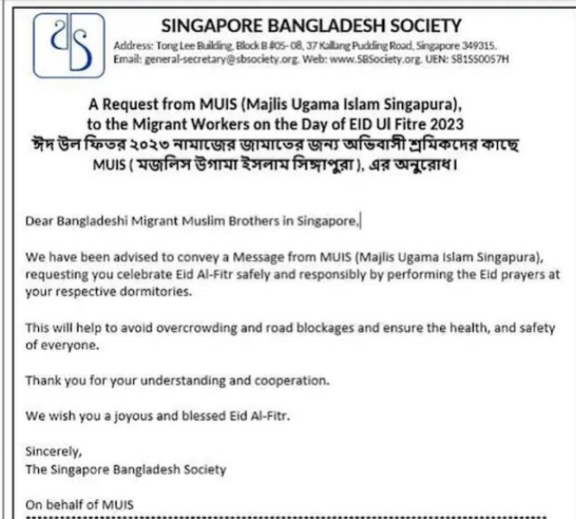
Figure 3: Circular by Singapore Bangladeshi Society urging migrant workers to perform Eid prayers in their dormitories

Thereafter, MUIS clarified that there was no intention to segregate or prevent migrant workers to partake in Eid prayers at mosques, but rather the circular issued by SBS was to “offer a range of choices to our congregants, across locations and times, so that they can perform their prayers in comfort and safety”. Nevertheless, the suggestion made to migrant workers that they remain in their dormitories depicted a mindset in which it was acceptable to exclude them from community spaces and events. The xenophobic effect of this statement was particularly hurtful to the migrant community as it came at the back of more than three years of confinement due to COVID-19.

Impact on Migrant Workers

Xenophobia takes a toll on the well-being and dignity of migrant workers. Beyond the economic hardships they endure, such as low, stagnated wages, and high recruitment debts, they grapple with social isolation and exclusion, discrimination, and psychological distress. The stigmatization of migrant communities contributes to their marginalization and hinders their integration into Singaporean society. Moreover, xenophobic attitudes perpetuate a cycle of injustice and inequality, undermining the nation’s commitment to equality and inclusivity.

Recommendations

- Establish cultural education programming aimed at teaching Singaporean citizens about the lives and cultural background of migrant workers to promote understanding and remove suspicion.

- Encourage the Singaporean public to treat migrant workers with greater empathy and appreciation.

- Living and recreation spaces for migrant workers should be moved closer to the spaces occupied by the rest of the population to prevent segregation of migrant workers.

- Take measures to prevent the social discrimination of migrant workers: in particular, the practice of heightened police presence in areas where migrant workers congregate should be stopped and MDWs should not be barred from entering private clubs or using facilities in the condominiums where they live in.

Ministry of Manpower, “Foreign workforce numbers”.
Ministry of Manpower, “Work passes and permits”
Ministry of Manpower, “List of foreign worker dormitories”.
TWC2, “House rules designed to ensure maids know their place”, 13 February 2013.
Cynthia Choo, “Domestic worker denied entry at SCC: Private clubs’ rules are ‘discriminatory’, ‘archaic’, some say”, 28 November 2018.
Andrew Koay, “Thomson Rd condo forbids maids from using facilities, threatens non-complying residents with 'period ban”, Mothership, 7 February 2021.
“Little India Riot: Violence sparked by accident, alcohol ‘major factor’”, says COI, The Straits TImes (20 Jan 2016).
Liquor Control (Supply and Consumption) Act 2015, Part 4, s(15)(1).
Lim Yi Han, “Stricter rules in Geylang and Little India as alcohol laws kick in”, 31 March 2015, The Straits Times.
Liquor Control (Supply and Consumption) Act 2015, Part 4, s(16).
“Simulated dormitory riot reinforced racist stereotypes of migrant workers, says NGO”, 12 November 2014, Today Online.
MP Denise Phua apologies for describing large crowds at Little India as ‘walking time bombs’”, 8 April 2016, Today Online.
Ibid.
HOME, “COVID-19 report 2020”, page 5; Andreas Illmer, “Singapore’s migrant worker infections were three times higher”, 16 December 2020, BBC.
Ang Hwee Min and Rachel Phua, “IN FOCUS: The long, challenging journey to bring COVID-19 under control in migrant worker dormitories”, 12 September 2020, Channel News Asia.
Janice Lim, “Foreign workers in dorms barred from leaving premises under tighter measures to curb Covid-19 spread”, 21 April 2020, Today Online.
HOME & TWC2, “Response to Post-Circuitbreaker Amendments to the Employment of Foreign Manpower (Work Passes) Regulations”, 26 June 2020.
Employment of Foreign Manpower (Work Passes) Regulations Fourth Schedule Part VI cl 9 and 11A, read with Part III, cl 2C—2D. Cf Employment of Foreign Manpower (Work Passes) Regulations Fourth Schedule Part III cl 2C, prior to the semantic amendments of 14 September 2020.
Humanitarian Organization for Migration Economics, “Concerns related to migrant workers during the ongoing Covid-19 outbreak”, 26 March 2020
SM Naheswari and Tessa Oh, “The Big Read: Grappling with isolation, migrant workers in dorms long for a return to the wider community”, 17 July 2021, Channel News Asia
“Ending circuit breaker: phased approach to resuming activities safely”, 28 May 2020
Rei Kurohi, “Capacity limits for nightclubs, exit pass requirement for migrant workers to be eased”, 10 June 2022, The Straits Times.
John Geddie and Aradhana Aravindan, “Spate of suicides among migrant workers in Singapore raises concern”, 5 August 2020, Reuters.
Ang Hwee Min, “Potential for violence led to police presence at Jalan Tukang dorm”, 01 November 2021, CNA.
And Hwee Min, “Shortcomings by all parties involved in Jalan Tukang dorm incident”, 01 November 2021, CNA.
MUIS, “Clarification on Singapore Bangladeshi Society (SBS) Memo”, 17 April 2023

